

Mars Atmosphere and Volatile Evolution (MAVEN) Mission

Solar Wind Ion Analyzer (SWIA)

PDS Archive

Software Interface Specification

Rev 1.3

SWIA Draft

5/25/2015

Prepared by

Jasper S Halekas

(jasper-halekas@uiowa.edu)

**MAVEN**

**Solar Wind Ion Analyzer (SWIA)**

**PDS Archive**

**Software Interface Specification**

**Rev. 1.3 SWIA Draft**

**May 25, 2015**

Custodian:

Jasper S Halekas Date

SWIA Principal Investigator

Approved:

Alexandria DeWolfe Date

MAVEN SDC Lead

Raymond J. Walker Date

PDS PPI Node Manager

Thomas H. Morgan Date

PDS Project Manager

Table of Contents

[1 Introduction 1](#_Toc420619822)

[1.1 Distribution List 1](#_Toc420619823)

[1.2 Document Change Log 1](#_Toc420619824)

[1.3 TBD Items 2](#_Toc420619825)

[1.4 Abbreviations 2](#_Toc420619826)

[1.5 Glossary 4](#_Toc420619827)

[1.6 MAVEN Mission Overview 6](#_Toc420619828)

[1.6.1 Mission Objectives 6](#_Toc420619829)

[1.6.2 Payload 7](#_Toc420619830)

[1.7 SIS Content Overview 8](#_Toc420619831)

[1.8 Scope of this document 8](#_Toc420619832)

[1.9 Applicable Documents 8](#_Toc420619833)

[1.10 Audience 9](#_Toc420619834)

[2 SWIA Instrument Description 10](#_Toc420619835)

[2.1 Science Objectives 10](#_Toc420619836)

[2.2 Electrostatic Optics and Detectors 11](#_Toc420619837)

[2.3 Electronics 15](#_Toc420619838)

[2.4 Measured Parameters 18](#_Toc420619839)

[2.5 Operational Modes 19](#_Toc420619840)

[2.6 Operational Considerations 20](#_Toc420619841)

[2.7 Ground Calibration 21](#_Toc420619842)

[2.8 Inflight Calibration 24](#_Toc420619843)

[3 Data Overview 26](#_Toc420619844)

[3.1 Data Reduction Levels 26](#_Toc420619845)

[3.2 Products 27](#_Toc420619846)

[3.3 Product Organization 27](#_Toc420619847)

[3.3.1 Collection and Basic Product Types 28](#_Toc420619848)

[3.4 Bundle Products 29](#_Toc420619849)

[3.5 Data Flow 29](#_Toc420619850)

[4 Archive Generation 31](#_Toc420619851)

[4.1 Data Processing and Production Pipeline 31](#_Toc420619852)

[4.1.1 Raw Data Production Pipeline 31](#_Toc420619853)

[4.1.2 Calibrated Data Production Pipeline 31](#_Toc420619854)

[4.2 Data Validation 32](#_Toc420619855)

[4.2.1 Instrument Team Validation 32](#_Toc420619856)

[4.2.2 MAVEN Science Team Validation 32](#_Toc420619857)

[4.2.3 PDS Peer Review 32](#_Toc420619858)

[4.3 Data Transfer Methods and Delivery Schedule 34](#_Toc420619859)

[4.4 Data Product and Archive Volume Size Estimates 35](#_Toc420619860)

[4.5 Data Validation 35](#_Toc420619861)

[4.6 Backups and duplicates 35](#_Toc420619862)

[5 Archive organization and naming 37](#_Toc420619863)

[5.1 Logical Identifiers 37](#_Toc420619864)

[5.1.1 LID Formation 37](#_Toc420619865)

[5.1.2 VID Formation 38](#_Toc420619866)

[5.2 SWIA Archive Contents 38](#_Toc420619867)

[5.2.1 SWIA Calibrated (MAVEN Level 2) Science Data Bundle 38](#_Toc420619868)

[6 Archive products formats 44](#_Toc420619869)

[6.1 Data File Formats 44](#_Toc420619870)

[6.1.1 Calibrated data file structure 44](#_Toc420619871)

[6.2 Document Product File Formats 51](#_Toc420619872)

[6.3 PDS Labels 51](#_Toc420619873)

[6.3.1 XML Documents 51](#_Toc420619874)

[6.4 Delivery Package 52](#_Toc420619875)

[6.4.1 The Package 52](#_Toc420619876)

[6.4.2 Transfer Manifest 52](#_Toc420619877)

[6.4.3 Checksum Manifest 52](#_Toc420619878)

[Appendix A Data Users’ Guide 53](#_Toc420619879)

[A.1 Unit Conversion and Moment Computation 53](#_Toc420619880)

[A.2 Example Data 53](#_Toc420619881)

[Appendix B Support staff and cognizant persons 56](#_Toc420619882)

[Appendix C Naming conventions for MAVEN science data files 57](#_Toc420619883)

[Appendix D Sample Bundle Product Label 58](#_Toc420619884)

[Appendix E </Product\_Bundle>Sample Collection Product Label 61](#_Toc420619885)

[Appendix F Sample Data Product Labels 65](#_Toc420619886)

[Appendix G PDS Delivery Package Manifest File Record Structures 66](#_Toc420619887)

[G.1 Transfer Package Directory Structure 66](#_Toc420619888)

[G.2 Transfer Manifest Record Structure 66](#_Toc420619889)

[G.3 Checksum Manifest Record Structure 66](#_Toc420619890)

[Appendix H PDS4 Labels for SWIA CDF Data Files 67](#_Toc420619891)

[H.1 CDF Formatted Data Files 67](#_Toc420619892)

[H.2 CDF and PDS4 Metadata 67](#_Toc420619893)

[H.3 PDS4 Label Structure 67](#_Toc420619894)

[H.3.1 PDS Label Physical Structure Description 67](#_Toc420619895)

[H.3.2 Parameter Logical Relationships 69](#_Toc420619896)

[H.3.3 Constant Values 72](#_Toc420619897)

[H.4 CDF References 72](#_Toc420619898)

**List of Figures**

Figure 1: The SWIA instrument and its location on the spacecraft. 10

Figure 2: SWIA analyzer optics for no deflection (top) and selected up and down deflections, achieved by placing different combinations of voltages on the inner hemisphere and the two toroidal deflector surfaces. 12

Figure 3: SWIA intrinsic energy, phi, and theta resolution at zero deflection, with attenuator open (black) and closed (red). 13

Figure 4: SWIA deflection angle vs. voltage (top), and geometric factor vs. deflection angle (bottom), for attenuator open (black) and closed (red). The +/– deflection voltages indicate the operation of the two deflectors; both deflector voltages are in fact positive. 14

Figure 5: SWIA intrinsic energy/theta response for six different sensor phi angles, showing 0.1 and 0.5 response level contours with no deflection (left), and energy response integrated over all theta angles (right). 21

Figure 6: SWIA energy/theta response for five different deflection angles [0, +20, -20, +35, -35], comparing the measured response (left) and simulation results (right), for the same ratio of inner hemisphere to deflector voltage. Each simulation plot has four panels showing the integrated energy and angular response, and the energy-angle response with the axes in both senses. The measurement should be compared to the upper right panel in each case. Note the slightly different scales of measured and simulated plots. 23

Figure 7: SWIA sensor phi response for coarse (bottom two panels) and fine (top panel) resolution products, measured during a full phi rotation of the instrument. Colored lines show response for each individual anode, white line shows the integrated response. Bottom panel shows response with attenuator closed, top two panels with attenuator open 24

Figure 8: A graphical depiction of the relationship among bundles, collections, and basic products. 28

Figure 9: MAVEN Ground Data System responsibilities and data flow. Note that this figure includes portions of the MAVEN GDS which are not directly connected with archiving, and are therefore not described in Section 3.5 above. 30

Figure 10: Duplication and dissemination of SWIA archive products at PDS/PPI. 36

Figure 11. Sample PDS4 Array objects. 68

Figure 12. Sample Alternate\_Values object. 69

Figure 13. Sample Particle\_Observation object. 71

Figure 14. Sample Parameter objects. 72

**List of Tables**

Table 1: Distribution list 1

Table 2: Document change log 1

Table 3: List of TBD items 2

Table 4: Abbreviations and their meaning 2

Table 5: MAVEN SWIA Archive Schema and Schematron 26

Table 6: Data reduction level designations 26

Table 7: Collection product types 29

*Table 8: SWIA Bundles* **Error! Bookmark not defined.**

Table 9: MAVEN PDS review schedule 32

Table 10: Archive bundle delivery schedule 34

Table 11: swia.calibrated Level 2 Science Data Collections 38

Table 12: SWIA Calibrated Science Data Documents 43

Table 13: Contents for maven.swia.calibrated:data.coarse\_svy\_3d and maven.swia.calibrated:data.coarse\_arc\_3d calibrated data files 44

Table 14: Contents for maven.swia.calibrated:data.fine\_svy\_3d and maven.swia.calibrated:data.fine\_arc\_3d calibrated data files 46

Table 15: Contents for maven.swia.calibrated:data.onboard\_svy\_mom calibrated data files 48

Table 16: Contents for maven.swia.calibrated:data.onboard\_svy\_spec calibrated data files 50

Table 17: Archive support staff 56

# Introduction

This software interface specification (SIS) describes the format and content of the Solar Wind Ion Analyzer (SWIA) Planetary Data System (PDS) data archive. It includes descriptions of the data products and associated metadata, and the archive format, content, and generation pipeline.

## Distribution List

Table 1: Distribution list

| **Name** | **Organization** | **Email** |
| --- | --- | --- |
| Jasper S Halekas | UCB/SSL | jazzman@ssl.berkeley.edu |
| Dave Mitchell | UCB/SSL | mitchell@ssl.berkeley.edu |
| Alexandria DeWolfe | LASP/SDC | alex.dewolfe@lasp.colorado.edu |
| Steve Joy | UCLA/PDS/PPI | [sjoy@igpp.ucla.edu](mailto:sjoy@igpp.ucla.edu) |
| Ray Walker | UCLA/PDS/PPI | [rwalker@igpp.ucla.edu](mailto:rwalker@igpp.ucla.edu) |
| Joe Mafi | UCLA/PDS/PPI | jmafi@igpp.ucla.edu |

## Document Change Log

Table 2: Document change log

|  |  |  |  |
| --- | --- | --- | --- |
| **Version** | **Change** | **Date** | **Affected portion** |
| 0.0 | Initial template | 2012-Aug-24 | All |
| 0.1 | Updated template | 2013-Feb-13 | All |
| 0.2 | Final template | 2013-Feb-15 | All |
| 0.3 | Revised for SWIA | 2013-Mar-22 | All |
| 0.4 | First partially completed version | 2013-Aug-09 | All |
| 0.5 | Fully completed version | 2013-Sep-07 | All |
| 0.6 | Updated format of data files, lids to lower case | 2014-Jan-31 | All |
| 0.7 | Updated file formats to make use of /novary support data, waiting for requirements to be agreed upon before generating new sample files | 2014-Mar-06 | All |
| 0.8 | Format edits by Joe Mafi, removed some context and XML schema from SWIA bundle | 2014-Mar-14 | All |
| 1.0 | Updated sections from original template to better reflect current archive plans | 2014-Mar-24 | All |
| 1.1 | Update documentation to reflect results of PDS review, added description of moments and survey vs archive. Clarified file-naming convention and data types. Revised files to be ISTP-compliant | 2014-Sep-16 | All |
| 1.2 | Added numerous caveats and descriptions | 2015-Jan-30 | All |
| 1.3 | Updated to address liens from Delta Peer Review | 2015-May-25 | All |

## TBD Items

Table 3 lists items that are not yet finalized.

Table 3: List of TBD items

| **Item** | **Section(s)** | **Page(s)** |
| --- | --- | --- |
| Full references for PDS4 Standards Reference, and Data Provider’s Handbook documents (to be provided by PDS/PPI) | 1.9 | 8 |
| Sample labels (to be provided by PDS/PPI) | Appendices C, D, and E | 51-53 |
|  |  |  |

## Abbreviations

Table 4: Abbreviations and their meaning

| **Abbreviation** | **Meaning** |
| --- | --- |
| ASCII | American Standard Code for Information Interchange |
| Atmos | PDS Atmospheres Node (NMSU, Las Cruces, NM) |
| CCSDS | Consultative Committee for Space Data Systems |
| CDR | Calibrated Data Record |
| CFDP | CCSDS File Delivery Protocol |
| CK | C-matrix Kernel (NAIF orientation data) |
| CODMAC | Committee on Data Management, Archiving, and Computing |
| CRC | Cyclic Redundancy Check |
| CU | University of Colorado (Boulder, CO) |
| DAP | Data Analysis Product |
| DDR | Derived Data Record |
| DMAS | Data Management and Storage |
| DPF | Data Processing Facility |
| E&PO | Education and Public Outreach |
| EDR | Experiment Data Record |
| EUV | Extreme Ultraviolet; also used for the EUV Monitor, part of LPW (SSL) |
| FEI | File Exchange Interface |
| FOV | Field of View |
| FTP | File Transfer Protocol |
| GB | Gigabyte(s) |
| GSFC | Goddard Space Flight Center (Greenbelt, MD) |
| HK | Housekeeping |
| HTML | Hypertext Markup Language |
| ICD | Interface Control Document |
| IM | Information Model |
| ISO | International Standards Organization |
| ITF | Instrument Team Facility |
| IUVS | Imaging Ultraviolet Spectrograph (LASP) |
| JPL | Jet Propulsion Laboratory (Pasadena, CA) |
| LASP | Laboratory for Atmosphere and Space Physics (CU) |
| LID | Logical Identifier |
| LIDVID | Versioned Logical Identifer |
| LPW | Langmuir Probe and Waves instrument (SSL) |
| MAG | Magnetometer instrument (GSFC) |
| MAVEN | Mars Atmosphere and Volatile EvolutioN |
| MB | Megabyte(s) |
| MD5 | Message-Digest Algorithm 5 |
| MOI | Mars Orbit Insertion |
| MOS | Mission Operations System |
| MSA | Mission Support Area |
| MSO | Mars Solar Orbital Coordinate System |
| NAIF | Navigation and Ancillary Information Facility (JPL) |
| NASA | National Aeronautics and Space Administration |
| NGIMS | Neutral Gas and Ion Mass Spectrometer (GSFC) |
| NMSU | New Mexico State University (Las Cruces, NM) |
| NSSDC | National Space Science Data Center (GSFC) |
| PCK | Planetary Constants Kernel (NAIF) |
| PDS | Planetary Data System |
| PDS4 | Planetary Data System Version 4 |
| PF | Particles and Fields (instruments) |
| PPI | PDS Planetary Plasma Interactions Node (UCLA) |
| RS | Remote Sensing (instruments) |
| SCET | Spacecraft Event Time |
| SDC | Science Data Center (LASP) |
| SCLK | Spacecraft Clock |
| SEP | Solar Energetic Particle instrument (SSL) |
| SIS | Software Interface Specification |
| SOC | Science Operations Center (LASP) |
| SPE | Solar Particle Event |
| SPICE | Spacecraft, Planet, Instrument, C-matrix, and Events (NAIF data format) |
| SPK | Spacecraft and Planetary ephemeris Kernel (NAIF) |
| SSL | Space Sciences Laboratory (UCB) |
| STATIC | Supra-Thermal And Thermal Ion Composition instrument (SSL) |
| SWEA | Solar Wind Electron Analyzer (SSL) |
| SWIA | Solar Wind Ion Analyzer (SSL) |
| TBC | To Be Confirmed |
| TBD | To Be Determined |
| UCB | University of California, Berkeley |
| UCLA | University of California, Los Angeles |
| URN | Uniform Resource Name |
| UV | Ultraviolet |
| XML | eXtensible Markup Language |

## Glossary

**Archive –** A place in which public records or historical documents are preserved; also the material preserved – often used in plural. The term may be capitalized when referring to all of PDS holdings – the PDS Archive.

**Basic Product** – The simplest product in PDS4; one or more data objects (and their description objects), which constitute (typically) a single observation, document, etc. The only PDS4 products that are *not* basic products are collection and bundle products.

**Bundle** **Product** – A list of related collections. For example, a bundle could list a collection of raw data obtained by an instrument during its mission lifetime, a collection of the calibration products associated with the instrument, and a collection of all documentation relevant to the first two collections.

**Class** – The set of attributes (including a name and identifier) which describes an item defined in the PDS Information Model. A class is generic – a template from which individual items may be constructed.

**Collection** **Product** – A list of closely related basic products of a single type (e.g. observational data, browse, documents, etc.). A collection is itself a product (because it is simply a list, with its label), but it is not a *basic* product.

**Data Object –** A generic term for an object that is described by a description object. Data objects include both digital and non-digital objects.

**Description Object –** An object that describes another object. As appropriate, it will have structural and descriptive components. In PDS4 a ‘description object’ is a digital object – a string of bits with a predefined structure.

**Digital Object –** An object which consists of real electronically stored (digital) data.

**Identifier** – A unique character string by which a product, object, or other entity may be identified and located. Identifiers can be global, in which case they are unique across all of PDS (and its federation partners). A local identifier must be unique within a label.

**Label –** The aggregation of one or more description objects such that the aggregation describes a single PDS product. In the PDS4 implementation, labels are constructed using XML.

**Logical Identifier** (**LID**) – An identifier which identifies the set of all versions of a product.

**Versioned Logical Identifier (LIDVID)** – The concatenation of a logical identifier with a version identifier, providing a unique identifier for each version of product.

**Manifest** - A list of contents.

**Metadata** – Data about data – for example, a ‘description object’ contains information (metadata) about an ‘object.’

**Non-Digital Object –** An object which does not consist of digital data. Non-digital objects include both physical objects like instruments, spacecraft, and planets, and non-physical objects like missions, and institutions. Non-digital objects are labeled in PDS in order to define a unique identifier (LID) by which they may be referenced across the system.

**Object** – A single instance of a class defined in the PDS Information Model.

**PDS Information Model –** The set of rules governing the structure and content of PDS metadata. While the Information Model (IM) has been implemented in XML for PDS4, the model itself is implementation independent.

**Product** – One or more tagged objects (digital, non-digital, or both) grouped together and having a single PDS-unique identifier. In the PDS4 implementation, the descriptions are combined into a single XML label. Although it may be possible to locate individual objects within PDS (and to find specific bit strings within digital objects), PDS4 defines ‘products’ to be the smallest granular unit of addressable data within its complete holdings.

**Tagged Object** – An entity categorized by the PDS Information Model, and described by a PDS label.

**Registry** – A data base that provides services for sharing content and metadata.

**Repository** – A place, room, or container where something is deposited or stored (often for safety).

**XML** – eXtensible Markup Language.

**XML schema** – The definition of an XML document, specifying required and optional XML

elements, their order, and parent-child relationships.

## MAVEN Mission Overview

The MAVEN mission is scheduled to launch on an Atlas V between November 18 and December 7, 2013. After a ten-month ballistic cruise phase, Mars orbit insertion will occur on or after September 22, 2014. Following a 5-week transition phase, the spacecraft will orbit Mars at a 75° inclination, with a 4.5 hour period and periapsis altitude of 140-170 km (density corridor of 0.05-0.15 kg/km3). Over a one-Earth-year period, periapsis will precess over a wide range of latitude and local time, while MAVEN obtains detailed measurements of the upper atmosphere, ionosphere, planetary corona, solar wind, interplanetary/Mars magnetic fields, solar EUV and solar energetic particles, thus defining the interactions between the Sun and Mars. MAVEN will explore down to the homopause during a series of five 5-day “deep dip” campaigns for which periapsis will be lowered to an atmospheric density of 2 kg/km3 (~125 km altitude) in order to sample the transition from the collisional lower atmosphere to the collisionless upper atmosphere. These five campaigns will be interspersed though the mission to sample the subsolar region, the dawn and dusk terminators, the anti-solar region, and the north pole.

### Mission Objectives

The primary science objectives of the MAVEN project will be to provide a comprehensive picture of the present state of the upper atmosphere and ionosphere of Mars and the processes controlling them and to determine how loss of volatiles to outer space in the present epoch varies with changing solar conditions. Knowing how these processes respond to the Sun’s energy inputs will enable scientists, for the first time, to reliably project processes backward in time to study atmosphere and volatile evolution. MAVEN will deliver definitive answers to high-priority science questions about atmospheric loss (including water) to space that will greatly enhance our understanding of the climate history of Mars. Measurements made by MAVEN will allow us to determine the role that escape to space has played in the evolution of the Mars atmosphere, an essential component of the quest to “follow the water” on Mars. MAVEN will accomplish this by achieving science objectives that answer three key science questions:

* What is the current state of the upper atmosphere and what processes control it?
* What is the escape rate at the present epoch and how does it relate to the controlling processes?
* What has the total loss to space been through time?

MAVEN will achieve these objectives by measuring the structure, composition, and variability of the Martian upper atmosphere, and it will separate the roles of different loss mechanisms for both neutrals and ions. MAVEN will sample all relevant regions of the Martian atmosphere/ionosphere system—from the termination of the well-mixed portion of the atmosphere (the “homopause”), through the diffusive region and main ionosphere layer, up into the collisionless exosphere, and through the magnetosphere and into the solar wind and downstream tail of the planet where loss of neutrals and ionization occurs to space—at all relevant latitudes and local solar times. To allow a meaningful projection of escape back in time, measurements of escaping species will be made simultaneously with measurements of the energy drivers and the controlling magnetic field over a range of solar conditions. Together with measurements of the isotope ratios of major species, which constrain the net loss to space over time, this approach will allow thorough identification of the role that atmospheric escape plays today and to extrapolate to earlier epochs.

### Payload

MAVEN will use the following science instruments to measure the Martian upper atmospheric and ionospheric properties, the magnetic field environment, the solar wind, and solar radiation and particle inputs:

* NGIMS Package:
  + Neutral Gas and Ion Mass Spectrometer (NGIMS) measures the composition, isotope ratios, and scale heights of thermal ions and neutrals.
* RS Package:
  + Imaging Ultraviolet Spectrograph (IUVS) remotely measures UV spectra in four modes: limb scans, planetary mapping, coronal mapping and stellar occultations. These measurements provide the global composition, isotope ratios, and structure of the upper atmosphere, ionosphere, and corona.
* PF Package:
  + Supra-Thermal and Thermal Ion Composition (STATIC) instrument measures the velocity distributions and mass composition of thermal and suprathermal ions from below escape energy to pickup ion energies.
  + Solar Energetic Particle (SEP) instrument measures the energy spectrum and angular distribution of solar energetic electrons (30 keV – 1 MeV) and ions (30 keV – 12 MeV).
  + Solar Wind Ion Analyzer (SWIA) measures solar wind and magnetosheath ion density, temperature, and bulk flow velocity. These measurements are used to determine the charge exchange rate and the solar wind dynamic pressure.
  + Solar Wind Electron Analyzer (SWEA) measures energy and angular distributions of 5 eV to 5 keV solar wind, magnetosheath, and auroral electrons, as well as ionospheric photoelectrons. These measurements are used to constrain the plasma environment, magnetic field topology and electron impact ionization rate.
  + Langmuir Probe and Waves (LPW) instrument measures the electron density and temperature and electric field in the Mars environment. The instrument includes an EUV Monitor that measures the EUV input into Mars atmosphere in three broadband energy channels.
  + Magnetometer (MAG) measures the vector magnetic field in all regions traversed by MAVEN in its orbit.

## SIS Content Overview

Section 2 describes the Solar Wind Ion Analyzer (SWIA) sensor. Section 3 gives an overview of data organization and data flow. Section 4 describes data archive generation, delivery, and validation. Section 5 describes the archive structure and archive production responsibilities. Section 6 describes the file formats used in the archive, including the data product record structures. Appendix A contains a guide for new users of these data. Individuals involved with generating the archive volumes are listed in Appendix B. Appendix C contains a description of the MAVEN science data file naming conventions. Appendix D, Appendix E, and Appendix F contain sample PDS product labels. Appendix G describes SWIA archive product PDS deliveries formats and conventions. Appendix H contains guidelines for understanding and reading the CDF formatted data files using the PDS label.

## Scope of this document

The specifications in this SIS apply to all SWIA products submitted for archive to the Planetary Data System (PDS), for all phases of the MAVEN mission. This document includes descriptions of archive products that are produced by both the SWIA team and by PDS.

## Applicable Documents

1. Planetary Data System Data Provider’s Handbook, Version 1.3.0, September 2014.
2. Planetary Data System Standards Reference, Version 1.3.0, 18 September 2014.
3. PDS4 Data Dictionary – Abridged, Version 1.4.0.0, 31 March 2015.
4. Planetary Data System (PDS) PDS4 Information Model Specification, Version 1.4.0.0.
5. Mars Atmosphere and Volatile Evolution (MAVEN) Science Data Management Plan, Rev. C, doc. no.MAVEN-SOPS-PLAN-0068
6. Archive of MAVEN CDF in PDS4, T. King and J. Mafi, 16 July 2013.

## Audience

This document describes the interactions between the MAVEN Project, SWIA instrument team, and PDS, defining the roles and responsibilities of each in producing SWIA PDS archive products. It is also useful to those wishing to understand the format and content of the SWIA PDS data product archive collection. Typically, these individuals would include scientists, data analysts, and software engineers.

# SWIA Instrument Description

The Solar Wind Ion Analyzer (SWIA) [See Fig. 1] is an electrostatic analyzer designed to measure solar wind and magnetospheric ions in the Martian system over an energy/charge range of ~5-25000 eV/q, and an angular range of 360x90 degrees [minus spacecraft obstructions]. The SWIA sensor is based on heritage from the Mars Global Surveyor Electron Reflectometer, Lunar Prospector Electron Reflectometer, Wind 3dp, FAST ESA, and THEMIS ESA instruments. The SWIA electronics are most directly based on those of THEMIS ESA, and the analyzer includes new deflection optics in order to provide a large field of view on the 3-axis stabilized MAVEN spacecraft. The SWIA sensor is mounted on the corner of the top deck of the spacecraft as shown in Fig. 1, positioned to ensure a clear field of view over both sides of the solar panel. For the nominal sun-pointed spacecraft orientation, the sensor is aligned such that the sun is centered in the sensor field of view, with an unobstructed field of view around the nominal solar wind flow direction.

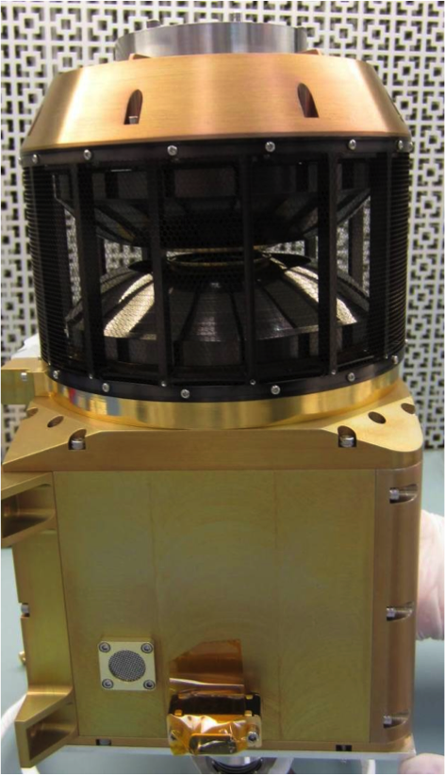

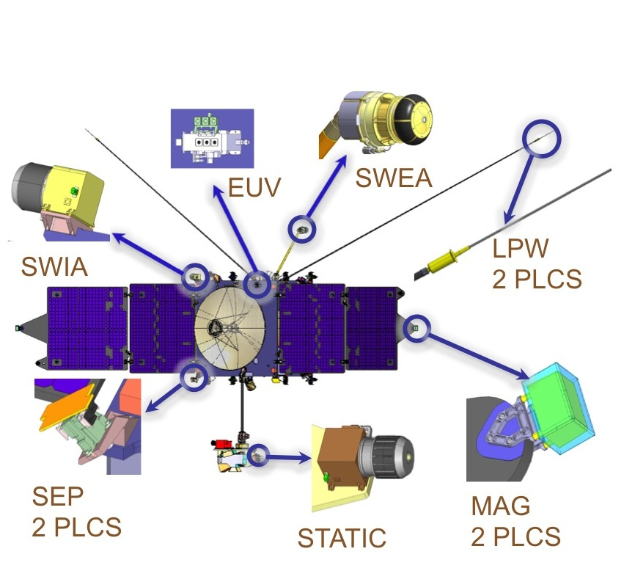

Figure 1: The SWIA instrument and its location on the spacecraft.

## Science Objectives

SWIA provides measurements that satisfy the MAVEN level 1 requirement to determine density and velocity distributions of solar wind and magnetosheath protons from 1000 km/s to 50 km/s, with better than 15% energy resolution and better than 30 degrees angular resolution. MAVEN carries a suite of instruments that measure the significant energy inputs into the Martian system and the neutral and charged populations of escaping atmospheric gases, in order to determine how the former drives the latter, with the goal of characterizing the state of the upper atmosphere and its evolution over Mars’ history. Within this framework, the main science objective for the SWIA sensor is to measure the properties of the energy input to the Martian system from the solar wind. Solar wind ion properties determine the solar wind and magnetosheath properties near Mars and constrain the nature of the solar wind interactions with the upper atmosphere, determine the ionization rates of neutrals from charge exchange, and determine the pickup acceleration of newly formed ions by the **v X B** electric field. SWIA measurements also contribute to the goal of determining the current state of the upper atmosphere and characterizing the non-thermal ion loss processes that occur, by providing high-cadence measurements of ion 3-d velocity distributions throughout the Martian magnetosphere.

In order to achieve these science goals, SWIA satisfies and in most cases significantly exceeds the following MAVEN Level 3 measurement requirements:

* SWIA shall measure energy fluxes from 107 to 1010 eV/[cm2 s sr eV] w/ no worse than 25% precision
* SWIA shall measure ion flow velocities from 50-1000 km/s
* SWIA shall have energy resolution ΔE/E at least 15%
* SWIA shall have angular resolution of at least 30 degrees (10 degrees in Sun direction)
* SWIA shall have time resolution of at least 1 minute or better
* SWIA shall have a FOV of 180 x 40 degrees or better

## Electrostatic Optics and Detectors

SWIA measures ions of a given energy by sweeping the negative voltage on the inner of two concentric toroidal hemispheres, ions of a given sensor phi angle (0-360 degrees) with a segmented charge collecting anode (24 anodes total, 10 with 4.5 degree resolution in the sun direction and 14 more with 22.5 degree resolution elsewhere) below a chevron pair of micro-channel plates, and ions of a given sensor theta angle (±45 degrees) by sweeping the positive voltage on the upper or lower deflectors [See Fig. 2]. A mechanical attenuator consisting of a “visor” with a slit centered in the field of view reduces the sensitivity in the sun direction when closed, in order to prevent saturation during periods of intense solar wind fluxes.

The SWIA electrostatic optics were simulated in detail, utilizing a Laplacian solver to derive the electrostatic potential produced by each charged surface in the analyzer, and a Runge-Kutta algorithm to trace charged particles through the resulting electrostatic fields. Our simulations indicate that (given an high voltage power supply that can produce an inner hemisphere voltage which can reach -4 kV) SWIA can cover ion energy per charges of up to ~31 keV/q. In normal operation, we sweep the inner hemisphere voltage in order to cover the range from 5 eV/q to 25 keV/q, utilizing a logarithmic energy sweep. SWIA can measure particles with sensor theta angles of up to ±45 degrees by placing a voltage of up to ~6.4 times the inner hemisphere voltage on one of the two toroidal deflector surfaces. In normal operation, each deflector voltage is scanned over its full range at each energy step, in order to cover as much of this angular range as possible. Given the maximum deflector high voltage supply output of +4 kV, full range deflection is only possible for ions with energy per charge of up to ~5 keV/q; above this energy, we sweep the deflectors so as to evenly cover the angular range accessible to the instrument.

**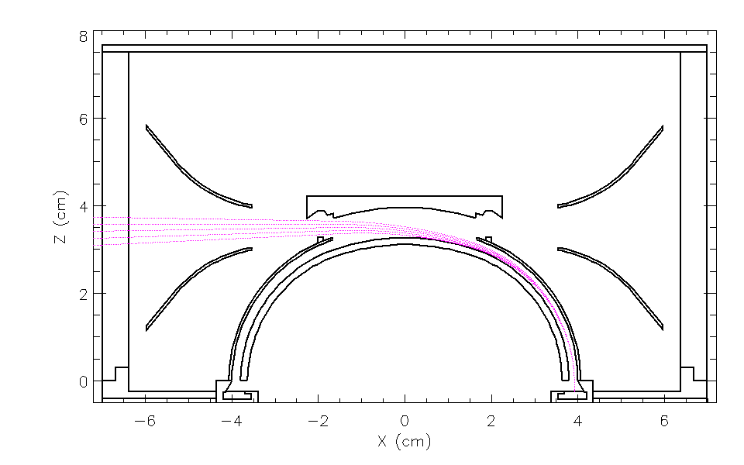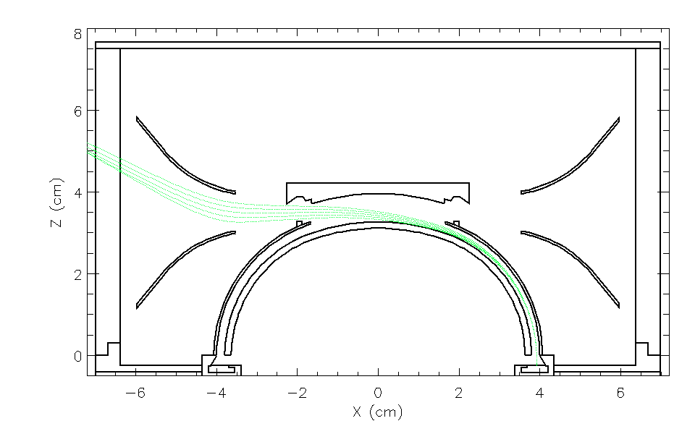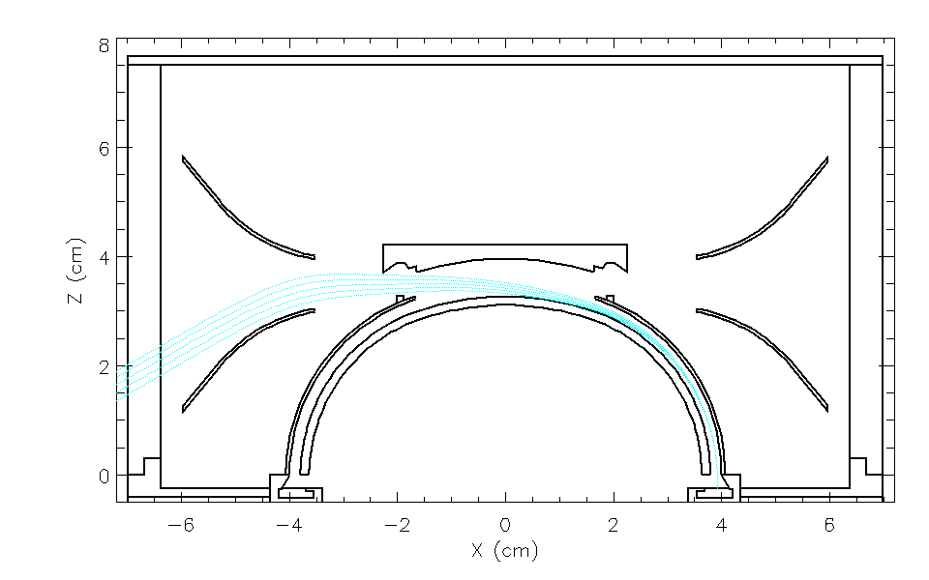**

Figure 2: SWIA analyzer optics for no deflection (top) and selected up and down deflections, achieved by placing different combinations of voltages on the inner hemisphere and the two toroidal deflector surfaces.

When closed, the mechanical attenuator slightly improves the energy and theta angle resolution of the sensor, since it has the effect of collimating the response in the theta angle. As shown in Fig. 3, the simulated energy resolution of the sensor is ~14.5% with the attenuator open, and ~10% with it closed. The theta resolution is ~7 degrees with the attenuator open, and ~3 degrees with it closed, at zero deflection. The intrinsic phi resolution of the instrument is very narrow, on the order of a degree, thanks to the natural focusing properties of the top-hat electrostatic analyzer. However, we note that the actual phi resolution of the sensor is ultimately set by the convolution of this response with the anode width (4.5 degrees wide near sun, 22.5 degrees wide elsewhere) rather than solely by the intrinsically narrow analyzer phi resolution. The SWIA sensor angular response varies somewhat as a function of deflection angle, due to the focusing/de-focusing properties of the electrostatic optics [See calibration results in Section 2.7 for more details].

**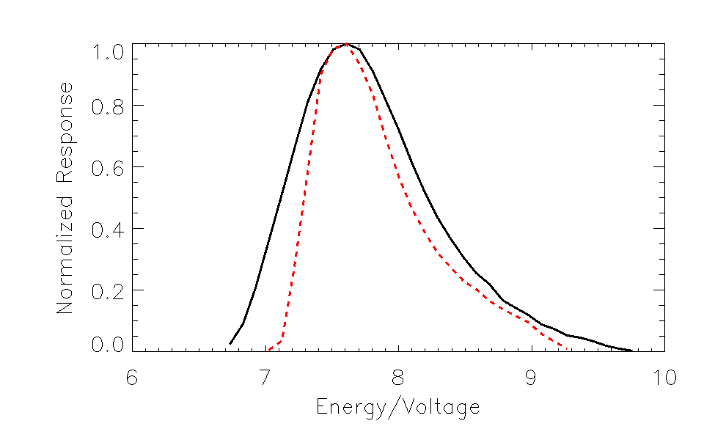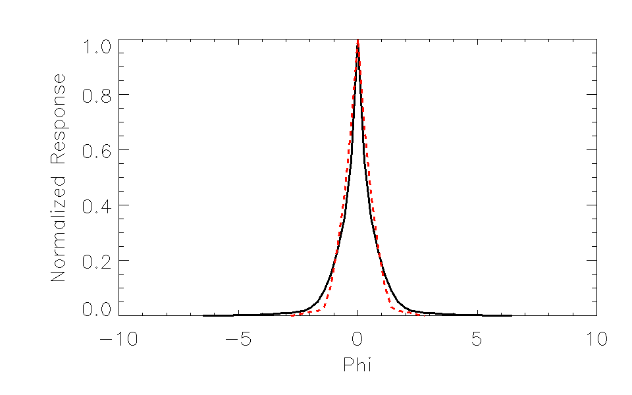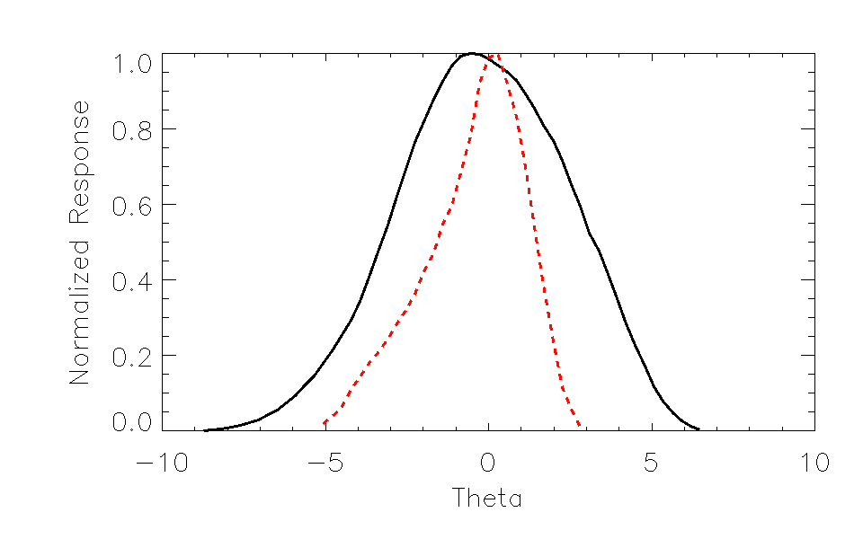**

Figure 3: SWIA intrinsic energy, phi, and theta resolution at zero deflection, with attenuator open (black) and closed (red).

The deflection angle as a function of deflector voltage (normalized by hemisphere voltage), and the geometric factor as a function of deflection angle are shown in Fig. 4. The predicted deflection angle as a function of deflector voltage is very linear over the entire angular range. The predicted sensitivity is uniform over +/-22.5 sensor theta angle (sufficient to cover the normal range of solar wind velocities, for nominal sun-pointed orientation of the spacecraft), with a graceful roll-off to ~50% at the edges of the range resulting from collimation by the deflectors. Note that the deflectors are serrated in order to eliminate any possible issues with scattered ions from the deflectors, and the internal surfaces are scalloped and blackened with Ebanol-C in order to eliminate both scattered charged particles and photons. The predicted sensor 360° geometric factor at zero deflection angle is 0.0236 cm2 sr. With all grid transmissions and nominal MCP detector efficiencies folded in, the predicted sensor geometric factor is 0.0056 cm2 sr, distributed proportionally over the 24 anodes (see below). Inflight calibrations will be utilized to determine the actual MCP efficiency, as described in section 2.8.

* *Simulated Instrument Geometric Factor, w/ grid transmissions and approximate MCP efficiency included (MCP efficiency to be confirmed on-orbit):* 
  + Analyzer 360° geometric factor: 0.0236 cm2 sr
  + Sensor 360° geometric factor with predicted efficiencies included: 0.0056 cm2 sr
  + Large anode geometric factor: 0.00035 cm2 sr
  + Small anode geometric factor: 0.000070 cm2
  + Small anode geometric factor with attenuator in: 0.0000047 cm2 sr
* *Measurable Flux Range:* 
  + Measurable count rates per anode: few Hz to 2 MHz
  + Measurable diff. energy fluxes in small anodes: 5x104 to 7x1011 eV/(cm2 s sr eV)
  + Measurable diff. energy fluxes in large anodes: 1x104 to 5x109 eV/(cm2 s sr eV)
* *Required/Desirable Measurable Flux Range:*
  + Level 3 requirements: 1x107 to 1x1010 eV/(cm2 s sr eV)
  + Lowest expected fluxes in magneto-sheath: 1x105 eV/(cm2 s sr eV)
  + Highest expected fluxes for cold dense solar wind: 5x1011 eV/(cm2 s sr eV)

**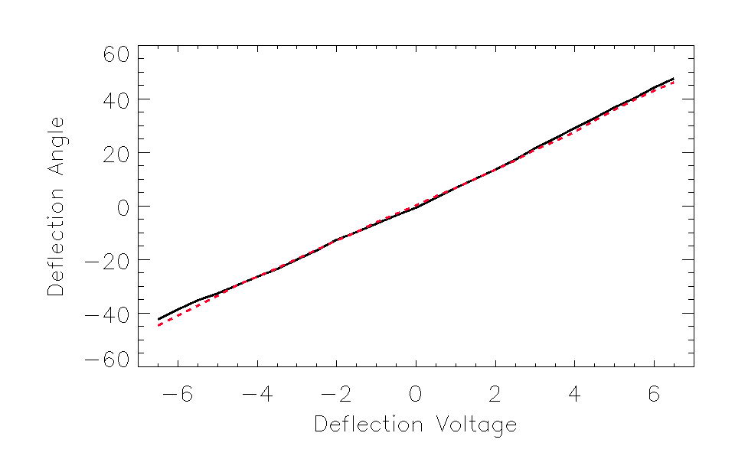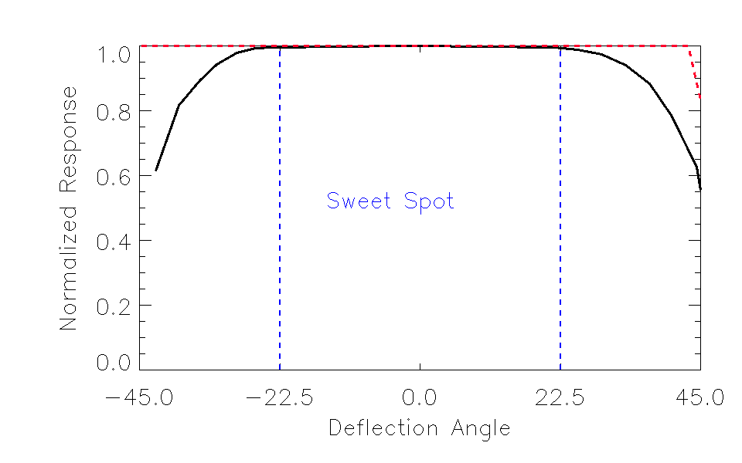**

Figure 4: SWIA deflection angle vs. voltage (top), and geometric factor vs. deflection angle (bottom), for attenuator open (black) and closed (red). The +/– deflection voltages indicate the operation of the two deflectors; both deflector voltages are in fact positive.

The SWIA sensor utilizes a chevron pair of annular microchannel plate detectors to produce a secondary electron cascade (triggered by each incoming ion) to produce a pulse of ~106 electrons that can be registered by the electronics. The SWIA flight plates have a total stack resistance of 17.3 Mohms (at room temperature). This low resistance corresponds to a high strip recharge current that allows the sensor to count at a high rate on the order of 500 kHz, or higher for brief periods, before significant MCP droop occurs. Since the solar wind is only observed for a brief period of the energy/deflector sweep pattern, and the mechanical attenuator limits instrument sensitivity in the sun direction, MCP droop should not affect the sensor in normal operation.

## Electronics

A block diagram of the SWIA sensor that details the key features of the electronics design is shown below. As described in section 2.2 above, each incoming ion triggers a secondary electron cascade in the microchannel plates, producing a charge pulse that is collected by one of the 14 22.5-degree anodes or 10 4.5-degree anodes that cover the full range of sensor phi angles. The microchannel plates are mechanically clamped (and thermally coupled) to the ANODE board, with a metal spacer seated on a metallized ring setting the gap between the output face of the channel plates and the anodes, and a 330 Kohm resistor from this ring to ground providing a small pre-acceleration voltage to focus the charge pulses from the channel plates to the anodes. High voltages for the channel plates and the inner hemisphere are carried on coaxial cables to the ANODE board, with the coax sheathes soldered to pads connected to the ground plane, and pass through the board on custom connections.

Charge pulses collected on the metallized anodes are carried on Hypertronics KA-17 connectors to the PREAMP/MCP board, which contains 24 Amptek A121 charge-sensitive preamplifiers. A 1 Mohm resistor from each anode to ground dissipates any DC charge buildup. The signals are capacitively coupled to the inputs of the preamplifiers, which have a digitally programmable threshold controlled by the FPGA on the DIGITAL board. The A121’s are tuned with external resistors to produce a digital output pulse with a width of 50 ns, and to have a well-characterized fixed dead time of 100 ns (allowing count rates of up to 10 MHz periodic for each signal chain). The output signals are carried on MDM connectors to pigtails on the DIGITAL board, and ultimately to ripple counters in the FPGA. The preamplifiers can also be stimulated by a capacitively coupled test pulse signal generated by the FPGA on the DIGITAL board, allowing testing without an analyzer and/or without high voltage enabled. The digitally produced test pulse signal is divided down into four different frequencies, such that adjacent anodes do not share the same frequency (enabling testing for crosstalk). Each preamplifier is protected from high voltage discharges by clamp diodes.

The PREAMP/MCP board is shared with the high voltage supply for the microchannel plates, which produces a negative voltage of up to -2.5 kV that is applied to the input face of the channel plates. This voltage is controlled by a 0-4 V DAC output from the DIGITAL board. The MCP high voltage supply drives a significant resistive load (~2 kV across ~17.3 Mohms at room temperature), so the transistors are heat-sunk to the chassis to dissipate any heat buildup on the board. High voltage control lines and read-backs share the same MDM connectors with the preamplifier output signals. The high voltage return is connected to the board so that currents close appropriately, and connected to the board analog ground (which is connected to chassis).

The SWEEP/HVPS board has a single bi-polar raw supply that operates at a nominal voltage of 4.3 kV, with optically coupled high voltage outputs for the inner hemisphere (negative), and the two deflectors (positive), each with a range of 0-4 kV. These high voltages are routed from the SWEEP board to their respective destinations through custom connectors and coaxial cables, and the high voltage grounds are returned to the board so any currents can close, and connected to analog ground at the board (which is connected to chassis). The raw supply and each of the outputs are controlled by 0-4V DAC outputs from the digital board. The SWEEP board is connected to the DIGITAL board via stacking WTAX connectors.

The DIGITAL board contains an FPGA that controls the high voltage sweep, accumulates data, produces data products, and interfaces with the PFDPU. Digital counts from the preamplifiers for each signal chain are converted to a 3.3 volt level for the FPGA and then accumulated in ripple counters over 1.7 ms accumulation intervals, for each of the 96Ex24D steps in the sweep table (4-second full product cycle), and processed to produce the three data products described below in section 2.4. Short ~1 ms dead times at the end of each energy step, and a longer ~21.5 ms dead time at the end of the cycle, ensure that counts are not accumulated during high voltage retraces. The FPGA also produces the test pulse signal that goes to the PREAMP board, allowing testing of the electronics without the analyzer and/or without high voltage operating. The FPGA controls the DACs that set high voltage levels and preamplifier thresholds, and multiplexes and converts housekeeping values for all of the secondary and high voltages, as well as two thermistors. High voltage DACs are controlled utilizing a sweep table stored in SRAM, and product accumulations are stored in the SRAM (for those products that aren’t transmitted to the PFDPU immediately). Digital and analog grounds are tied together on the board, and analog ground is connected to chassis.

Secondary digital voltages of 2.5, 3.3, and 5 volts, as well as analog voltages of -5, +5, 12, and 28 volts are produced in the LVPS (low voltage power converter) board, which is connected to the DIGITAL board through a stacking WTAX connector. All secondary voltages are isolated from the primary 28 input voltage from the PFDPU. Secondary returns are connected to chassis. The secondary 28 analog voltage, which powers the high voltage supplies, passes through an enable plug before going to the digital board (where it also passes through a FET switch controlled by the FPGA, which can only be opened after receipt of two software key codes), ensuring that high voltage can not be powered on when not desired.

Instrument temperature sensor readbacks, power for the one-time contamination cover (TiNi pinpuller), and heater power, are connected directly to the spacecraft through a high density D-sub connector. The sensor has three high-density D-sub connections to the PFDPU, which carry primary 28 to the LVPS, command, clock, and telemetry to the DIGITAL board, and power for the mechanical attenuator (which does not enter the SWIA electronics box).

Macintosh HD:Users:jhalekas:Documents:Work:Research:SWIA:Board Layouts:SWIA Block Diagram_rev7.pdf

## Measured Parameters

SWIA covers its entire energy range (96 energy steps), sweeping the deflectors over their full angular range (24 deflection steps) at each energy step, once every four seconds. At each sweep/deflector step, counts are accumulated for each anode for 1.7 milliseconds. From these accumulations, the SWIA FPGA produces three data products (as well as housekeeping and checksums). The P0 product, sent to the PFDPU immediately, contains 96E\*24D values for each of the 24 anodes, resulting in a 96x24x24 array. The P1 product, sent to the PFDPU every other energy step, sums over the ten small anodes in two groups to produce a total of 16 22.5 degree bins, sums over groups of 6 deflection steps to produce 4 deflection bins, and sums over adjacent energy steps to produce 48 energy bins. The P2 product buffers all small anode counts for an entire cycle, finds the peak count rate, and sends back the small anode count rates for 48 energy steps and 12 deflection steps around the location of the peak to the PFDPU, with a delay of 4 seconds from data acquisition during which the peak-search and buffer selection occurs. P0, P1, and P2 are all sent from the SWIA FPGA to the PFDPU in the form of small messages of a few tens of words.

In normal operation on orbit, P1 and P2 provide the main data products, since P0 is formidably large and cannot be telemetered from Mars at a reasonable time resolution. The P2 product is designed to measure the very localized intense solar wind flux. The P1 product is designed to measure the more thermalized fluxes in the Martian magnetosphere, and also to search for pickup ions.

The P0, P1, and P2 messages can all be packaged by flight software into data products, packetized, compressed, and telemetered to the ground [P0 => Raw, P1 => Coarse, P2 => Fine]. In normal operation, only Coarse and/or Fine distributions are telemetered. Coarse distribution telemetry has the same angular resolution as the raw P1 product (16 phi bins x 4 deflection angles), and either the intrinsic P1 energy resolution (48 energy steps), or a binned resolution of 24 or 16 energy steps (produced by summing adjacent P1 energy steps in pairs or triplets). Fine distribution telemetry contains the same resolution and coverage as the raw P2 product (10 phi bins x 12 deflection angles x 48 energy steps), or the central subset of these quantities (6 phi bins x 8 deflection angles x 32 energy steps). Binning options are commandable and software-controlled, and can vary depending on telemetry mode [See Section 2.5 below for more detail].

Coarse products can be sampled or summed in powers of two in order to produce a lower time resolution than the intrinsic 4-second resolution, in order to fit within telemetry constraints. Since Fine distributions move in phase space as a function of time in response to changes in the plasma distributions, they can only be sampled. Coarse and Fine 3d products can each be sent either to Survey or to Archive data streams, with different binning options and time resolution possible. All Survey telemetry is returned to the ground, where it can then be used to select stored Archive data for intervals of interest for subsequent playback (subject to telemetry constraints – the amount of Archive data that can be telemetered depends in part on the efficiency of packet compression for the Survey data).

In addition to the full 3d products, an onboard moment computation produces the 13 quantities n, n**v**, n**p**, and n**q** [density, velocity vector, pressure tensor, and heat flux vector] in the spacecraft frame, from either P1 or P2 products, taking into account the energy-angle dependence of the instrument response, and the effect of the attenuator when closed. Moment coefficients are stored in the flash memory in the PFDPU. The onboard moments are computed as a simple weighted sum, using these coefficients. Moments are computed in 64-bit fixed-point arithmetic, to maintain a broad dynamic range. The moments are then compressed using a floating-point algorithm with 9 bits of mantissa (using ‘hidden bit’ formatting). This results in a dynamic range of 512 for a given density range, and thus the moments are quantized at that level. For typical solar wind parameters, the resulting density quantization is only ~1-2 orders of magnitude greater than that introduced by changing one count in the distribution, particularly with the attenuator closed, so the quantization level is well within statistical uncertainties. On the ground, these floating-point values are decommutated, then the moments n, **v**, **p**, and **q** are recovered from the onboard moments by appropriately normalizing by density and subtracting bulk flow components to determine the value in the plasma frame, where appropriate.

Moments are computed under the assumption that all ions are protons. This assumption is never valid in the Martian magnetosphere, and even in the solar wind can have consequences, as described in more detail in the description of the data products in section 5. For many situations, these moments should only be used as qualitative diagnostics.

Finally, flight software produces energy spectra by summing the P1 counts over all angles to produce a 48-element array of accumulated counts. These energy spectra should only be used for quantitative purposes with some care, since there is no weighting for the reduced geometric factor at high deflection angles; instead the spectra represent a simple sum of counts as a function of energy. Their primary purpose is as a diagnostic that can be sent at high time resolution, though they can also be used for quantitative purposes if the distribution is narrow enough (e.g. in the solar wind).

For all data products, the time reported in the L0 and L2 files corresponds to the start time of the accumulation. For plotting purposes, it may be more convenient to plot data according to the center time of the accumulation [start time + 2.0 seconds, for products that are not accumulated over multiple sweeps].

## Operational Modes

SWIA has only one hardware mode. The sensor, in normal operation, always operates from a single high voltage sweep table (loaded from the PFDPU EEPROM at instrument turn-on, stored redundantly in the SWIA FPGA, and check-summed to ensure fidelity, with a re-load to SWIA triggered by any change in the table checksum returned from SWIA), and covers the same range of energies and angles every four seconds. The SWIA sweep table can be changed or re-uploaded to the EEPROM if necessary, but only by ground command [Note: If the sweep table is changed, all moment coefficients also must be changed]. SWIA does have two “modes”; however, these modes simply consist of a different mix of Coarse/Fine telemetry appropriate for different regions of space, rather than an actual change in hardware operation.

SWIA always produces Coarse, Fine, Moment, and Spectra telemetry [as defined above in Section 2.4] at programmable cadences, sized such that the total telemetry fits within the available constraints during each mission phase. A number of options control how and when each of these products is packaged and telemetered; these options can change by telemetry mode and whether the product is bound for Survey or Archive data streams. First, for each telemetry mode and data stream, each product has an associated parameter *n* that determines how often the product is packetized and sent (for a given *n*, a product is sent every 2n 4-second cycles). In the case of Coarse and Spectra telemetry, the product can either be a sum over the 2n cycles, or a sample sent every 2nth cycle. In the case of Fine and Moment telemetry, only sampling is possible, since these products cannot be gracefully summed. The Coarse and Fine 3-d products also have additional options that control the binning of energy steps (for Coarse distributions) and the sub-sampling of a selection of energy/angle bins (for Fine distributions), enabling higher time resolution at the expense of energy/angle resolution or coverage.

SWIA’s two telemetry modes are designed to send the most useful mix of products for each plasma region through which MAVEN orbits. In “Solar Wind” mode, we include mostly Fine distributions appropriate for characterizing the narrow solar wind beam in both Survey and Archive data streams, with a smattering of Coarse distributions included to characterize the occurrence of pickup ions. In “Sheath” mode, on the other hand, only Coarse distributions appropriate for characterizing a more thermalized ion distribution are included in both Archive and Survey data streams. In both modes, spectra and moments are sent in the Survey data stream; however, in “Solar Wind” mode the moments are calculated from P2 products, while in “Sheath” mode they are calculated from P1 products. The switch from “Solar Wind” to “Sheath” modes is internally triggered, based on the ratio of the total counts contained in the P1 product to that in the P2 product. If most of the counts are contained in P2, the telemetry switches to “Solar Wind” mode. If the counts are more distributed, with significant counts not contained in the narrow energy/angle range covered by P2, then the telemetry switches to “Sheath” mode. The telemetry mode switches are based on two programmable count ratio thresholds, and are only allowed to occur at a programmable 2n interval, ensuring that changes in the telemetry mode do not occur too often (for instance if MAVEN crosses an oscillating boundary multiple times in short succession, we intend that only one mode switch should occur).

In addition, SWIA has a mechanical attenuator to reduce the sunward instrument sensitivity that is also internally triggered, based on the peak count rate recorded by the sensor, with two programmable thresholds that trigger opening and closing of the attenuator. Similarly to the mode changes, attenuator actuations can only occur at a programmable 2n interval, ensuring that the attenuator does not “shutter”. In addition to this programmable 2n limit, a hardware limit ensures that actuations cannot occur too frequently (~5 minute minimum timeout), and a time-based actuation limit prevents the attenuator from operating too often and causing excessive mechanical wear in any mission phase. The attenuation state, which is required to convert counts to physical units since the attenuator changes the geometric factor in the sunward field-of-view, is recorded in all telemetry

## Operational Considerations

During normal operation, SWIA operates continuously in the same hardware mode, as described above in section 2.5.

The SWIA high voltage will be turned off if the spacecraft encounters densities higher than 5e-4 Torr, which may be encountered during deep dips, though calculations suggest that these densities should never be encountered. In such a situation, the high voltage will be disarmed automatically in response to a spacecraft-issued zone alert, and then autonomously ramped back up once the spacecraft returns to a normal density corridor. During these time periods, the SWIA sensor will return no counts since the micro-channel plates will not be operating.

There are very few other constraints on SWIA’s operation, other than a restriction that not every type of message (P0, P1, P2, HSK, LUT) can be sent from the SWIA FPGA to the PFDPU simultaneously without exceeding the bandwidth and causing minor timing issues. Since the P0 messages are only for calibration purposes, this limitation has few consequences.

Some odd features in the data can exist around the time of a mode switch or attenuator actuation. If coarse distributions or spectra are in a summing mode, a non-2n number of distributions may be contained in a packet near the time of a mode change; however, the number of accumulations will be reported correctly in the packet. Of more note is the fact that attenuator states and moments can change in the middle of a moment packet (containing 16 sets of moments), but only one value is provided in the packet header. As a result, if the time of a telemetry mode change or attenuator actuation is not known exactly, the conversion of the moments to physical units can have ambiguities that last for up to 15 sets of moments (typically 60 seconds). Similar issues can exist for the energy spectra (16 sets of spectra per packet).

## Ground Calibration

The SWIA calibration utilized a vacuum chamber with a 3-axis manipulator to scan the sensor, and a controllable electron-impact ion source to produce a collimated beam of ionized residual gases in the chamber to stimulate the sensor. During calibration, we performed a large number of energy/angle scans of the instrument, at a variety of phi and theta angles, and at ion energies of 125 eV and 2 keV. As shown in Fig. 5 below, the energy response is constant to within a few percent around the analyzer, demonstrating that the hemispheres have very good concentricity. The analyzer constant varies from 7.6-7.8 around the analyzer, a variation of <2%. The measured SWIA energy resolution is ~14.5%, in good agreement with simulation results. We also performed a full scan over energies from ~5 eV up to 5 keV to ensure that the analyzer energy response is constant over energy.

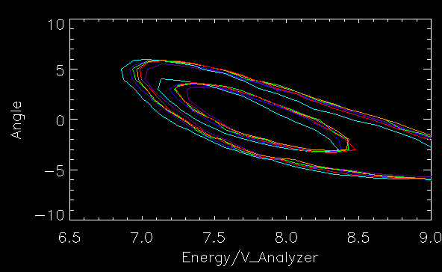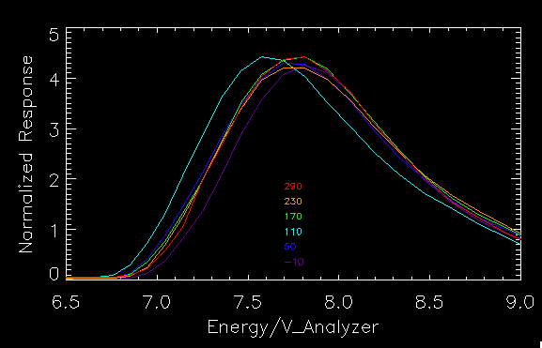

Figure 5: SWIA intrinsic energy/theta response for six different sensor phi angles, showing 0.1 and 0.5 response level contours with no deflection (left), and energy response integrated over all theta angles (right).

We also covered the entire deflection range in our calibration. The analyzer energy response is very constant over the deflection range, but the angular response does vary to some degree due to the focusing properties of the deflection optics, as shown in Fig. 6 below. The correspondence between measurement and simulation is quite good over the entire deflection range, with only a few minor exceptions. Our ion beam is a few degrees wide, so we cannot reproduce the narrow width of the theta angle response predicted by the simulation results at some deflection angles in calibration. Allowing for the slight broadening of the measurement due to beam width, the correspondence is very good.

**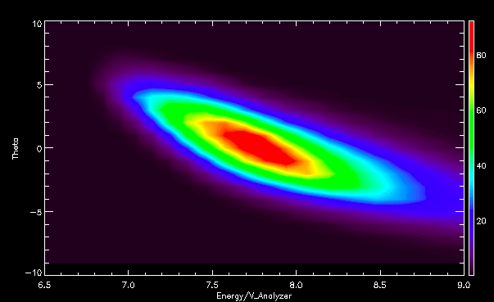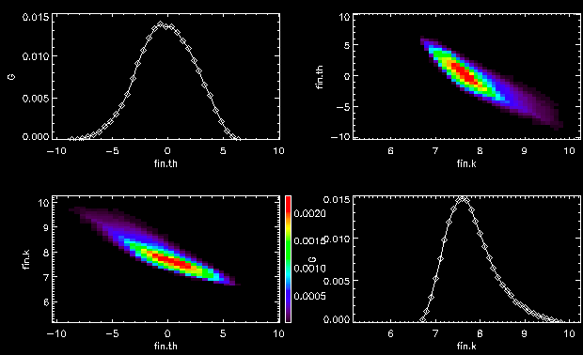:eascan_0.tiff:model_0.tiff:eascan_0.tiff:model_0.tiff:eascan_0.tiff:model_0.tiff:eascan_0.tiff:model_0.tiff**

Figure 6: SWIA energy/theta response for five different deflection angles [0, +20, -20, +35, -35], comparing the measured response (left) and simulation results (right), for the same ratio of inner hemisphere to deflector voltage. Each simulation plot has four panels showing the integrated energy and angular response, and the energy-angle response with the axes in both senses. The measurement should be compared to the upper right panel in each case. Note the slightly different scales of measured and simulated plots.

Finally, we covered the entire sensor phi angle range in our sensor calibration, as shown in Fig. 7 below. The anode resolution is 4.5 degrees in the 45-degree wide region around the sun covered by the small anodes (and the P2 product), and 22.5 degrees outside of that. The dips in the overall response result from mechanical blockage by the ribs in the “spider plate” at the exit of the analyzer that holds the two hemispheres and keeps them concentric (there is no rib facing the sun; thus the increase rather than decrease at phi = 0). The large dip at phi = 180 results from the blockage by the harness cover, where cables carries deflector voltages and attenuator/actuator services to the upper part of the sensor. Some broadening in the phi response results from the spread of the electron cloud from the output face of the channel plates to the anodes, resulting in a moderate ~20-25% level of double-counting between adjacent small anodes.

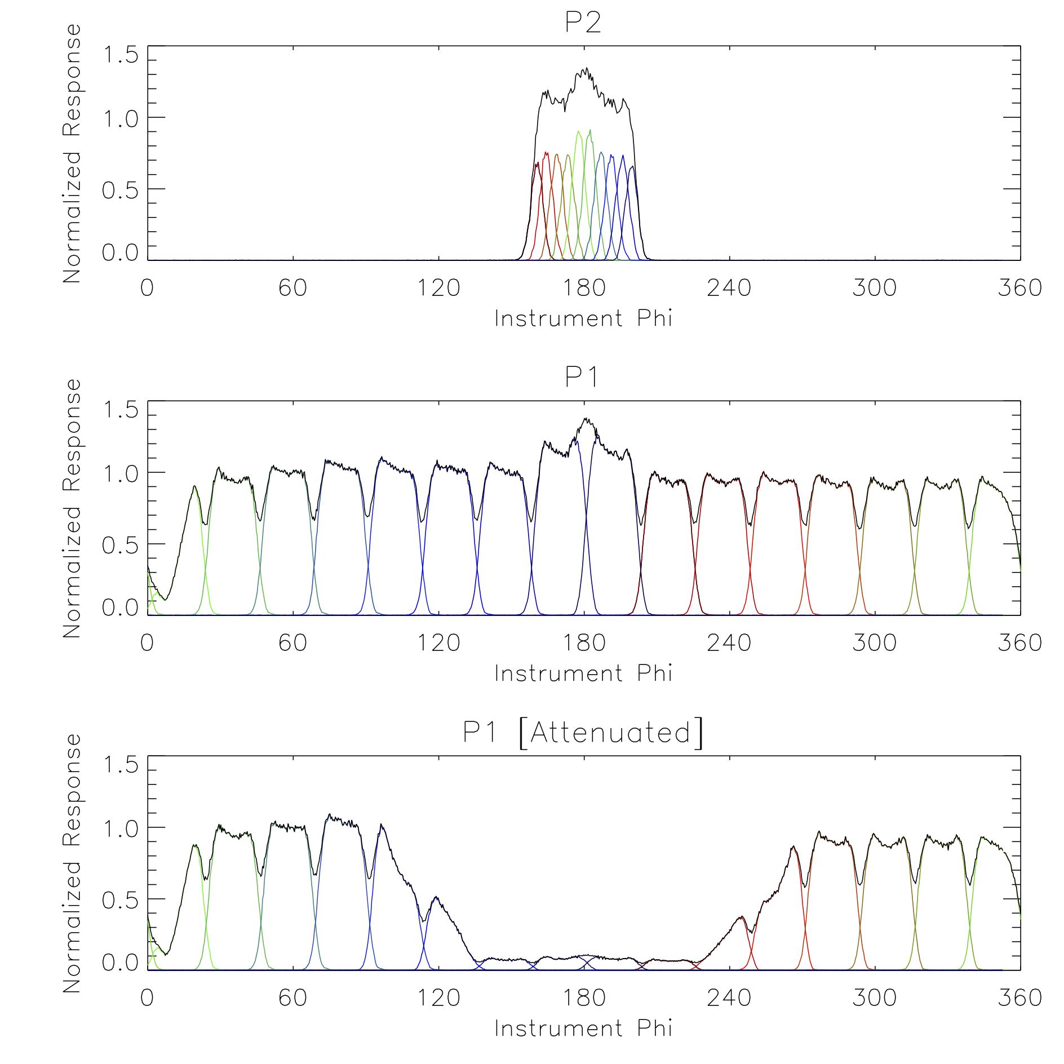

Figure 7: SWIA sensor phi response for coarse (bottom two panels) and fine (top panel) resolution products, measured during a full phi rotation of the instrument. Colored lines show response for each individual anode, white line shows the integrated response. Bottom panel shows response with attenuator closed, top two panels with attenuator open

## Inflight Calibration

SWIA is required to have an in-flight calibration procedure to determine its absolute sensitivity to within 25%. The SWIA angular and energy responses and the geometric factor (minus detection efficiency) is determined on the ground (see above) to within ~10% by calibrations and electrostatic optics simulations. However, to obtain the absolute sensitivity, the detection efficiency must also be known. This efficiency depends on the microchannel plate (MCP) efficiency, which varies during the mission, especially in the first few months of operation. Thus, an in-flight calibration procedure is needed to measure and track this efficiency. The approach is to first determine the detection efficiency of STATIC and then to cross calibrate SWIA with STATIC. There are two independent methods of determining STATIC’s detection efficiency, which provide redundancy and cross checks.

First, STATIC can be compared with LPW. LPW measures plasma density with two independent methods. I-V curves provide the total density, temperature, and spacecraft potential in the ionosphere with a 2-sec cadence. Additionally, plasma waves generally show a peak or cutoff at the plasma frequency, which provides an accurate measure of the total density (fpe = 8.98 kHz × ne½). Measurements of this peak/cutoff, although not always present, provide an absolute calibration of density measured from the I-V Below 500 km, STATIC is oriented so that the ram direction is in the center plane of its field of view (FOV). The spacecraft velocity ranges from 3.9 to 4.2 km/s, so that the dominant ion (O2+) has a ram energy of 2.6-2.9 eV. The best measurements are obtained below ~200 km, where the ion temperature is ~0.03 eV, the spacecraft potential (measured by LPW) is of order –0.1 V, and collisional coupling with the neutral atmosphere limits the plasma bulk flow to less than ~0.3 km/s. Under these conditions, the ion distribution is beamed along the ram direction entirely within STATIC’s FOV. Comparisons of STATIC and LPW measurements of the total density under these conditions provide an absolute calibration of STATIC to within 15%.

Secondly, STATIC can determine absolute START and STOP efficiencies from ratios START/(START+STOP) and STOP/(START+STOP) events, which can be combined with mechanical analyzer geometric factor knowledge from electrostatic optics simulations to get an absolute sensitivity, with error determined by mechanical tolerance and supported by the analyzer energy constant. This procedure will work whenever there is only one ion species present – for instance in the solar wind or outer magnetosheath. The results of this analysis should agree with those from the LPW comparison, providing a consistency check.

After STATIC is calibrated, SWIA can be calibrated to STATIC in the magnetosheath or in the solar wind at times with less intense fluxes. This calibration can be performed without any need to calculate a total density moment, since the two measurements overlap in both energy and angle coverage, and the sensors have the same analyzer electrostatic optics. We estimate that this calibration can be made with an accuracy of 5%, so that the absolute sensitivity of SWIA can be determined in flight to better than 20%.

# Data Overview

This section provides a high level description of archive organization under the PDS4 Information Model (IM) as well as the flow of the data from the spacecraft through delivery to PDS. Unless specified elsewhere in this document, the MAVEN SWIA archive conforms with version 1.4.0.0 of the PDS4 IM [4] and the XML Schema and Schematron documents listed in Table 5 below.

Table 5: MAVEN SWIA Archive Schema and Schematron

|  |  |  |
| --- | --- | --- |
| **XML Document** | **Steward** | **Product LIDVID** |
| PDS Master Schema & Schematron, v. 1.4.0.0 | PDS | urn:nasa:pds:system\_bundle:xml\_schema:pds-xml\_schema::1.7 |
| MAVEN Mission Schema & Schematron, v. 1.0.1.1 | PPI | urn:nasa:pds:system\_bundle:xml\_schema:mvn-xml\_schema::1.2 |
| Particles Discipline Schema & Schematron, v.1.0.0.0 | PPI | urn:nasa:pds:system\_bundle:xml\_schema:particle-xml\_schema::1.0 |
| Alt Discipline Schema & Schematron, v.1.0.0.0 | PPI | urn:nasa:pds:system\_bundle:xml\_schema:alt-xml\_schema::1.0 |

## Data Reduction Levels

A number of different systems may be used to describe data processing level. This document refers to data by their PDS4 reduction level. Table 6 provides a description of these levels along with the equivalent designations used in other systems.

Table 6: Data reduction level designations

| **PDS4 reduction level** | **PDS4 reduction level description** | **MAVEN Processing Level** | **CODMAC Level** | **NASA Level** |
| --- | --- | --- | --- | --- |
| Raw | Original data from an instrument. If compression, reformatting, packetization, or other translation has been applied to facilitate data transmission or storage, those processes are reversed so that the archived data are in a PDS approved archive format. | 0 | 2 | 1A |
| Reduced | Data that have been processed beyond the raw stage but which are not yet entirely independent of the instrument. | 1 | 2 | 1A |
| Calibrated | Data converted to physical units entirely independent of the instrument. | 2 | 3 | 1B |
| Derived | Results that have been distilled from one or more calibrated data products (for example, maps, gravity or magnetic fields, or ring particle size distributions). Supplementary data, such as calibration tables or tables of viewing geometry, used to interpret observational data should also be classified as ‘derived’ data if not easily matched to one of the other three categories. | 3+ | 4+ | 2+ |

## Products

A PDS product consists of one or more digital and/or non-digital objects, and an accompanying PDS label file. Labeled digital objects are data products (i.e. electronically stored files). Labeled non-digital objects are physical and conceptual entities which have been described by a PDS label. PDS labels provide identification and description information for labeled objects. The PDS label defines a Logical Identifier (LID) by which any PDS labeled product is referenced throughout the system. In PDS4 labels are XML formatted ASCII files. More information on the formatting of PDS labels is provided in Section 6.3. More information on the usage of LIDs and the formation of MAVEN LIDs is provided in Section 5.1.

## Product Organization

The highest level of organization for PDS archive is the bundle. A bundle is a list of one or more related collections of products, which may be of different types. A collection is a list of one or more related basic products, which are all of the same type. Figure 8 below illustrates these relationships.

**Bundle**

**Collection A**

**Basic Product A1**

**Basic Product A2**

**Basic Product A3**

**Basic Product A*N***

**…**

**Collection B**

**Basic Product B1**

**Basic Product B2**

**Basic Product B3**

**Basic Product B*N***

**…**

**Collection C**

**Basic Product C1**

**Basic Product C2**

**Basic Product C3**

**Basic Product C*N***

**…**

Figure 8: A graphical depiction of the relationship among bundles, collections, and basic products.

Bundles and collections are logical structures, not necessarily tied to any physical directory structure or organization. Bundle and collection membership is established by a member inventory list. Bundle member inventory lists are provided in the bundle product labels themselves. Collection member inventory lists are provided in separate collection inventory table files. Sample bundle and collection labels are provided in Appendix D and Appendix E, respectively.

### Collection and Basic Product Types

Collections are limited to a single type of basic products. The types of archive collections that are defined in PDS4 are listed in Table 7.

Table 7: Collection product types

|  |  |
| --- | --- |
| **Collection Type** | **Description** |
| Browse | Contains products intended for data characterization, search, and viewing, and not for scientific research or publication. |
| Context | Contains products which provide for the unique identification of objects which form the context for scientific observations (e.g. spacecraft, observatories, instruments, targets, etc.). |
| Document | Contains electronic document products which are part of the PDS Archive. |
| Data | Contains scientific data products intended for research and publication. |
| SPICE | Contains NAIF SPICE kernels. |
| XML\_Schema | Contains XML schemas and related products which may be used for generating and validating PDS4 labels. |

## Bundle Products

The SWIA data archive is organized into 1 bundle. A description of the bundle is provided in Table 8, and a more detailed description of the contents and format is provided in Section 5.2.

## Data Flow

This section describes only those portions of the MAVEN data flow that are directly connected to archiving. A full description of MAVEN data flow is provided in the MAVEN Science Data Management Plan [5]. A graphical representation of the full MAVEN data flow is provided in Figure 9 below.

All ITFs will produce calibrated products. Following an initial 2-month period at the beginning of the mapping phase, the ITFs will routinely deliver preliminary calibrated data products to the SDC for use by the entire MAVEN team within two weeks of ITF receipt of all data needed to generate those products. The SOC will maintain an active archive of all MAVEN science data, and will provide the MAVEN science team with direct access through the life of the MAVEN mission. After the end of the MAVEN project, PDS will be the sole long-term archive for all public MAVEN data.

Updates to calibrations, algorithms, and/or processing software are expected to occur regularly, resulting in appropriate production system updates followed by reprocessing of science data products by ITFs for delivery to SDC. Systems at the SOC, ITFs and PDS are designed to handle these periodic version changes.

| **Bundle Logical Identifier** | **PDS4 Reduction Level** | **Description** | **Data Provider** |
| --- | --- | --- | --- |
| urn:nasa:pds:maven.swia.calibrated | Calibrated | Fully calibrated ion velocity distributions, energy spectra, and density, temperature, and velocity moments from onboard calculations. Tables of sensitivity and energy/angle maps included in files. | ITF |

Table 8. SWIA Bundles

The data bundle intended for the archive is identified in Table 8.

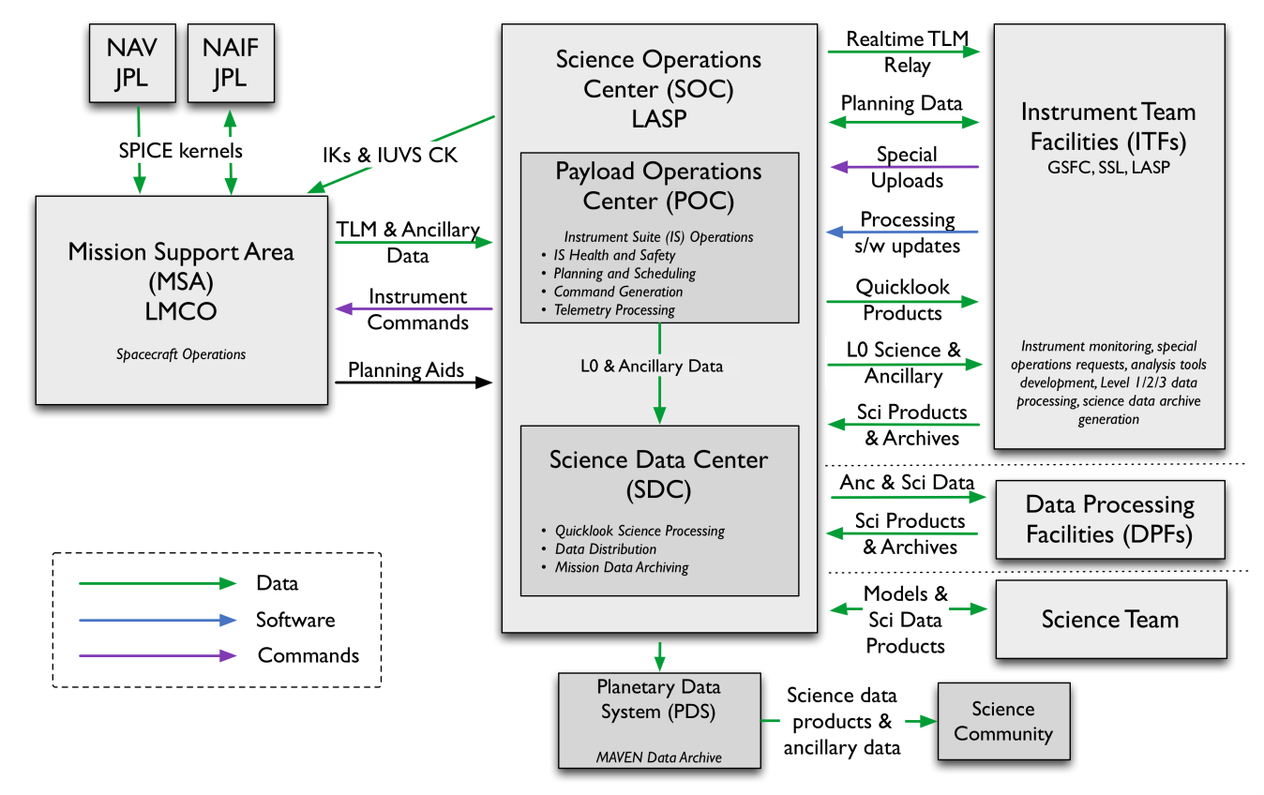

Figure 9: MAVEN Ground Data System responsibilities and data flow. Note that this figure includes portions of the MAVEN GDS which are not directly connected with archiving, and are therefore not described in Section 3.5 above.

# Archive Generation

The SWIA archive products are produced by the SWIA team in cooperation with the SDC, and with the support of the PDS Planetary Plasma Interactions (PPI) Node at the University of California, Los Angeles (UCLA). The archive volume creation process described in this section sets out the roles and responsibilities of each of these groups. The assignment of tasks has been agreed upon by all parties. Archived data received by the PPI Node from the SWIA team are made available to PDS users electronically as soon as practicable but no later two weeks after the delivery and validation of the data.

## Data Processing and Production Pipeline

The following sections describe the process by which data products in the SWIA bundle listed in **Error! Reference source not found.**is produced.

### Raw Data Production Pipeline

After receiving Level 0 data from the POC, the SDC will process the Level 0 into Quicklook science products using software provided by the SWIA ITF. The SDC will provide the SWIA ITF with Level 0 data files (consisting of compressed PF packets in their native format, one file per UT day for all PF Survey data, and one file per UT day for all PF Archive data), Quicklook science data and all ancillary data required for science processing. From this data, the SWIA ITF will generate Level 2 calibrated science data products. The science data products that the SWIA ITF delivers to the SDC will be stored by the SDC for the duration of the project, and will be made available to the MAVEN team. The SDC will deliver archival-quality science data products to the PDS for distribution to the public and long-term archiving in accordance with the SWIA-PDS SIS (this document) and the SOC-PDS SIS. The SDC will also be responsible for delivering Level 0 archives and non-SPICE ancillary data to the PDS for long-term archiving, in accordance with the SOC-PDS SIS and the Export Control Checklist.

### Calibrated Data Production Pipeline

Calibrated SWIA Level 2 data will be produced from the raw level 0 PF data files by the SWIA ITF using IDL software, and provided for archiving in the PDS in CDF format. The data production pipeline will be run in an automated fashion to produce archival-ready files from the raw level 0 data.

Beginning as soon as possible but no later than 2 months after the start of science operations, the SWIA ITF will routinely generate Level 2 science data products and deliver them to the SOC. After the initial 2-month calibration period, the SWIA ITF will deliver preliminary Level 2 products to the SDC for distribution to the MAVEN team within two weeks of receiving all data required for science processing (including all SPICE kernels and other ancillary data required for processing) by the ITFs. Final Level 2 SWIA products will be delivered to the SDC as soon as they are complete, no later than needed to meet the PDS delivery schedule in Table 9.

The SWIA ITF does not plan to produce Level 3 products, instead using Level 2 as the final science products.

The SWIA ITF will deliver validated science data products and associated metadata for PDS archiving to the SOC two weeks prior to every PDS delivery deadline. The first PDS delivery will occur no later than 6 months after the start of science operations, and subsequent deliveries will take place every 3 months after the first delivery. The first delivery will include data collected during the cruise and transition phases in addition to the science data from the first 3 months of the mapping phase. Each subsequent delivery will contain data from the 3 months following the previous delivery. The final delivery may contain products involving data from the entire mission.

The SWIA ITF will also provide the SDC with data product descriptions, appropriate for use by the MAVEN science team in using MAVEN science data products and consistent with PDS metadata standards.

## Data Validation

### Instrument Team Validation

All SWIA data will be calibrated and converted to physical units by the SWIA ITF, then spot-checked by the instrument lead and his designees for accuracy and integrity.

### MAVEN Science Team Validation

The MAVEN science team will work with the same SWIA products that will be archived in the PDS. If any calibration issues or other anomalies are noted, they will be addressed at the SWIA ITF by the instrument lead or his designees.

### PDS Peer Review

The PPI node will conduct a full peer review of all of the data types that the SWIA team intends to archive. The review data will consist of a fully formed bundle populated with candidate final versions of the data and other products and the associated metadata.

Table 9: MAVEN PDS review schedule

| **Date** | **Activity** | **Responsible Team** |
| --- | --- | --- |
| 2014-Mar-24 | Signed SIS deadline | ITF |
| 2014-Apr-18 | Sample data products due | ITF |
| 2014-May  to  2014-Aug | Preliminary PDS Peer Review (SIS, sample data files) | PDS |
| 2015-Mar-02 | Release #1: Data due to PDS | ITF/SDC |
| 2014-Mar  to  2015-Apr | Release #1: Data PDS Peer Review | PDS |
| 2015-May-01 | Release #1: Public release | PDS |

Reviews will include a preliminary delivery of sample products for validation and comment by PDS PPI and Engineering node personnel. The data provider will then address the comments coming out of the preliminary review, and generate a full archive delivery to be used for the peer review.

Reviewers will include MAVEN Project and SWIA team representatives, researchers from outside of the MAVEN project, and PDS personnel from the Engineering and PPI nodes. Reviewers will examine the sample data products to determine whether the data meet the stated science objectives of the instrument and the needs of the scientific community and to verify that the accompanying metadata are accurate and complete. The peer review committee will identify any liens on the data that must be resolved before the data can be ‘certified’ by PDS, a process by which data are made public as minor errors are corrected.

In addition to verifying the validity of the review data, this review will be used to verify that the data production pipeline by which the archive products are generated is robust. Additional deliveries made using this same pipeline will be validated at the PPI node, but will not require additional external review.

As expertise with the instrument and data develops the SWIA team may decide that changes to the structure or content of its archive products are warranted. Any changes to the archive products or to the data production pipeline will require an additional round of review to verify that the revised products still meet the original scientific and archival requirements or whether those criteria have been appropriately modified. Whether subsequent reviews require external reviewers will be decided on a case-by-case basis and will depend upon the nature of the changes. A comprehensive record of modifications to the archive structure and content is kept in the Modification\_History element of the collection and bundle products.

The instrument team and other researchers are encouraged to archive additional SWIA products that cover specific observations or data-taking activities. The schedule and structure of any additional archives are not covered by this document and should be worked out with the PPI node.

## Data Transfer Methods and Delivery Schedule

The SOC is responsible for delivering data products to the PDS for long-term archiving. While ITFs are primarily responsible for the design and generation of calibrated and derived data archives, the archival process is managed by the SOC. The SOC (in coordination with the ITFs) will also be primarily responsible for the design and generation of the raw data archive. The first PDS delivery will take place within 6 months of the start of science operations. Additional deliveries will occur every following 3 months and one final delivery will be made after the end of the mission. Science data are delivered to the PDS within 6 months of its collection. If it becomes necessary to reprocess data which have already been delivered to the archive, the ITFs will reprocess the data and deliver them to the SDC for inclusion in the next archive delivery. A summary of this schedule is provided in Table 10 below.

Table 10: Archive bundle delivery schedule

|  |  |  |  |
| --- | --- | --- | --- |
| Bundle Logical Identifier | First Delivery to PDS | Delivery Schedule | Estimated Delivery Size |
| urn:nasa:pds:maven.swia.calibrated | No later than 6 months after the start of science operations | Every 3 months | TBR |

Each delivery will comprise both data and ancillary data files organized into directory structures consistent with the archive design described in Section 5, and combined into a deliverable file(s) using file archive and compression software. When these files are unpacked at the PPI Node in the appropriate location, the constituent files will be organized into the archive structure.

Archive deliveries are made in the form of a “delivery package”. Delivery packages include all of the data being transferred along with a transfer manifest, which helps to identify all of the products included in the delivery, and a checksum manifest which helps to insure that integrity of the data is maintained through the delivery. The format of these files is described in Section 6.4.

Data are transferred electronically (using the *ssh* protocol) from the SOC to an agreed upon location within the PPI file system. PPI will provide the SOC a user account for this purpose. Each delivery package is made in the form of a compressed *tar* or *zip* archive. Only those files that have changed since the last delivery are included. The PPI operator will decompress the data, and verify that the archive is complete using the transfer and MD5 checksum manifests that were included in the delivery package. Archive delivery status will be tracked using a system defined by the PPI node.

Following receipt of a data delivery, PPI will reorganize the data into its PDS archive structure within its online data system. PPI will also update any of the required files associated with a PDS archive as necessitated by the data reorganization. Newly delivered data are made available publicly through the PPI online system once accompanying labels and other documentation have been validated. It is anticipated that this validation process will require no more than fourteen working days from receipt of the data by PPI. However, the first few data deliveries may require more time for the PPI Node to process before the data are made publicly available.

The MAVEN prime mission begins approximately 5 weeks following MOI and lasts for 1 Earth-year. Table 10 shows the data delivery schedule for the entire mission.

## Data Product and Archive Volume Size Estimates

SWIA data products consist of files that span one UT day, breaking at 0h UTC SCET. Files vary in size depending on the telemetry rate and allocation.

## Data Validation

Routine data deliveries to the PDS are validated at the PPI node to insure that the delivery meets PDS standards, and that the data conform to the standards defined in the SIS, and set in the peer review. As long as there are no changes to the data product formats or data production pipeline no additional external review will be conducted.

## Backups and duplicates

The PPI Node keeps three copies of each archive product. One copy is the primary online archive copy, another is an onsite backup copy, and the final copy is an off-site backup copy. Once the archive products are fully validated and approved for inclusion in the archive, copies of the products are sent to the National Space Science Data Center (NSSDC) for long-term archive in a NASA-approved deep-storage facility. The PPI Node may maintain additional copies of the archive products, either on or off-site as deemed necessary. The process for the dissemination and preservation of SWIA data is illustrated in Figure 10.

MAVEN PF SWIA ITF

Deep Archive (NSSDC)

PDS Planetary Plasma Interactions (PDS-PPI) Node

Peer Review

Committee

PDS-PPI Node Mirror Site

Data Users

PDS-PPI Public Web Pages

Review Data

Validation Report

Archive Delivery

Delivery Receipt

Backup Copy

Archive Assurance

Validated Data

Figure 10: Duplication and dissemination of SWIA archive products at PDS/PPI.

# Archive organization and naming

This section describes the basic organization of an SWIA bundle, and the naming conventions used for the product logical identifiers, and bundle, collection, and basic product filenames.

## Logical Identifiers

Every product in PDS is assigned an identifier which allows it to be uniquely identified across the system. This identifier is referred to as a Logical Identifier or LID. A LIDVID (Versioned Logical Identifier) includes product version information, and allows different versions of a specific product to be referenced uniquely. A product’s LID and VID are defined as separate attributes in the product label. LIDs and VIDs are assigned by the entity generating the labels and are formed according to the conventions described in sections 5.1.1 and 5.1.2 below. The uniqueness of a product’s LIDVID may be verified using the PDS Registry and Harvest tools.

### LID Formation

LIDs take the form of a Uniform Resource Name (URN). LIDs are restricted to ASCII lower case letters, digits, dash, underscore, and period. Colons are also used, but only to separate prescribed components of the LID. Within one of these prescribed components dash, underscore, or period are used as separators. LIDs are limited in length to 255 characters.

MAVEN SWIA LIDs are formed according to the following conventions:

* Bundle LIDs are formed by appending a bundle specific ID to the MAVEN SWIA base ID:

urn:nasa:pds:<bundle ID>

Since all PDS bundle LIDs are constructed this way, the combination of maven.swia.bundle must be unique across all products archived with the PDS.

* Collection LIDs are formed by appending a collection specific ID to the collection’s parent bundle LID:

urn:nasa:pds:<bundle ID>:<collection ID>

Since the collection LID is based on the bundle LID, which is unique across PDS, the only additional condition is that the collection ID must be unique across the bundle. Collection IDs correspond to the collection type (e.g. “browse”, “data”, “document”, etc.). Additional descriptive information may be appended to the collection type (e.g. “data-raw”, “data-calibrated”, etc.) to insure that multiple collections of the same type within a single bundle have unique LIDs.

* Basic product LIDs are formed by appending a product specific ID to the product’s parent collection LID:

urn:nasa:pds:<bundle ID>:<collection ID>:<product ID>

Since the product LID is based on the collection LID, which is unique across PDS, the only additional condition is that the product ID must be unique across the collection.

A list of SWIA bundle LIDs is provided in *Table 8*. Collection LIDs are listed in Table 11.

### VID Formation

Product version ID’s consist of major and minor components separated by a “.” (M.n). Both components of the VID are integer values. The major component is initialized to a value of “1”, and the minor component is initialized to a value of “0”. The minor component resets to “0” when the major component is incremented.

## SWIA Archive Contents

The SWIA archive includes the calibrated (MAVEN level 2) bundle listed in *Table 8***Error! Reference source not found.**. The following section describes the contents of this bundle in greater detail.

### SWIA Calibrated (MAVEN Level 2) Science Data Bundle

The swia.calibrated Level 2 Science Data Bundle contains fully calibrated data in physical units, consisting of Coarse and Fine resolution 3d distributions and energy spectra and moments from onboard computations. The Coarse and Fine resolution data come in two forms, termed ‘Survey’ and ‘Archive’. The Survey data nominally represents data with lower resolution (time, angle, and/or energy) but complete temporal coverage. The Archive data nominally represents data with higher resolution (time, angle, and/or energy), but incomplete temporal coverage, selected by ground command to provide better characterization of “interesting” time periods, based on human selection of time intervals using the Survey data.

Table 11: swia.calibrated Level 2 Science Data Collections

| **Collection LID** | **Description** |
| --- | --- |
| urn:nasa:pds:maven.swia.calibrated:data.coarse\_svy\_3d | Full 3d ion distributions in units of differential energy flux from SWIA coarse survey data |
| urn:nasa:pds:maven.swia.calibrated:data.coarse\_arc\_3d | Full 3d ion distributions in units of differential energy flux from SWIA coarse archive data |
| urn:nasa:pds:maven.swia.calibrated:data.fine\_svy\_3d | Full 3d ion distributions in units of differential energy flux from SWIA fine survey data |
| urn:nasa:pds:maven.swia.calibrated:data.fine\_arc\_3d | Full 3d ion distributions in units of differential energy flux from SWIA fine archive data |
| urn:nasa:pds:maven.swia.calibrated:data.onboard\_svy\_mom | Ion density, temperature, and velocity moments in physical units and coordinates calculated onboard from SWIA coarse or fine data (depending on mode) |
| urn:nasa:pds:maven.swia.calibrated:data.onboard\_svy\_spec | Ion energy spectra in units of differential energy flux calculated onboard from SWIA coarse data |
| urn:nasa:pds:maven.swia.calibrated:document | Documents related to the swia.calibrated bundle. |
| urn:nasa:pds:maven.swia.calibrated:browse |  |

#### maven.swia.calibrated:data.coarse\_svy\_3d Data Collection

SWIA coarse survey 3d collection contains files with time-ordered fully calibrated ion distributions in units of differential energy flux derived from the SWIA Coarse distribution Survey telemetry, as well as a header of ancillary information needed by CDF tools to interpret the data.

Units of differential energy flux are valid for any ion mass; however, any derived moments calculated from these products must rely on assumptions about ion composition [not measured directly by SWIA].

The data files contain a time-ordered array with time in Epoch time, Mission-Elapsed-Time (MET) and Unix time (Seconds since 1970-01-01/00:00), a 48 energies X 4 deflection (theta) angles X 16 anode (phi) angles array of data, the attenuator state (1 = open, 2 = closed), the data binning format (0 = 48 energies, 1 = 24 binned energies, 2 = 16 binned energies), and the number of accumulations per data product, at each time step. All times correspond to the start time of the accumulation [4 seconds for products that are not summed over multiple accumulations].

For data with 24 or 16 binned energies, a full 48-energy data structure is provided for commonality and ease of use, but the 48 energy steps contain the binned counts divided by the binning factor and duplicated in pairs or triplets. For example, for a case with 16 binned energy steps, the first three steps of the 48 energies contain the number of counts in the first binned energy step divided by three. This re-binning scheme ensures that moments or other sums computed from binned Coarse data still come out right, and use of Coarse data with different binning schemes is transparent to the end user.

The data files contain a 48-element list of energies, two 48x4-element arrays of theta angles for attenuator open and closed, two 48x4-element arrays of relative sensitivities for attenuator open and closed, a 16-element array of phi angles, two 16-element arrays of anode geometric factors for attenuator open and closed, and integration time, for use with the coarse data products. The files also contain the energy resolution of the sweep tables and full sensor geometric factor. All of these support data are stored as /novary records in the CDF files.

The SWIA ITF will produce these products, with one file per UT day, with the naming convention mvn\_swi\_l2\_coarsesvy3d\_<yyyy><mm><dd>\_v<xx>\_r<yy>.cdf

#### maven.swia.calibrated:data.coarse\_arc\_3d Data Collection

SWIA coarse archive 3d collection contains files with time-ordered fully calibrated ion distributions in units of differential energy flux derived from the SWIA Coarse distribution Archive telemetry, as well as a header of ancillary information needed by CDF tools to interpret the data.

Units of differential energy flux are valid for any ion mass; however, any derived moments calculated from these products must rely on assumptions about ion composition [not measured directly by SWIA].

The data files contain a time-ordered array with time in Epoch time, Mission-Elapsed-Time (MET) and Unix time (Seconds since 1970-01-01/00:00), a 48 energies X 4 deflection (theta) angles X 16 anode (phi) angles array of data, the attenuator state (1 = open, 2 = closed), the data binning format (0 = 48 energies, 1 = 24 binned energies, 2 = 16 binned energies), and the number of accumulations per data product, at each time step. All times correspond to the start time of the accumulation [4 seconds for products that are not summed over multiple accumulations].

For data with 24 or 16 binned energies, a full 48-energy data structure is provided for commonality and ease of use, but the 48 energy steps contain the binned counts divided by the binning factor and duplicated in pairs or triplets. For example, for a case with 16 binned energy steps, the first three steps of the 48 energies contain the number of counts in the first binned energy step divided by three. This re-binning scheme ensures that moments or other sums computed from binned Coarse data still come out right, and use of Coarse data with different binning schemes is transparent to the end user.

The data files contain a 48-element list of energies, two 48x4-element arrays of theta angles for attenuator open and closed, two 48x4-element arrays of relative sensitivities for attenuator open and closed, a 16-element array of phi angles, two 16-element arrays of anode geometric factors for attenuator open and closed, and integration time, for use with the coarse data products. The files also contain the energy resolution of the sweep tables and full sensor geometric factor. All of these support data are stored as /novary records in the CDF files.

The SWIA ITF will produce these products, with one file per UT day, with the naming convention mvn\_swi\_l2\_coarsearc3d\_<yyyy><mm><dd>\_v<xx>\_r<yy>.cdf

#### maven.swia.calibrated:data.fine\_svy\_3d Data Collection

SWIA fine survey 3d collection contains files with time-ordered fully calibrated ion distributions in units of differential energy flux derived from the SWIA Fine distribution Survey telemetry, as well as a header of ancillary information needed by CDF tools to interpret the data.

Units of differential energy flux are valid for any ion mass; however, any derived moments calculated from these products must rely on assumptions about ion composition [not measured directly by SWIA].

The data files contain a time-ordered array with time in Epoch time, Mission-Elapsed-Time (MET) and Unix time (Seconds since 1970-01-01/00:00), a 48 energies X 12 deflection (theta) angles X 10 anode (phi) angles array of data, the starting energy step, the starting deflection step, the attenuator state (1 = open, 2 = closed), and the data format (0 = 48 energies X 12 deflections X 10 anodes, 1 = 32 energies X 8 deflections X 6 anodes), at each time step. All times correspond to the start time of the accumulation [4 seconds for products that are not summed over multiple accumulations].

For the case with data format = 1, a full 48x12x10 array is still provided, but with only the central values containing non-zero counts. This allows Fine data products with different formats to be mixed in a transparent way.

In order to determine which elements of the energy and angle tables in the supporting data to use, it is necessary to use the starting energy step and deflection step. In other words, the correct energies for each distribution will consist of the 48 elements of the 96 energies ranging from the starting energy step (0 to 48) to the starting energy step + 47. Similarly, the correct deflection angles for each distribution will consist of the 12 elements of the 24 deflection steps ranging from the starting deflection step (0 to 12) to the starting deflection step + 11.

The data files contain a 96-element list of energies, two 96x24-element arrays of deflection angles for attenuator open and closed, two 96x24-element arrays of relative sensitivities for attenuator open and closed, a 10-element array of phi angles, two 10-element arrays of anode geometric factors for attenuator open and closed, and integration time, for fine data products. The files also contain the energy resolution of the sweep tables and full sensor geometric factor. All of these support data are stored as /novary records in the CDF files.

The SWIA ITF will produce these products, with one file per UT day, with the naming convention mvn\_swi\_l2\_finesvy3d\_<yyyy><mm><dd>\_v<xx>\_r<yy>.cdf

#### maven.swia.calibrated:data.fine\_arc\_3d Data Collection

SWIA fine archive 3d collection contains files with time-ordered fully calibrated ion distributions in units of differential energy flux derived from the SWIA Fine distribution Archive telemetry, as well as a header with ancillary information needed by CDF tools to interpret the data.

Units of differential energy flux are valid for any ion mass; however, any derived moments calculated from these products must rely on assumptions about ion composition [not measured directly by SWIA].

The data files contain a time-ordered array with time in Epoch time, Mission-Elapsed-Time (MET) and Unix time (Seconds since 1970-01-01/00:00), a 48 energies X 12 deflection (theta) angles X 10 anode (phi) angles array of data, the starting energy step, the starting deflection step, the attenuator state (1 = open, 2 = closed), and the data format (0 = 48 energies X 12 deflections X 10 anodes, 1 = 32 energies X 8 deflections X 6 anodes), at each time step. All times correspond to the start time of the accumulation [4 seconds for products that are not summed over multiple accumulations].

For the case with data format = 1, a full 48x12x10 array is still provided, but with only the central values containing non-zero counts. This allows Fine data products with different formats to be mixed in a transparent way.

In order to determine which elements of the energy and angle tables in the supporting data to use, it is necessary to use the starting energy step and deflection step. In other words, the correct energies for each distribution will consist of the 48 elements of the 96 energies ranging from the starting energy step (0 to 48) to the starting energy step + 47. Similarly, the correct deflection angles for each distribution will consist of the 12 elements of the 24 deflection steps ranging from the starting deflection step (0 to 12) to the starting deflection step + 11.

The data files contain a 96-element list of energies, two 96x24-element arrays of deflection angles for attenuator open and closed, two 96x24-element arrays of relative sensitivities for attenuator open and closed, a 10-element array of phi angles, two 10-element arrays of anode geometric factors for attenuator open and closed, and integration time, for fine data products. The files also contain the energy resolution of the sweep tables and full sensor geometric factor. All of these support data are stored as /novary records in the CDF files.

The SWIA ITF will produce these products, with one file per UT day, with the naming convention mvn\_swi\_l2\_finearc3d\_<yyyy><mm><dd>\_v<xx>\_r<yy>.cdf

#### maven.swia.calibrated:data.onboard\_svy\_mom Data Collection

SWIA onboard moment collection contains files with time-ordered ion moments converted to physical units and coordinates, as computed onboard from Coarse and Fine ion distributions, as well as a header with ancillary information needed by CDF tools to interpret the moments.

Onboard-computed moments, from which key parameters are also derived, are computed under the assumption that all ions are protons, and that the entire distribution is within the field of view and the energy range of the instrument. The quality flag in the L2 files attempts to identify and flag those cases where a significant portion of the distribution is outside of SWIA's field of view and/or outside of the energy range of the instrument, but the computation of the quality flag is not infallible and there may still be cases where part of the distribution is missing. Meanwhile, there is no quality flag or correction for multi-ion issues. Thus, SWIA key parameter data taken inside the induced magnetospheric boundary should typically not be used for quantitative purposes. Even in the solar wind, which is ~94-97% protons, there are some values which cannot be used quantitatively, since the moments are computed over a distribution which includes not only the protons, but also ~3-6% alpha particles with twice the energy per charge. This has only a few percent effect on the density and velocity moments, so these values can safely be relied on, but even a small alpha population leads to an artificially large temperature moment (particularly the component aligned with the flow, which is often 2x or more higher than the true value). Thus, the SWIA temperature moments cannot typically be used for quantitative purposes [for qualitative purposes they may be okay in the solar wind and magnetosheath]. Those wishing to look quantitatively at solar wind temperature should use the SWIA Level 2 3-d Fine data and use appropriate routines [provided on request] to separately compute proton and alpha temperature.

The data files contain a time-ordered array with time in Epoch time, Mission-Elapsed-Time (MET) and Unix time (Seconds since 1970-01-01/00:00), the calculated ion density, three components of temperature in instrument coordinates and Mars Solar Orbital coordinates, three components of velocity in instrument and Mars Solar Orbital coordinates, the attenuator state (1 = open, 2 = closed), and the telemetry mode (1 = ‘Sheath’, 0 = “Solar Wind”) that defines which distribution the moments are calculated from, at each time step. All times correspond to the start time of the accumulation [4 seconds for products that are not summed over multiple accumulations].

The SWIA ITF will produce these products, with one file per UT day, with the naming convention mvn\_swi\_l2\_onboardsvymom\_<yyyy><mm><dd>\_v<xx>\_r<yy>.cdf

#### maven.swia.calibrated:data.onboard\_svy\_spec Data Collection

SWIA onboard moment collections contain files with time-ordered angle-averaged ion energy spectra in units of differential energy flux, as computed onboard from Coarse ion distributions, as well as a header with ancillary information needed by CDF tools to interpret the spectra.

Units of differential energy flux are valid for any ion mass; however, any derived moments calculated from these products must rely on assumptions about ion composition [not measured directly by SWIA].

The data files contain a time-ordered array with time in Epoch time, Mission-Elapsed-Time (MET) and Unix time (Seconds since 1970-01-01/00:00), a 48-element array of angle-averaged differential energy fluxes, the attenuator state (1 = open, 2 = closed), and the number of accumulations used to compute the spectra, at each time step. All times correspond to the start time of the accumulation [4 seconds for products that are not summed over multiple accumulations].

The data files also contain a 48-element list of energies, and the intrinsic energy resolution of the sweep table, integration time, and full sensor geometric factor. All of these support data are stored as /novary records in the CDF files.

The SWIA ITF will produce these products, with one file per UT day, with the naming convention mvn\_swi\_l2\_onboardsvyspec\_<yyyy><mm><dd>\_v<xx>\_r<yy>.cdf

#### maven.swia.calibrated:document Document Collection

The SWIA calibrated data document collection contains documents which are useful for understanding and using the SWIA Calibrated (MAVEN Level 2) Science Data bundle. Table 12 contains a list of the documents included in this collection, along with the LID, and responsible group. Following this a brief description of each document is also provided.

Table 12: SWIA Calibrated Science Data Documents

| **Document Name** | **LID** | **Responsiblility** |
| --- | --- | --- |
| MAVEN Science Data Management Plan | urn:nasa:pds:maven:document:sdmp | MAVEN Project |
| MAVEN SWIA Archive SIS | urn:nasa:pds:maven.swia.calibrated:document:sis | SWIA Team |
| MAVEN SWIA Instrument Paper | urn:nasa:pds:maven.swia:document:instpaper | SWIA Team |

**MAVEN Science Data Management Plan** – describes the data requirements for the MAVEN mission and the plan by which the MAVEN data system will meet those requirements

**MAVEN SWIA Archive SIS** – describes the format and content of the SWIA PDS data archive, including descriptions of the data products and associated metadata, and the archive format, content, and generation pipeline (this document)

**MAVEN SWIA Instrument Paper** – describes the instrument operation and data products.

While responsibility for the individual documents varies, the document collection itself is managed by the PDS/PPI node.

# Archive products formats

Data that comprise the SWIA archives are formatted in accordance with PDS specifications [see *Planetary Science Data Dictionary* [4], *PDS Data Provider’s Handbook* [2], and *PDS Standards Reference* [3]. This section provides details on the formats used for each of the products included in the archive.

## Data File Formats

This section describes the format and record structure of each of the data file types.

### Calibrated data file structure

SWIA calibrated data files will be archived with PDS as Common Data Format (CDF). In order to allow the archival CDF files to be described by PDS metadata a number of requirements have been agreed to between the SWIA ITF and the PDS-PPI node. An early version of these requirements is detailed in the document *Archive of MAVEN CDF in PDS4* (T. King and J. Mafi, July 16, 2013). All parties agreed upon the final requirements before sample files were produced. These CDF files will be the same ones used and distributed by the SWIA ITF internally.

Data parameters are stored within a CDF files as arrays of values. While tools designed to read CDF files do not require users to have a specific knowledge of the internal structure of a CDF file, the PDS labels accompanying the CDF data files on this volume are designed to provide sufficient information on that structure to enable data users to read the data without the use of CDF tools. A description of the contents of the SWIA CDF files is provided in the tables below. Information on how to use the PDS label to read the CDF file is provided in Appendix HAppendix H.

Table 13: Contents for maven.swia.calibrated:data.coarse\_svy\_3d and maven.swia.calibrated:data.coarse\_arc\_3d calibrated data files

|  |  |  |  |
| --- | --- | --- | --- |
| **Parameter Name** | **CDF Data Type** | **PDS Data Type** | **Description** |
| epoch | CDF\_TIME\_TT2000 | SignedMSB8 | UTC time from 01-Jan-2000 12:00:00.000 including leap seconds), one element per ion distribution (num\_dists elements) |
| time\_met | CDF\_DOUBLE | IEEE754MSBDouble | Mission elapsed time for this data record, one element per ion distribution (num\_dists elements) |
| time\_unix | CDF\_DOUBLE | IEEE754MSBDouble | Unix time (elapsed seconds since 1970-01-01/00:00 without leap seconds) for this data record, one element per ion distribution (num\_dists elements) |
| atten\_state | CDF\_UINT1 | UnsignedByte | Attenuator state (1 = open, 2 = closed, 3 = cover shut), one element per ion distribution (num\_dists elements) |
| grouping | CDF\_UINT1 | UnsignedByte | Resolution of coarse 3d ion distribution (0 = 48x12x10, 1 = 24 energies, 2 = 16 energies), one element per ion distribution (num\_dists elements) |
| num\_accum | CDF\_INT2 | SignedMSB2 | Number of four second accumulations per distribution, one element per ion distribution (num\_dists elements) |
| counts | CDF\_FLOAT | IEEE754MSBSingle | 48x4x16-element array of Coarse product counts, one array per coarse 3d distribution (num\_distsx48x4x16 elements). See notes below, which also apply to this table. |
| diff\_en\_fluxes | CDF\_FLOAT | IEEE754MSBSingle | 48x4x16-element array of differential energy fluxes [eV/(cm2 s sr eV)] computed from the counts array, the full sensor geometric factor geom\_factor, the relative phi and theta sensitivities g\_theta and g\_phi (or g\_theta\_atten and g\_phi\_atten), the accumulation time accum\_time, and the number of accumulations per distribution num\_accum, one array per distribution (num\_distsx48x4x16 elements). For convenience, in cases with binned data with 24 or 16 energies (GROUPING = 1 or 2) a full 48-energy data structure is still provided for commonality and ease of use, but the 48 energy steps contain the binned counts divided by the binning factor and duplicated in pairs or triplets (on the ground, thus no information is lost). For example, for a case with 16 binned energy steps, the first three steps of the 48 energies contain the number of counts in the first binned energy step divided by three. This re-binning scheme ensures that moments or other sums computed from binned Coarse data still come out right, and use of Coarse data with different binning schemes is transparent to the end user. |
| geom\_factor | CDF\_FLOAT (NOVARY) | IEEE754MSBSingle | Full sensor geometric factor [cm2 s sr eV/eV] |
| de\_over\_e\_coarse | CDF\_FLOAT (NOVARY) | IEEE754MSBSingle | Energy resolution of coarse distributions |
| accum\_time\_coarse | CDF\_FLOAT (NOVARY) | IEEE754MSBSingle | Accumulation time for each sample, nominally 12\*1.7 ms to account for the summation over 2 energy and 6 deflection steps for each element of the P1 product that is used to make the coarse distributions [An additional summation over the 16x4 angle elements of the coarse distribution is required to use this for energy spectra] |
| energy\_coarse | CDF\_FLOAT (NOVARY) | IEEE754MSBSingle | 48-element array of energies (eV) covered by the distribution |
| theta\_coarse | CDF\_FLOAT (NOVARY) | IEEE754MSBSingle | 48x4-element array of theta angles (instrument coordinates) covered by the distribution with the attenuator open |
| theta\_atten\_coarse | CDF\_FLOAT (NOVARY) | IEEE754MSBSingle | 48x4-element array of theta angles (instrument coordinates) covered by the distribution with the attenuator closed |
| g\_theta\_coarse | CDF\_FLOAT (NOVARY) | IEEE754MSBSingle | 48x4-element array of relative sensitivity as a function of theta with the attenuator open |
| g\_theta\_atten\_coarse | CDF\_FLOAT (NOVARY) | IEEE754MSBSingle | 48x4-element array of relative sensitivity as a function of theta with the attenuator closed |
| phi\_coarse | CDF\_FLOAT (NOVARY) | IEEE754MSBSingle | 16-element array of phi angles (instrument coordinates) |
| g\_phi\_coarse | CDF\_FLOAT (NOVARY) | IEEE754MSBSingle | 16-element array of relative sensitivity as a function of phi with the attenuator open |
| g\_phi\_atten\_coarse | CDF\_FLOAT (NOVARY) | IEEE754MSBSingle | 16-element array of relative sensitivity as a function of phi with the attenuator closed |
| dindex | CDF\_UINT1 (NOVARY) | UnsignedByte | 4-element array of deflection indices for ISTP-compatibility |
| phi\_label | CDF\_CHAR (NOVARY) | SignedMSB2 | 16-element array of phi bin labels for ISTP-compatibility |
| def\_label | CDF\_CHAR (NOVARY) | SignedMSB2 | 4-element array of deflection bin labels for ISTP-compatibility |
| en\_label | CDF\_CHAR (NOVARY) | SignedMSB2 | 48-element array of energy bin labels for ISTP-compatibility |
| num\_dists | CDF\_INT2 (NOVARY) | SignedMSB2 | Number of coarse 3d distributions in the file |

Table 14: Contents for maven.swia.calibrated:data.fine\_svy\_3d and maven.swia.calibrated:data.fine\_arc\_3d calibrated data files

|  |  |  |  |
| --- | --- | --- | --- |
| **Parameter Name** | **CDF Data Type** | **PDS Data Type** | **Description** |
| epoch | CDF\_TIME\_TT2000 | SignedMSB8 | UTC time from 01-Jan-2000 12:00:00.000 including leap seconds), one element per ion distribution (num\_dists elements) |
| time\_met | CDF\_DOUBLE | IEEE754MSBDouble | Mission elapsed time for this data record, one element per ion distribution (num\_dists elements) |
| time\_unix | CDF\_DOUBLE | IEEE754MSBDouble | Unix time (elapsed seconds since 1970-01-01/00:00 without leap seconds) for this data record, one element per ion distribution (num\_dists elements) |
| atten\_state | CDF\_UINT1 | UnsignedByte | Attenuator state (1 = open, 2 = closed, 3 = cover shut), one element per ion distribution (num\_dists elements) |
| grouping | CDF\_UINT1 | UnsignedByte | Coverage of fine 3d ion distribution (0 = 48x12x10 elements, 1 = 32x8x6 elements), one element per ion distribution (num\_dists elements) |
| estep\_first | CDF\_UINT1 | UnsignedByte | Address of starting energy step for P2 distribution, one element per ion distribution (num\_dists elements) |
| dstep\_first | CDF\_UINT1 | UnsignedByte | Address of starting deflection step for P2 distribution, one element per ion distribution (num\_dists elements) |
| counts | CDF\_FLOAT | IEEE754MSBSingle | 48x12x10-element array of Fine product counts, one array per fine distribution (num\_distsx48x12x10 elements). See notes below, which also apply to this table. |
| diff\_en\_fluxes | CDF\_FLOAT | IEEE754MSBSingle | 48x12x10-element array of differential energy fluxes [eV/(cm2 s sr eV)] computed from the counts array, the full sensor geometric factor geom\_factor, the relative phi and theta sensitivities g\_theta and g\_phi (or g\_theta\_atten and g\_phi\_atten), the accumulation time accum\_time, and the number of accumulations per distribution num\_accum, one array per distribution (num\_distsx48x12x10 elements). For convenience, for the case with grouping = 1, a full 48x12x10 array is still provided, but with only the central values containing non-zero counts. This allows Fine data products with different formats to be mixed in a transparent way. In order to determine which elements of the energy and theta tables in the supporting data to use when working with these data, it is necessary to use the starting energy step and deflection step. In other words, the correct energies for each distribution will consist of the 48 elements of the 96 energies ranging from the starting energy step (0 to 48) to the starting energy step + 47. Similarly, the correct theta angles for each distribution will consist of the 12 elements of the 24 theta angles ranging from the starting deflection step (0 to 12) to the starting deflection step + 11. |
| geom\_factor | CDF\_FLOAT (NOVARY) | IEEE754MSBSingle | Full sensor geometric factor [cm2 s sr eV/eV] |
| de\_over\_e\_fine | CDF\_FLOAT (NOVARY) | IEEE754MSBSingle | Energy resolution of fine distributions |
| accum\_time\_fine | CDF\_FLOAT (NOVARY) | IEEE754MSBSingle | Accumulation time for each sample |
| energy\_fine | CDF\_FLOAT (NOVARY) | IEEE754MSBSingle | 96-element array of energies (eV) covered by the distribution |
| theta\_fine | CDF\_FLOAT (NOVARY) | IEEE754MSBSingle | 96x24-element array of theta angles (instrument coordinates) covered by the distribution with the attenuator open |
| theta\_atten\_fine | CDF\_FLOAT (NOVARY) | IEEE754MSBSingle | 96x24-element array of theta angles (instrument coordinates) covered by the distribution with the attenuator closed |
| g\_theta\_fine | CDF\_FLOAT (NOVARY) | IEEE754MSBSingle | 96x24-element array of relative sensitivity as a function of theta with the attenuator open |
| g\_theta\_atten\_fine | CDF\_FLOAT (NOVARY) | IEEE754MSBSingle | 96x24-element array of relative sensitivity as a function of theta with the attenuator closed |
| phi\_fine | CDF\_FLOAT (NOVARY) | IEEE754MSBSingle | 10-element array of phi angles (instrument coordinates) |
| g\_phi\_fine | CDF\_FLOAT (NOVARY) | IEEE754MSBSingle | 10-element array of relative sensitivity as a function of phi with the attenuator open |
| g\_phi\_atten\_fine | CDF\_FLOAT (NOVARY) | IEEE754MSBSingle | 10-element array of relative sensitivity as a function of phi with the attenuator closed |
| eindex | CDF\_UINT1 (NOVARY) | UnsignedByte | 48-element array of energy indices for ISTP-compatibility |
| dindex | CDF\_UINT1 (NOVARY) | UnsignedByte | 12-element array of deflection indices for ISTP-compatibility |
| phi\_label | CDF\_CHAR (NOVARY) | UnsignedByte | 10-element array of phi bin labels for ISTP-compatibility |
| def\_label | CDF\_CHAR (NOVARY) | UnsignedByte | 12-element array of deflection bin labels for ISTP-compatibility |
| en\_label | CDF\_CHAR (NOVARY) | UnsignedByte | 48-element array of energy bin labels for ISTP-compatibility |
| num\_dists | CDF\_INT2 (NOVARY) | SignedMSB2 | Number of fine 3d distributions in the file |

Table 15: Contents for maven.swia.calibrated:data.onboard\_svy\_mom calibrated data files

|  |  |  |  |
| --- | --- | --- | --- |
| **Field Name** | **CDF Data Type** | **PDS Data Type** | **Description** |
| epoch | CDF\_TIME\_TT2000 | SignedMSB8 | UTC time from 01-Jan-2000 12:00:00.000 including leap seconds), one element per ion distribution (num\_mom elements) |
| time\_met | CDF\_DOUBLE | IEEE754MSBDouble | Mission elapsed time for this data record, one element per set of moments (num\_mom elements) |
| time\_unix | CDF\_DOUBLE | IEEE754MSBDouble | Unix time (elapsed seconds since 1970-01-01/00:00 without leap seconds) for this data record, one element per set of moments (num\_mom elements) |
| atten\_state | CDF\_UINT1 | UnsignedByte | Attenuator state (1 = open, 2 = closed, 3 = cover shut), one element per set of moments (num\_mom elements) |
| telem\_mode | CDF\_UINT1 | UnsignedByte | The telemetry mode (1 = ‘Sheath’, 0 = “Solar Wind”) that defines which distribution the moments are calculated from (Coarse for Sheath, Fine for Solar Wind), one element per set of moments (num\_mom elements) |
| quality\_flag | CDF\_FLOAT | IEEE754MSBSingle | Quality flag based on whether the bulk of the distribution is covered by the angular field of view and the energy sweep (exact definition TBD, 0 = bad, 1 = good), one element per set of moments (num\_mom elements) |
| decom\_flag | CDF\_FLOAT | IEEE754MSBSingle | Quality flag based on whether the attenuator state or telemetry mode is ambiguous (0 = bad, 1 = good), one element per set of moments (num\_mom elements) |
| density | CDF\_FLOAT | IEEE754MSBSingle | Onboard density moment (particles per cc), calculated assuming all ions are protons, one element per set of moments (num\_mom elements) |
| pressure | CDF\_FLOAT | IEEE754MSBSingle | Onboard pressure tensor (eV per cc) calculated assuming all ions are protons, in instrument coordinates, one array per set of moments (num\_mom\*6 elements) |
| velocity | CDF\_FLOAT | IEEE754MSBSingle | Onboard velocity vector (km/s) calculated assuming all ions are protons, in instrument coordinates, one array per set of moments (num\_momx3 elements) |
| velocity\_mso | CDF\_FLOAT | IEEE754MSBSingle | Onboard velocity vector (km/s) calculated assuming all ions are protons, in MSO coordinates, one array per set of moments (num\_momx3 elements) |
| temperature | CDF\_FLOAT | IEEE754MSBSingle | Onboard temperature vector (km/s) calculated assuming all ions are protons, in instrument coordinates, one array per set of moments (num\_momx3 elements) |
| temperature\_mso | CDF\_FLOAT | IEEE754MSBSingle | Onboard temperature vector (km/s) calculated assuming all ions are protons, in MSO coordinates, one array per set of moments (num\_momx3 elements) |
| pindex | CDF\_UINT1 (NOVARY) | UnsignedByte | 6-element array of pressure indices for ISTP-compatibility |
| vindex | CDF\_UINT1 (NOVARY) | UnsignedByte | 3-element array of velocity indices for ISTP-compatibility |
| tindex | CDF\_UINT1 (NOVARY) | UnsignedByte | 3-element array of temperature indices for ISTP-compatibility |
| p\_label | CDF\_CHAR (NOVARY) | UnsignedByte | 6-element array of pressure labels for ISTP-compatibility |
| v\_label | CDF\_CHAR (NOVARY) | UnsignedByte | 3-element array of velocity labels for ISTP-compatibility |
| t\_label | CDF\_CHAR (NOVARY) | UnsignedByte | 3-element array of temperature labels for ISTP-compatibility |
| num\_mom | CDF\_INT2 (NOVARY) | SignedMSB2 | Number of moment samples in the file |

Table 16: Contents for maven.swia.calibrated:data.onboard\_svy\_spec calibrated data files

|  |  |  |  |
| --- | --- | --- | --- |
| **Field Name** | **CDF Data Type** | **PDS Data Type** | **Description** |
| epoch | CDF\_TIME\_TT2000 | SignedMSB8 | UTC time from 01-Jan-2000 12:00:00.000 including leap seconds), one element per ion distribution (num\_spec elements) |
| time\_met | CDF\_DOUBLE | IEEE754MSBDouble | Mission elapsed time for this data record, one element per energy spectrum (num\_spec elements) |
| time\_unix | CDF\_DOUBLE | IEEE754MSBDouble | Unix time (elapsed seconds since 1970-01-01/00:00 without leap seconds) for this data record, one element per energy spectrum (num\_spec elements) |
| atten\_state | CDF\_UINT1 | UnsignedByte | Attenuator state (1 = open, 2 = closed, 3 = cover shut), one element per energy spectrum (num\_spec elements) |
| num\_accum | CDF\_INT2 | SignedMSB2 | Number of four second accumulations per energy spectra, one element per spectrum (num\_spec elements) |
| decom\_flag | CDF\_FLOAT | IEEE754MSBSingle | Quality flag based on whether the attenuator state or telemetry mode is ambiguous (0 = bad, 1 = good), one element per energy spectrum (num\_spec elements) |
| spectra\_counts | CDF\_FLOAT | IEEE754MSBSingle | 48-element array of counts calculated by summing over all angles in the coarse 3d ion distributions, one array per energy spectrum (num\_specx48 elements) |
| spectra\_diff\_en\_fluxes | CDF\_FLOAT | IEEE754MSBSingle | 48-element array of differential energy fluxes [eV/(cm2 s sr eV)] computed from the spectra\_counts array, the full sensor geometric factor geom\_factor, the accumulation time accum\_time, and the number of accumulations per distribution num\_accum, one array per energy spectrum, one array per energy spectrum (num\_specx48 elements) |
| geom\_factor | CDF\_FLOAT (NOVARY) | IEEE754MSBSingle | Full sensor geometric factor [cm2 s sr eV/eV] |
| de\_over\_e\_spectra | CDF\_FLOAT (NOVARY) | IEEE754MSBSingle | Energy resolution of energy spectra |
| accum\_time\_spectra | CDF\_FLOAT (NOVARY) | IEEE754MSBSingle | Accumulation time for each sample, nominally 12\*64\*1.7 ms to account for the summation over 2 energy and 6 deflection steps for each element of the P1 product that is used to make the coarse distributions, then summation over the 16x4 angle elements of the coarse distributions to make the spectra |
| energy\_spectra | CDF\_FLOAT (NOVARY) | IEEE754MSBSingle | 48-element array of energies (eV) covered by the distribution |
| num\_spec | CDF\_INT2 (NOVARY) | SignedMSB2 | Number of energy spectra in the file |

## Document Product File Formats

Documents are provided in either Adobe Acrobat PDF/A or plain ASCII text format. Other versions of the document (including HTML, Microsoft Word, etc.) may be included as well.

## PDS Labels

PDS labels are ASCII text files written, in the eXtensible Markup Language (XML). All product labels are detached from the digital files (if any) containing the data objects they describe (except Product\_Bundle). There is one label for every product. Each product, however, may contain one or more data objects. The data objects of a given product may all reside in a single file, or they may be stored in multiple separate files. PDS4 label files must end with the file extension “.xml”.

The structure of PDS label files is governed by the XML documents described in Section 6.3.1.

### XML Documents

For the MAVEN mission PDS labels will conform to the PDS master schema based upon the 1.4.0.0 version of the PDS Information Model for structure, and the 1.4.0.0 version of the PDS Schematron for content. By use of an XML editor these documents may be used to validate the structure and content of the product labels.

Examples of PDS labels required for the SWIA archive are shown in Appendix D (bundle products), Appendix E (collection products), and Appendix F (basic products).

## Delivery Package

Data transfers, whether from data providers to PDS or from PDS to data users or to the deep archive, are accomplished using delivery packages. Delivery packages include the following required elements:

1. The package which consists of a compressed bundle of the products being transferred.
2. A transfer manifest which maps each product’s LIDVID to the physical location of the product label in the package after uncompression.
3. A checksum manifest which lists the MD5 checksum of each file included in the package after uncompression.

SWIA archive delivery packages (including the transfer and checksum manifests) for delivery to PDS are produced at the MAVEN SDC.

### The Package

The directory structure used in for the delivery package is described in the Appendix in Section. Delivery packages are compressed using tar/gzip and are transferred electronically using the ssh protocol.

### Transfer Manifest

The “transfer manifest” is a file provided with each transfer to, from, or within PDS. The transfer manifest is external to the delivery package. It contains an entry for each label file in the package, and maps the product LIDVID to the file specification name for the associated product’s label file.

The transfer manifest is external to the delivery package, and is not an archive product. As a result, it does not require a PDS label.

### Checksum Manifest

The checksum manifest contains an MD5 checksum for every file included as part of the delivery package. This includes both the PDS product labels and the files containing the digital objects which they describe. The format used for a checksum manifest is the standard output generated by the md5deep utility.

The checksum manifest is external to the delivery package, and is not an archive product. As a result, it does not require a PDS label.

1. Data Users’ Guide
   1. Unit Conversion and Moment Computation

Bulk ion moments can be computed from either the raw counts or the differential energy fluxes stored in SWIA Level 2 files. If starting from count data, the counts for each energy-angle bin should first be converted to differential energy fluxes by dividing by the accumulation time per bin and the per-pixel geometric factor, after any background subtraction or dead-time corrections needed. The per-pixel geometric factor can be computed by multiplying the full instrument geometric factor by the relative phi and theta sensitivities. All necessary quantities are contained in the Level 2 files.

After converting to differential energy fluxes, the bulk moments of the distribution can be extracted by forming an array from the product of the differential energy fluxes dJE/dE and a power of the velocity for each bin, then summing over all angles with an appropriate solid angle for each bin, and finally summing over all energies with a factor of dE/E \* 1/v to correctly account for the units of differential energy flux, the size of the energy bin, and the Jacobian for velocity-space integration. Depending on the units used for each variable and the final units desired, an additional multiplicative constant may also be needed.

For example: $n= \sum{\sum{\frac{1}{v}\frac{∆E}{E}∆Ω\frac{dJ_{E}}{dE} }}$

It can be seen that this quantity has the correct units s/cm \* eV/eV \* sr \* eV/[cm2 s sr eV] = cm-3. Similarly, including velocity components in the weighted sum would result in a quantity with dimensions of velocity [a.k.a. the first moment], etc.

The greatest confusion in computing moments may come in the process of inputting the correct solid angle and energy range for each bin, particularly since not all SWIA distributions cover all solid angle, and each product has different energy and angular resolution. The solid angles for each bin are not explicitly given in the Level 2 files, but can be computed from the center phi and theta angles given in the files, given the constraint that the measurement bins for each energy step do not overlap in angle. The fractional energy range for each bin is a constant for each data type, and this constant is explicitly stored in the Level 2 files for each product. Therefore, all quantities needed to compute bulk moments are contained in the Level 2 files with the data.

It should be noted that moments computed from coarse, fine, and spectra distributions may not always agree exactly, given differences in energy and angular coverage and resolution between the three products. This is particularly true in cases where the distribution is very anisotropic (in which case moments from the omnidirectional spectra may not agree with the others), or in cases where the distribution lies outside of the fine energy/angle range (in which case moments from fine distributions will disagree with the others). An additional caveat, of course, is that in cases with multiple ion species, corrections must be applied in order to compute physically meaningful moments.

* 1. Example Data

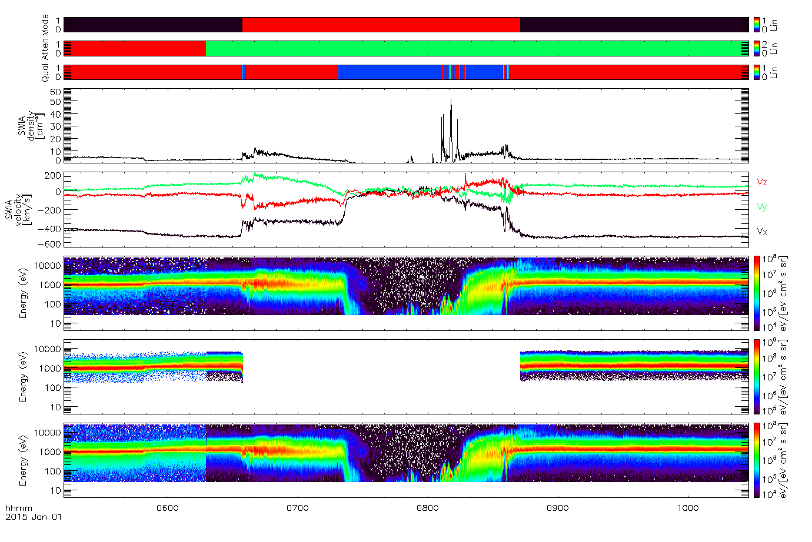

The figure above shows examples of SWIA onboard-computed moments, angle-averaged energy spectra from coarse distribution data, angle-averaged energy spectra from fine distribution data, and onboard-computed omnidirectional energy spectra obtained during approximately one orbit of MAVEN around Mars. During this orbit, MAVEN passes from the upstream solar wind, through the magnetosheath, inside the magnetosphere and magnetotail of Mars, back into the magnetosheath, and back into the upstream solar wind.

In order to properly interpret the data, the color bars at the top should be understood. The top color bar shows the instrument mode (black = solar wind, red = sheath), the next the attenuator status (red = closed, green = open), and the third the quality flag associated with the onboard moments (red = high, blue = low). The next two panels show onboard-computed density and velocity components in Mars Solar Orbital coordinates. In the solar wind, before ~06:30 and after ~08:40, the instrument operates in solar wind mode and computes moments from fine distributions. The consistently high quality flag in the solar wind indicates that SWIA is covering the entire distribution, and most moments can be trusted. Even in the solar wind, the contribution from the alpha particle population can significantly affect the temperature moment, though, so care should still be used.

Inside the bow shock, SWIA operates in sheath mode, and computes moments from coarse distributions. In the magnetosheath and magnetosphere, SWIA only covers the entire distribution for a portion of the time, in this case only during the inbound magnetosheath crossing, as indicated by the quality flags. Inside the magnetosphere proper, from ~07:20 to ~08:15, SWIA does not measure low enough in energy to cover most of the distribution, and can only measure trace populations. Furthermore, at these times, most ions measured are massive planetary ions, and SWIA’s non-mass-resolving data should only be used with great care.

The mechanical attenuator opens at ~06:17. Before this time, count rates from the solar wind direction are attenuated by a factor of ~15 in order to ensure that there is no saturation by cold dense solar wind. After correcting for this step in sensitivity, the differential energy flux of the main solar wind core is continuous. However, the relative background level for each data type changes with the attenuator, since the sensitivity level of the instrument changes, while the actual background rate does not. Therefore, measurements of the wings of the distribution should be interpreted with care.

1. Support staff and cognizant persons

Table 17: Archive support staff

|  |  |  |  |  |
| --- | --- | --- | --- | --- |
| SWIA **team** | | | | |
| **Name** | **Address** | **Phone** | **Email** | |
| Jasper S Halekas | 414 Van Allen Hall  Department of Physics and Astronomy  University of Iowa  Iowa City, IA 52242 | 319-335-1929 | jasper-halekas@uiowa.edu | |
|  |  |  |  | |
|  |  |  |  | |
|  |  |  |  | |
|  |  |  |  | |
|  |  |  |  | |
|  | | | | |
| **UCLA** | | | | |
| **Name** | **Address** | **Phone** | | **Email** |
| **Dr. Steven Joy** PPI Operations Manager | IGPP, University of California 405 Hilgard Avenue Los Angeles, CA 90095-1567 USA | +001 310 825 3506 | | sjoy@igpp.ucla.edu |
| **Mr. Joseph Mafi** PPI Data Engineer | IGPP, University of California 405 Hilgard Avenue Los Angeles, CA 90095-1567 USA | +001 310 206 6073 | | jmafi@igpp.ucla.edu |

1. Naming conventions for MAVEN science data files

This section describes the naming convention used for science data files for the MAVEN mission.

**Raw (MAVEN Level 0):**

mvn\_<inst>\_<grouping>\_l0\_< yyyy><mm><dd>\_v<xxx>.dat

**Level 1, 2, 3+:**

mvn\_<inst>\_<level>\_<descriptor>\_<yyyy><mm><dd>\_v<xx>\_r<yy>.<ext>

|  |  |
| --- | --- |
| **Code** | **Description** |
| <inst> | 3-letter instrument ID |
| <grouping> | Three-letter code: options are all, svy, arc for all data, survey data, archive data. Primarily for P&F to divide their survey & archive data at Level 0. |
| <yyyy> | 4-digit year |
| <mm> | 2-digit month, e.g. 01, 12 |
| <dd> | 2-digit day of month, e.g. 02, 31 |
| <hh> | 2-digit hour, separated from the date by T. OPTIONAL and not used by SWIA. |
| <mm> | 2-digit minute. OPTIONAL and not used by SWIA. |
| <ss> | 2-digit second. OPTIONAL and not used by SWIA. |
| v<xxx> | 2-digit software version: which version of the software was used to create this data product? |
| r<yyx> | 2-digit data version: is this a new version of a previous file, though the same software version was used for both? (Likely to be used in the case of retransmits to fill in data gaps) |
| <descriptor> | A description of the data. Defined by the creator of the dataset. There are no underscores in the value. |
| .<ext> | File type extension: .fits, .txt, .cdf, .png |
| <level> | A code indicating the MAVEN processing level of the data (valid values: l1, l2, l3) |

|  |  |
| --- | --- |
| **Instrument name** | **<instrument>** |
| IUVS | iuv |
| NGIMS | ngi |
| LPW | lpw |
| MAG | mag |
| SEP | sep |
| SWIA | swi |
| SWEA | swe |
| STATIC | sta |
| P&F package | pfp |

1. Sample Bundle Product Label

This section provides a sample bundle product label for the maven.swia.calibrated bundle.

<?xml version="1.0" encoding="UTF-8"?>

<?xml-model href="http://pds.nasa.gov/pds4/pds/v1/PDS4\_PDS\_1400.sch"

schematypens="http://purl.oclc.org/dsdl/schematron"?>

<Product\_Bundle

xmlns="http://pds.nasa.gov/pds4/pds/v1"

xmlns:xsi="http://www.w3.org/2001/XMLSchema-instance"

xsi:schemaLocation="

http://pds.nasa.gov/pds4/pds/v1

http://pds.nasa.gov/pds4/pds/v1/PDS4\_PDS\_1400.xsd

">

<Identification\_Area>

<logical\_identifier>urn:nasa:pds:maven.swia.calibrated</logical\_identifier>

<version\_id>1.0</version\_id>

<title>MAVEN SWIA Calibrated Data Bundle</title>

<information\_model\_version>1.4.0.0</information\_model\_version>

<product\_class>Product\_Bundle</product\_class>

<Citation\_Information>

<publication\_year>2015</publication\_year>

<keyword>MAVEN SWIA Calibrated Data</keyword>

<description>

This bundle contains fully calibrated MAVEN SWIA data, including ion velocity distributions,

energy spectra, and density, temperature, and velocity moments from onboard calculations.

Tables of sensitivity and energy/angle maps are included in files.

</description>

</Citation\_Information>

<Modification\_History>

<Modification\_Detail>

<modification\_date>2015-05-15</modification\_date>

<version\_id>1.0</version\_id>

<description>MAVEN Release 1</description>

</Modification\_Detail>

</Modification\_History>

</Identification\_Area>

<Context\_Area>

<Time\_Coordinates>

<start\_date\_time>2014-11-15T12:00:16.769Z</start\_date\_time>

<stop\_date\_time>2015-02-15T00:00:24.504Z</stop\_date\_time>

</Time\_Coordinates>

<Observing\_System>

<Observing\_System\_Component>

<name>Solar Wind Ion Analyzer</name>

<type>Instrument</type>

<Internal\_Reference>

<lid\_reference>urn:nasa:pds:context:instrument:swia.maven</lid\_reference>

<reference\_type>is\_instrument</reference\_type>

</Internal\_Reference>

</Observing\_System\_Component>

</Observing\_System>

</Context\_Area>

<Reference\_List>

<Internal\_Reference>

<lid\_reference>urn:nasa:pds:maven.swia.calibrated:document:sis</lid\_reference>

<reference\_type>bundle\_to\_document</reference\_type>

</Internal\_Reference>

</Reference\_List>

<Bundle>

<bundle\_type>Archive</bundle\_type>

<description>MAVEN SWIA Calibrated Data Bundle</description>

</Bundle>

<File\_Area\_Text>

<File>

<file\_name>Readme.txt</file\_name>

<local\_identifier>Readme</local\_identifier>

<creation\_date\_time>2015-03-25T08:31:00Z</creation\_date\_time>

<file\_size unit="byte">4730</file\_size>

<records>613</records>

<md5\_checksum>6775bea83521306919d0f3b1e30b0783</md5\_checksum>

<comment>This file contains a brief overview of the MAVEN SWIA Calibrated data bundle.</comment>

</File>

<Stream\_Text>

<name>Readme.txt</name>

<local\_identifier>Readme</local\_identifier>

<offset unit="byte">0</offset>

<object\_length unit="byte">4730</object\_length>

<parsing\_standard\_id>7-Bit ASCII Text</parsing\_standard\_id>

<description>This file contains a brief overview of the MAVEN SWIA Calibrated data bundle.</description>

<record\_delimiter>Carriage-Return Line-Feed</record\_delimiter>

</Stream\_Text>

</File\_Area\_Text>

<Bundle\_Member\_Entry>

<lidvid\_reference>urn:nasa:pds:maven.swia.calibrated:data.coarse\_arc\_3d::1.0</lidvid\_reference>

<member\_status>Primary</member\_status>

<reference\_type>bundle\_has\_data\_collection</reference\_type>

</Bundle\_Member\_Entry>

<Bundle\_Member\_Entry>

<lidvid\_reference>urn:nasa:pds:maven.swia.calibrated:data.coarse\_svy\_3d::1.0</lidvid\_reference>

<member\_status>Primary</member\_status>

<reference\_type>bundle\_has\_data\_collection</reference\_type>

</Bundle\_Member\_Entry>

<Bundle\_Member\_Entry>

<lidvid\_reference>urn:nasa:pds:maven.swia.calibrated:data.fine\_arc\_3d::1.0</lidvid\_reference>

<member\_status>Primary</member\_status>

<reference\_type>bundle\_has\_data\_collection</reference\_type>

</Bundle\_Member\_Entry>

<Bundle\_Member\_Entry>

<lidvid\_reference>urn:nasa:pds:maven.swia.calibrated:data.fine\_svy\_3d::1.0</lidvid\_reference>

<member\_status>Primary</member\_status>

<reference\_type>bundle\_has\_data\_collection</reference\_type>

</Bundle\_Member\_Entry>

<Bundle\_Member\_Entry>

<lidvid\_reference>urn:nasa:pds:maven.swia.calibrated:data.onboard\_svy\_mom::1.0</lidvid\_reference>

<member\_status>Primary</member\_status>

<reference\_type>bundle\_has\_data\_collection</reference\_type>

</Bundle\_Member\_Entry>

<Bundle\_Member\_Entry>

<lidvid\_reference>urn:nasa:pds:maven.swia.calibrated:data.onboard\_svy\_spec::1.0</lidvid\_reference>

<member\_status>Primary</member\_status>

<reference\_type>bundle\_has\_data\_collection</reference\_type>

</Bundle\_Member\_Entry>

<Bundle\_Member\_Entry>

<lidvid\_reference>urn:nasa:pds:maven.swia.calibrated:document::1.0</lidvid\_reference>

<member\_status>Primary</member\_status>

<reference\_type>bundle\_has\_document\_collection</reference\_type>

</Bundle\_Member\_Entry>

1. </Product\_Bundle>Sample Collection Product Label

This section provides a sample collection product label for the data.coarse\_arc\_3d collection.

<?xml version="1.0" encoding="UTF-8"?>

<?xml-model href="http://pds.nasa.gov/pds4/pds/v1/PDS4\_PDS\_1400.sch"

schematypens="http://purl.oclc.org/dsdl/schematron"?>

<?xml-model href="http://pds.nasa.gov/pds4/mvn/v1/PDS4\_MVN\_1010.sch"

schematypens="http://purl.oclc.org/dsdl/schematron"?>

<Product\_Collection

xmlns="http://pds.nasa.gov/pds4/pds/v1"

xmlns:xsi="http://www.w3.org/2001/XMLSchema-instance"

xmlns:mvn="http://pds.nasa.gov/pds4/mission/mvn/v1"

xsi:schemaLocation="

http://pds.nasa.gov/pds4/pds/v1

http://pds.nasa.gov/pds4/pds/v1/PDS4\_PDS\_1400.xsd

http://pds.nasa.gov/pds4/mission/mvn/v1

http://pds.nasa.gov/pds4/mvn/v1/PDS4\_MVN\_1010.xsd

">

<Identification\_Area>

<logical\_identifier>urn:nasa:pds:maven.swia.calibrated:data.coarse\_arc\_3d</logical\_identifier>

<version\_id>1.0</version\_id>

<title>MAVEN SWIA Calibrated Coarse Archive 3D Data Collection</title>

<information\_model\_version>1.4.0.0</information\_model\_version>

<product\_class>Product\_Collection</product\_class>

<Citation\_Information>

<publication\_year>2015</publication\_year>

<keyword>Coarse</keyword>

<keyword>Archive</keyword>

<keyword>3-D Distributions</keyword>

<description>

This collection contains SWIA coarse archive 3d files with time-ordered fully calibrated ion

distributions in units of differential energy flux derived from the SWIA Coarse

distribution Archive telemetry, as well as a header of ancillary information needed to

interpret the data.

</description>

</Citation\_Information>

<Modification\_History>

<Modification\_Detail>

<modification\_date>2015-05-15</modification\_date>

<version\_id>1.0</version\_id>

<description>MAVEN Review 1</description>

</Modification\_Detail>

</Modification\_History>

</Identification\_Area>

<Context\_Area>

<Time\_Coordinates>

<start\_date\_time>2014-11-15T12:00:40.769Z</start\_date\_time>

<stop\_date\_time>2015-02-14T23:59:52.504Z</stop\_date\_time>

</Time\_Coordinates>

<Primary\_Result\_Summary>

<purpose>Science</purpose>

<processing\_level>Calibrated</processing\_level>

<Science\_Facets>

<domain>Heliosphere</domain>

<discipline\_name>Particles</discipline\_name>

<facet1>Ions</facet1>

<facet2>Solar Energetic</facet2>

</Science\_Facets>

</Primary\_Result\_Summary>

<Observing\_System>

<Observing\_System\_Component>

<name>Solar Wind Ion Analyzer</name>

<type>Instrument</type>

<Internal\_Reference>

<lid\_reference>urn:nasa:pds:context:instrument:swia.maven</lid\_reference>

<reference\_type>is\_instrument</reference\_type>

</Internal\_Reference>

</Observing\_System\_Component>

</Observing\_System>

<Target\_Identification>

<name>Solar Wind</name>

<type>Plasma Stream</type>

<Internal\_Reference>

<lid\_reference>urn:nasa:pds:context:target:plasma\_stream.solar\_wind</lid\_reference>

<reference\_type>collection\_to\_target</reference\_type>

</Internal\_Reference>

</Target\_Identification>

<Mission\_Area>

<MAVEN xmlns="http://pds.nasa.gov/pds4/mvn/v1">

<mission\_phase\_name>Transition</mission\_phase\_name>

<mission\_phase\_name>Prime Mission</mission\_phase\_name>

<spacecraft\_clock\_start\_count>3.0757671432382992E13</spacecraft\_clock\_start\_count>

<spacecraft\_clock\_stop\_count>3.1275769366197008E13</spacecraft\_clock\_stop\_count>

<mission\_event\_time\_start\_count>4.693248231214142E8</mission\_event\_time\_start\_count>

<mission\_event\_time\_stop\_count>4.772303702071991E8</mission\_event\_time\_stop\_count>

</MAVEN>

</Mission\_Area>

</Context\_Area>

<Reference\_List>

</Reference\_List>

<Collection>

<collection\_type>Data</collection\_type>

<description>

This collection contains SWIA coarse archive 3d files with time-ordered fully calibrated ion

distributions in units of differential energy flux derived from the SWIA Coarse

distribution Archive telemetry, as well as a header of ancillary information needed to

interpret the data.

</description>

</Collection>

<File\_Area\_Inventory>

<File>

<file\_name>collection\_data\_coarse\_arc\_3d\_1.0.csv</file\_name>

<creation\_date\_time>2015-05-15T14:19:34</creation\_date\_time>

<file\_size unit="byte">7050</file\_size>

<records>75</records>

<md5\_checksum>7fa0d0776fa2b721b4e7aaa2b38d7289</md5\_checksum>

</File>

<Inventory>

<offset unit="byte">0</offset>

<parsing\_standard\_id>PDS DSV 1</parsing\_standard\_id>

<records>75</records>

<record\_delimiter>Carriage-Return Line-Feed</record\_delimiter>

<field\_delimiter>Comma</field\_delimiter>

<Record\_Delimited>

<fields>2</fields>

<groups>0</groups>

<maximum\_record\_length unit="byte">257</maximum\_record\_length>

<Field\_Delimited>

<name>Member\_Status</name>

<field\_number>1</field\_number>

<data\_type>ASCII\_String</data\_type>

<maximum\_field\_length unit="byte">1</maximum\_field\_length>

</Field\_Delimited>

<Field\_Delimited>

<name>LIDVID\_LID</name>

<field\_number>2</field\_number>

<data\_type>ASCII\_LIDVID\_LID</data\_type>

<maximum\_field\_length unit="byte">255</maximum\_field\_length>

</Field\_Delimited>

</Record\_Delimited>

<reference\_type>inventory\_has\_member\_product</reference\_type>

</Inventory>

</File\_Area\_Inventory>

</Product\_Collection>

1. Sample Data Product Labels

Due to the size of the basic product labels and the line length limitations on this document, sample data product labels are provided in a separate file: maven\_swia\_pds\_sample\_labels.xml (LID = urn:nasa:pds:maven.swia.calibrated:document.sample\_labels).

1. PDS Delivery Package Manifest File Record Structures

The delivery package includes two manifest files: a transfer manifest, and MD5 checksum manifest. When delivered as part of a data delivery, these two files are not PDS archive products, and do not require PDS labels files. The format of each of these files is described below.

* 1. Transfer Package Directory Structure

Directory structure for the transfer packages will be the same as that used in the MAVEN SDC holdings.

maven

|

data

|

sci

|

*inst*

|

*proc*

|

*yyyy*

|

*mm*

Where:

*inst* = instrument abbreviation

*proc* = MAVEN data processing level

*yyyy* = 4-digit year of start of data

*mm* = 2-digit month of start of data

* 1. Transfer Manifest Record Structure

The transfer manifest is defined as a two field fixed-width table where each row of the table describes one of the products in the package. The first field describes the LIDVID of each product in the package. The second field indicates the file specification name of the corresponding PDS product label in the package. The PDS product labels, in turn, indicate the name and characteristics of the file or files that they accompany. The file specification name defines the name and location of the product relative to the location of the bundle product.

* 1. Checksum Manifest Record Structure

The checksum manifest consists of records with two fields: a 32 character hexadecimal (using lowercase letters) MD5, and a file specification from the root directory of the unzipped delivery package to every file included in the package. The file specification uses forward slashes (“/”) as path delimiters. The two fields are separated by two spaces. Manifest records may be of variable length and should be terminated with a single line feed (0x0A) record delimiter. This is the standard output format for a variety of MD5 checksum tools (*e.g*. md5deep, etc.).

1. PDS4 Labels for SWIA CDF Data Files

This appendix describes the way that the metadata provided in the SWIA PDS4 label files may be used to understand the internal physical and logical structure of the SWIA data files, and how those labels may be used to access the data directly.

* 1. CDF Formatted Data Files

Common Data Format (CDF) is a self-describing data format for the storage of scalar and multidimensional data in a platform- and discipline-independent way. It has both library and toolkit support for the most commonly used platforms and programming languages. For the PDS archive, CDF files are required meet CDF-A specification with the PDS extensions [CDF-A]. In addition, the MAVEN mission includes other attributes in the CDF file as defined in the MAVEN archive CDF document [MAVEN CDF].

* 1. CDF and PDS4 Metadata

The PDS4 product label is an XML file that accompanies the CDF file. The PDS4 labels are designed to enable data users to read the CDF files without the use of a CDF reader or any awareness that the data are stored in a CDF file. Since the data consist of multiple data parameters (arrays) which have very specific relationships, the label describes both the physical structure of the data file, as well as the logical relationships between data parameters. This section describes the approach used to document both the physical structure and logical relationships.

* 1. PDS4 Label Structure

The PDS label is subdivided into a series of separate sections or “areas”. Metadata describing the data parameters and their relationships are located in different areas of the label. Data parameters in the label are assigned a “local\_identifier” and this identifier is referenced in the descriptions of the logical structure. A complete PDS4 label contains many areas. In this section we concentrate only on the areas which describe the physical structure and the logical relationships.

* + 1. PDS Label Physical Structure Description

The physical structure of the data files are described in the “File\_Area\_Observational” portion of the label. Each data parameter is described using an “Array” object. The Array object contains location, data type, size, and descriptive information for each parameter. An “Axis\_Array” object is provided for each axis of an array. Axis\_Array includes an “axis\_name” which is either set to the name of the CDF value associated with the axis or to the value “index” if the parameter is itself an independent variable. For each Array the “name” is the name assigned to the parameter (“variable” in CDF terms) in the CDF file. This is also assigned to “local\_identifier” since a variable name is unique within a CDF. Figure 11 contains sample Array objects.

<Array>  
 <name>epoch</name>  
 <local\_identifier>epoch</local\_identifier>  
 <offset unit="byte">17477</offset>  
 <axes>1</axes>  
 <axis\_index\_order>Last Index Fastest</axis\_index\_order>  
 <description>Time, start of sample, in TT2000 time base</description>  
 <Element\_Array>  
 <data\_type>IEEE754MSBDouble</data\_type>  
 <unit>ns</unit>  
 </Element\_Array>  
 <Axis\_Array>  
 <axis\_name>index</axis\_name>  
 <elements>5387</elements>  
 <sequence\_number>1</sequence\_number>  
 </Axis\_Array>

</Array>  
 .

.

.

<Array>  
 <name>diff\_en\_fluxes</name>  
 <local\_identifier>diff\_en\_fluxes</local\_identifier>  
 <offset unit="byte">66373737</offset>  
 <axes>4</axes>  
 <axis\_index\_order>Last Index Fastest</axis\_index\_order>  
 <description>Calibrated Differential Energy Flux</description>  
 <Element\_Array>  
 <data\_type>IEEE754MSBSingle</data\_type>  
 <unit>ev/[eV cm^2 sr s]</unit>  
 </Element\_Array>  
 <Axis\_Array>  
 <axis\_name>epoch</axis\_name>  
 <elements>5387</elements>  
 <sequence\_number>1</sequence\_number>  
 </Axis\_Array>  
 <Axis\_Array>  
 <axis\_name>phi\_coarse</axis\_name>  
 <elements>16</elements>  
 <sequence\_number>2</sequence\_number>  
 </Axis\_Array>  
 <Axis\_Array>  
 <axis\_name>dindex</axis\_name>  
 <elements>4</elements>  
 <sequence\_number>3</sequence\_number>  
 </Axis\_Array>  
 <Axis\_Array>  
 <axis\_name>energy\_coarse</axis\_name>  
 <elements>48</elements>  
 <sequence\_number>4</sequence\_number>  
 </Axis\_Array>  
</Array>

Figure 11. Sample PDS4 Array objects.

* + 1. Parameter Logical Relationships

The Discipline\_Area may contain objects which are specific to a discipline. The logical relationships of parameters is often specific to the types of observations, so is described in the Discipline\_Area. There are two logical relationship in the data products, one consisting of sets of values that are interchangeable and the other for particle observations.

The Alternate\_Values object is used to indicate parameters which may be used interchangeably with each other. For example, this object may be used to associate multiple time arrays which may be included in the data file. An Alternate\_Values object will contain a series of Data\_Values objects which references a parameter with a Local\_Internal\_Reference. Each of the Data\_Values parameters within a single Alternate\_Values group must have the same dimensions. Figure 12 contains a sample Alternate\_Values object. The schema for the Alternate\_Values object is defined in the “alt” schema [ALT].

<Alternate\_Values xmlns="http://pds.nasa.gov/pds4/alt/v1">  
 <name>time values</name>  
 <Data\_Values>  
 <Local\_Internal\_Reference>  
 <local\_identifier\_reference>epoch</local\_identifier\_reference>  
<local\_reference\_type>data\_values\_to\_data\_values</local\_reference\_type>  
 </Local\_Internal\_Reference>  
 </Data\_Values>  
 <Data\_Values>  
 <Local\_Internal\_Reference>  
 <local\_identifier\_reference>time\_met</local\_identifier\_reference>  
<local\_reference\_type>data\_values\_to\_data\_values</local\_reference\_type>  
 </Local\_Internal\_Reference>  
 </Data\_Values>  
 <Data\_Values>  
 <Local\_Internal\_Reference>  
 <local\_identifier\_reference>time\_unix</local\_identifier\_reference>  
<local\_reference\_type>data\_values\_to\_data\_values</local\_reference\_type>  
 </Local\_Internal\_Reference>  
 </Data\_Values>  
</Alternate\_Values>

Figure 12. Sample Alternate\_Values object.

The Particle\_Observation class is used to describe the relationship between (typically) multi-dimensional data and values that are associated with an axis or face of the mutli-dimensional data. In Particle\_Observation the Primary\_Values object identifies the primary data parameter. Each Axis\_Values object in Particle\_Observation associates data with one of the axes for the primary parameter. A Face\_Values object is used to indicate the relationship between multi-dimensional arrays and a face perpendicular to an axis of the primary parameter. In Face\_Values there is a Face\_Plane object which indicates which of the primary parameter’s axes each of the “face” parameters’ axes align with. Each “primary”, “axis”, and “face” parameter is referenced using the local\_identifier attribute of a Local\_Internal\_Reference. Figure 13 **Error! Reference source not found.**contains a sample Particle\_Observation object. The schema for the Particle\_Observation object is defined in the “particle” schema [PARTICLE].

<Particle\_Observation xmlns="http://pds.nasa.gov/pds4/particle/v1">  
 <name>counts</name>  
 <description>Raw Instrument counts</description>  
 <Primary\_Values>  
 <Local\_Internal\_Reference>  
 <local\_identifier\_reference>counts</local\_identifier\_reference>  
<local\_reference\_type>particle\_observation\_to\_observation\_values</local\_reference\_type>  
 </Local\_Internal\_Reference>  
 </Primary\_Values>  
 <Axis\_Values>  
 <Local\_Internal\_Reference>  
 <local\_identifier\_reference>epoch</local\_identifier\_reference>  
<local\_reference\_type>particle\_observation\_to\_axis\_values</local\_reference\_type>  
 </Local\_Internal\_Reference>  
 <axis\_number>1</axis\_number>  
 </Axis\_Values>  
 <Axis\_Values>  
 <Local\_Internal\_Reference>  
 <local\_identifier\_reference>phi\_coarse</local\_identifier\_reference>  
<local\_reference\_type>particle\_observation\_to\_axis\_values</local\_reference\_type>  
 </Local\_Internal\_Reference>  
 <axis\_number>2</axis\_number>  
 </Axis\_Values>  
 <Axis\_Values>  
 <Local\_Internal\_Reference>  
 <local\_identifier\_reference>dindex</local\_identifier\_reference>  
<local\_reference\_type>particle\_observation\_to\_axis\_values</local\_reference\_type>  
 </Local\_Internal\_Reference>  
 <axis\_number>3</axis\_number>  
 </Axis\_Values>  
 <Axis\_Values>  
 <Local\_Internal\_Reference>  
 <local\_identifier\_reference>energy\_coarse</local\_identifier\_reference>  
<local\_reference\_type>particle\_observation\_to\_axis\_values</local\_reference\_type>  
 </Local\_Internal\_Reference>  
 <axis\_number>4</axis\_number>  
 </Axis\_Values>  
 <Face\_Values>  
 <Local\_Internal\_Reference>  
 <local\_identifier\_reference>theta\_coarse</local\_identifier\_reference>  
<local\_reference\_type>particle\_observation\_to\_face\_values</local\_reference\_type>  
 </Local\_Internal\_Reference>  
 <Face\_Plane>  
 <face\_axis>3</face\_axis>  
 <face\_axis>4</face\_axis>  
 </Face\_Plane>  
 </Face\_Values>  
</Particle\_Observation>

Figure 13. Sample Particle\_Observation object.

* + 1. Constant Values

In some cases constants have been included as data parameters in the data files. These parameters are labeled in the File\_Area\_Observational as degenerate arrays (i.e. an array with a single axis, which contains a single element). The Mission\_Area provides the values of constant parameters included in the data file. This information is provided in a “Parameter” object. Figure 14 contains sample Parameter objects.

<Parameter>  
 <name>geom\_factor</name>  
 <description>Full Analyzer Geometric Factor</description>  
 <value>0.0056</value>  
</Parameter>

<Parameter>  
 <name>de\_over\_e\_coarse</name>  
 <description>Coarse DeltaE/E</description>  
 <value>0.15</value>  
</Parameter>

Figure 14. Sample Parameter objects.

* 1. CDF References

CDF Internal Format Description, Version 3.4. (2012, February 28). Retrieved from NASA/Goddard Space Flight Center/Space Physics Data Facility/CDAWeb: http://cdaweb.gsfc.nasa.gov/pub/software/cdf/doc/cdf34/cdf34ifd.pdf. PDS product LID = urn:nasa:pds:gsfc.spdf.cdf:document:cdf34ifd.

MAVEN CDF, Archive of MAVEN CDF in PDS4, Ver. 4, 15 Apr 2015, PDS product LID = usn:nasa:pds:maven:document:maven-cdf-pds4

CDF-A Specification, Version 1.0, http://ppi.pds.nasa.gov/doc/CDF-A-Specification-v1.0.pdf

ALT, Alternative Values Schema, Version 0.0.1, PDS product LID = urn:nasa:pds:system\_bundle:xml\_schema:alt-xml\_schema

PARTICLE, Particle Observation Schema, Version 0.0.1. PDS product LID = urn:nasa:pds:system\_bundle:xml\_schema:particle-xml\_schema