ROLSES-1 Dataset Description
Prepared by Scott A. Boardsen, scott.a.boardsen@nasa.gov.

- Brief mission/instrument/dataset description.
- Notes on Ground processing.
- What we are archiving.
- IDL example on how to load and plot each dataset.
- For each Dataset Type a List of Variables and their Key Metadata.
    - im-1_rolses_l1_efl_spectra
    - im-1_rolses_l2_efl_spectra
    - im-1_rolses_l1_efl_waveform

Brief IM-1 mission/ROLSES instrument/ROLSES dataset description

Intuitive Machines -1 (Odysseus) lunar lander mission was launched from the Kennedy Space Center on 02/15/2024 at 06:05 UT and landed near the Lunar south pole on 02/22/2024 at 23:23:53 UT. Upon landing it tipped over and therefore the power and telemetry for both downlink and uplink was very limited compared to that if it had landed as planned (https://nssdc.gsfc.nasa.gov/nmc/spacecraft/display.action?id=IM-1-NOVA).

The Radio wave Observation at the Lunar Surface of the photoElectron Sheath (ROLSES) instrument (Gopalswamy et al., 2023) has four 2.5 m monopole antennae for detecting the electric field signals. The signals at a sampling rate of 120 M samples per second are feed into Digital Signal Processors (DSP) for spectral analysis. Each antenna had its own dedicated DSP where the signals are processed into spectrum for both low (~0.003 to ~1.9 MHz) and high frequency bands (~0.06 to ~30 MHz) of 512 frequency channels each. The cadence of both bands from all 4 antennae (8 spectrum) is 8 seconds, with the low band and high band staggered by 4 seconds. No cross correlation was made between DSP FFTs so only the absolute values of the FFT amplitude are returned. Besides spectrum, infrequently the input signal of 4096 samples at 120 M samples per second to the DSP were also returned.

The antenna names and mapping to its DSP are 1) UPPER A which feeds DSP B, 2) LOWER A which feeds DSP A, 3) UPPER B which feeds DSP C, and 4) LOWER B which feeds DSP D. Due to the tipping over of the launch the deployment of the antenna was not as desired, antennae LOWER B and UPPER A lies on or are directed into the lunar surface, while UPPER B points at ~45 degrees from zenith, and LOWER A points near zenith. Also due to the tipping over commanding of the ROLSES instrumentation was limited. Therefore, the gain setting was in the lowest gain for all four antennae for all data intervals, and the performance of the instrument could not be optimized to extract remote signals. While on the Lunar surface only 36 minutes of spectral data was obtained compared to the projected 170 to 340 hours of lunar surface data, 83 minutes of cruise phase data was obtained. The latter was unexpected and due to the accidental deployment of antenna Lower B during cruise phase.

The dataset variable names contain letters like 'DH' where 'D' refers to DSP D and 'H' for high frequency band, 'AL' where 'A’ refers to DSP A and 'L' for low frequency band, etc. The uncalibrated L1 data consists of uncalibrated FFT absolute amplitude from the DSPs. The calibrated L2 data consists of calibrated FFT absolute amplitude from the DSPs in volts, along with power spectral densities where 2.5/4 m is used as the effective antenna length. Note for ease of intercomparison the PSDs (Power Spectral Densities) are computed regardless of whether the antenna is deployed. The ground test data is included because the voltage levels are almost identical to those observed during cruise and on the lunar surface. The raw waveform voltage is uncalibrated, and it is dominated by strong power supply spikes and of instrument/spacecraft generated electromagnetic interference, which also dominated the DSP signal processing.

The archive of spectrum data consists of ground integration on 12/07/2023 for 3.3 minutes, cruise phase on 02/21/2024 for 83 minutes, Lunar 1 on 02/26/2024 for 8 minutes, and Lunar 2 on 02/27/2024 for 28 minutes of data. The raw waveform data archive consists of ground integration on 12/07/2023 consisting of 35 to 36 waveforms per antenna, and Lunar 2 on 02/27/2024 consisting of 27 to 28 waveforms per antenna.

References

Gopalswamy N., R. J. MacDowall, P. A. Mäkelä, S. A. Boardsen, S. Yashiro, R. B. Katz, I. Kleyner, S. D. Murphy, R. C. Mills, C. Onyeachu, M. K. Choi, T. M. Schluszas, V. Gonzalez-leon, P. A. Sparacino, W. M. Farrell, D. C. Bradley, J. O. Burns, and J. J. Hibbard, The Radio-wave Observations at the Lunar Surface of the phoneElectron Shead (ROLSES) instrument onboard the Intuitive Machines-1 Mission to the Moon, arXiv e-prints, 2026. (https:doi.org/10.48550/arXiv.2603.22600)

Notes on Ground processing

The high and low frequency band labels in the telemetry data packet for Lunar-1 are flipped. So, on the ground, data labeled in the data packet as high frequency band was switched to low, and data labeled as low frequency band was switched to high. The data packet frequency band mode labels are correct for the ground integration data, the cruise data, and the Lunar-2 data.

Each telemetry data packet has two mission elapsed time (MET) entries one for the IM-1 lander and the other for the ROLSES instrument. The ROLSES MET gives time in integer seconds from the time of ROLSES turn-on. Every time ROLSES is turned on the ROLSES MET is reset to 0 s. Each histogram data packet contains one 512 frequency spectrum, measured over a 4 s interval, it has not been determined from the engineering notes if the ROLSES MET time tag is at the start, middle or end of this interval. The IM-1 MET is the integer time in seconds from J2000. The most significant byte (MSB) of the IM-1 MET time tagged is removed on-board before adding it to the data packet. The turning over of the second counter between IM-1 MET and ROLSES MET is not synced, introducing another potential timing error between 0 and 1 s. The spectrum’s time tags in the dataset are given as CDF_TT2000 derived from the IM-1 MET after re-adding the MSB.

Currently there is no plan to calibrate the raw time series data, so only uncalibrated L1 data is provided.

What we are archiving

Data sets:
- im-1_rolses_l1_efl_spectra: ROLSES spectra in uncalibrated voltage as a function of frequency and time.
- im-1_rolses_l2_efl_spectra: ROLSES calibrated spectra in both voltage and power spectral density (PSD) as a function of frequency and time.
- im-1_rolses_l1_efl_waveform: ROLSES uncalibrated waveforms.

Ground test integration data.
im-1_rolses_l1_efl_spectra_20231207201036_v01.cdf
im-1_rolses_l2_efl_spectra_20231207201036_v01.cdf
im-1_rolses_l1_efl_waveform_20231207201409_v01.cdf

Cruise data.
im-1_rolses_l1_efl_spectra_20240221031746_v01.cdf
im-1_rolses_l2_efl_spectra_20240221031746_v01.cdf

Lunar-1 data.
im-1_rolses_l1_efl_spectra_20240226171335_v01.cdf
im-1_rolses_l2_efl_spectra_20240226171335_v01.cdf

Lunar-2 data.
im-1_rolses_l1_efl_spectra_20240227053956_v01.cdf
im-1_rolses_l1_efl_waveform_20240227060745_v01.cdf
im-1_rolses_l2_efl_spectra_20240227053956_v01.cdf

Besides datasets, the MASTER CDFs and their skeleton tables are included, which contain a complete description of the CDF variables and their metadata (attributes).

IDL example on how to load and plot each dataset.

im-1_rolses_l1_efl_spectra

In order to run these examples, the CDAWEB IDL library must be installed(https://cdaweb.gsfc.nasa.gov/WebServices/REST/CdasIdlLibrary.html).
ipm, /install, 'https://cdaweb.gsfc.nasa.gov/WebServices/REST/SPDF_CDAS.zip'
restore, !package_path + '/SPDF_CDAS/spdfcdas.sav'
; above two commands are needed if spdfcdas is not installed and in your !PATH variable
file = 'im-1_rolses_l1_efl_spectra_20240221031746_v01.cdf'
d = read_mycdf(/all, v, file)
help, d
help, d.dh_epoch.dat
help, d.dh_volts.dat
help, d.DH_VOLTS.depend_0
help, d.DH_VOLTS.depend_1
it = 0 ; time step
cdf_tt2000,/break, d.DH_Epoch.dat[it], year, month, dom, hr, min, sec
date0 = string( year, month, dom, hr, min, sec, format='(i4,"-",I2.2,"-",i2.2,"T",i2.2,":",I2.2,":",f6.3)')
it = 624 ; time step
cdf_tt2000,/break, d.DH_Epoch.dat[it], year, month, dom, hr, min, sec
date1 = string( year, month, dom, hr, min, sec, format='(i4,"-",I2.2,"-",i2.2,"T",i2.2,":",I2.2,":",f6.3)')

title = date0 + ' to ' + date1
xtitle= 'Frequency, ' + d.FREQUENCY_HIGH_BAND.units
ytitle= 'Volts, ' + d.dh_volts.units
apt =plot(d.FREQUENCY_HIGH_BAND.dat, mean(d.dh_volts.dat, di=2), xtitle=xtitle,ytitle=ytitle, title=title)
apt.Save, "rolses_example1.png", BORDER=10, RESOLUTION=300, /TRANSPARENT

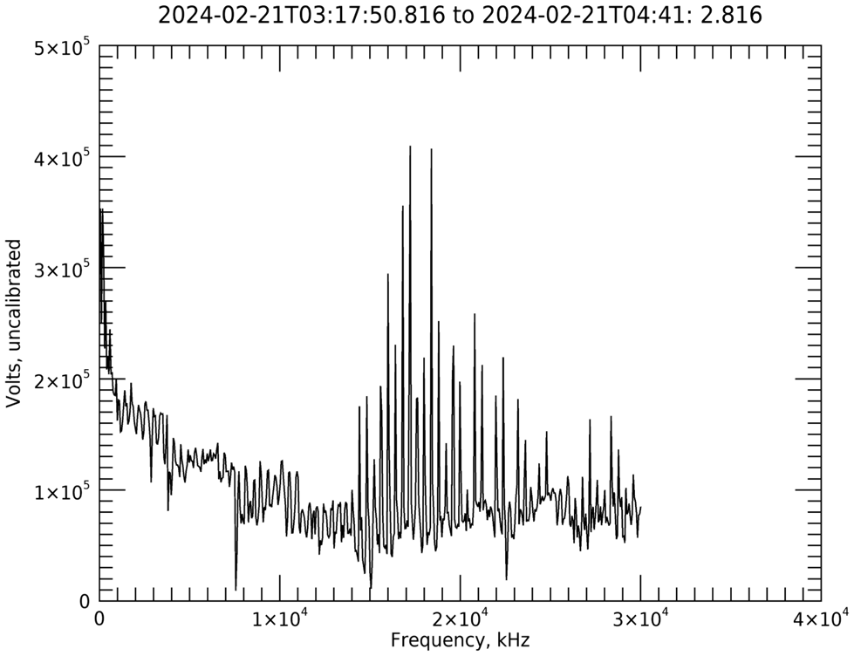

im-1_rolses_l2_efl_spectra
file = 'im-1_rolses_l2_efl_spectra_20240221031746_v01.cdf'
d = read_mycdf(/all, v, file)
it = 0 ; time step
cdf_tt2000,/break, d.DH_Epoch.dat[it], year, month, dom, hr, min, sec
date0 = string( year, month, dom, hr, min, sec, format='(i4,"-",I2.2,"-",i2.2,"T",i2.2,":",I2.2,":",f6.3)')
it = 624 ; time step:
cdf_tt2000,/break, d.DH_Epoch.dat[it], year, month, dom, hr, min, sec
date1 = string( year, month, dom, hr, min, sec, format='(i4,"-",I2.2,"-",i2.2,"T",i2.2,":",I2.2,":",f6.3)')
title = date0 + ' to ' + date1
xtitle= 'Frequency, ' + d.FREQUENCY_HIGH_BAND.units
ytitle= 'Volts, ' + d.dh_volts.units
apt =plot(d.FREQUENCY_HIGH_BAND.dat, mean(d.dh_volts.dat, di=2), xtitle=xtitle,ytitle=ytitle, title=title)
apt.Save, "rolses_example2.png", BORDER=10, RESOLUTION=300, /TRANSPARENT
ytitle= 'Volts, ' + d.dh_psd.units
apt =plot(d.FREQUENCY_HIGH_BAND.dat, mean(d.dh_psd.dat, di=2), xtitle=xtitle,ytitle=ytitle, title=title)
apt.Save, "rolses_example3.png", BORDER=10, RESOLUTION=300, /TRANSPARENT

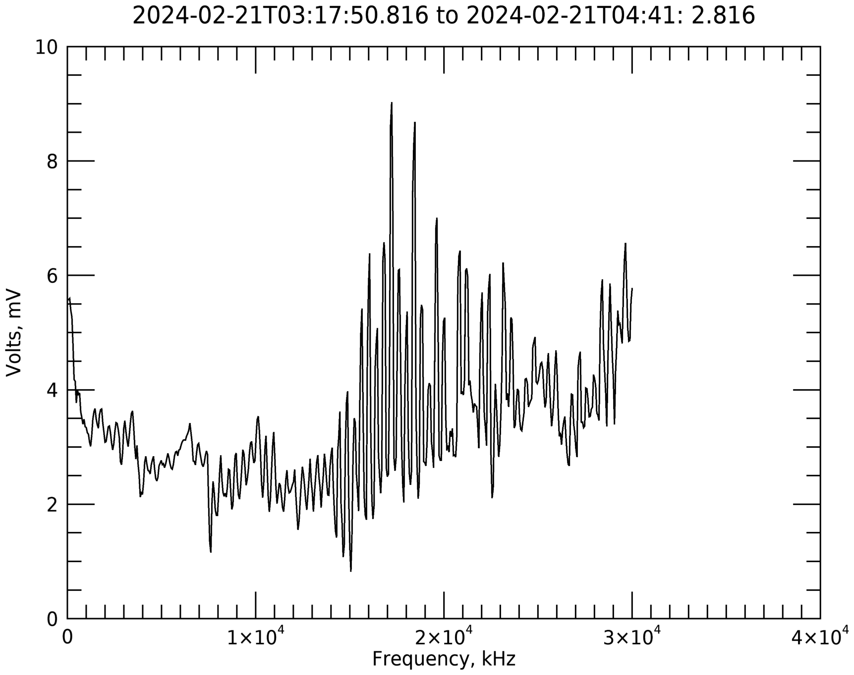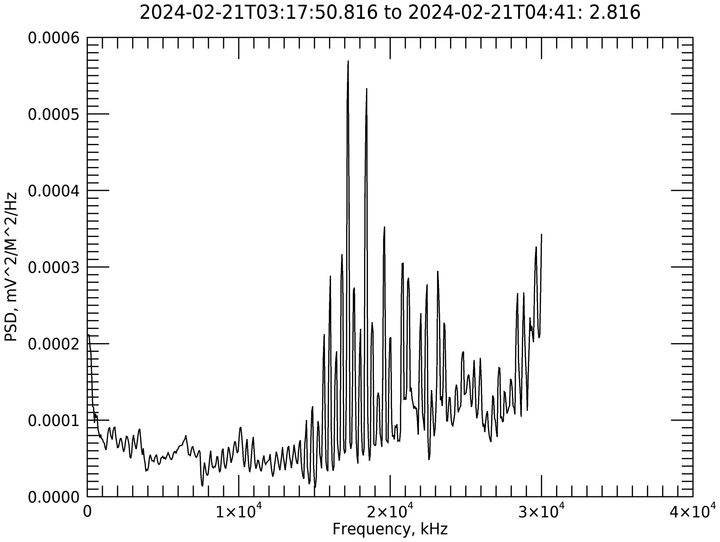

im-1_rolses_l1_efl_waveform

file = 'im-1_rolses_l1_efl_waveform_20240227060745_v01.cdf'
d = read_mycdf(/all, v, file)
it = 13 ; time step
cdf_tt2000,/break, d.B_Epoch.dat[it], year, month, dom, hr, min, sec
title = string( year, month, dom, hr, min, sec, format='(i4,"-",I2.2,"-",i2.2,"T",i2.2,":",I2.2,":",f6.3)')
t = d.TIME_MICROSEC.dat
help, d.B_WAVEFORM.dat
ytitle = 'Wave Form Amplitude, ' + d.B_WAVEFORM.units
xtitle = 'Time, ' + d.TIME_MICROSEC.units
apt = plot(d.TIME_MICROSEC.dat, d.B_WAVEFORM.dat[*,it],xtitle=xtitle, ytitle=ytitle, title=title)
apt.Save, "rolses_example4.png", BORDER=10, RESOLUTION=300, /TRANSPARENT

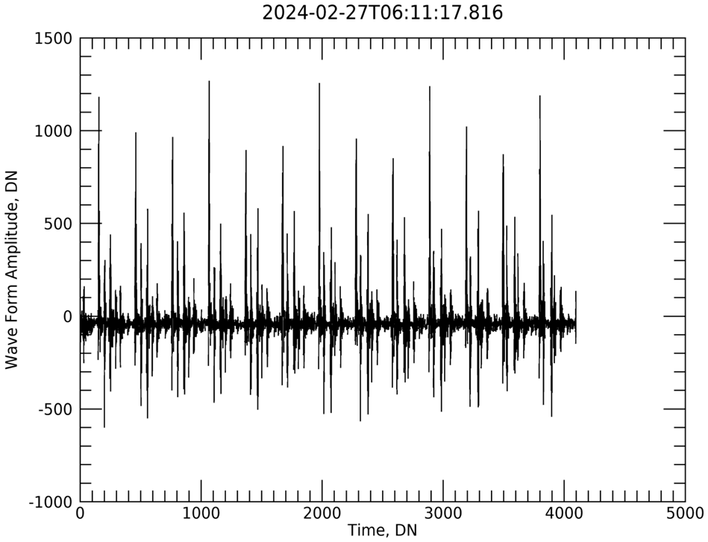

For each Dataset Type a List of Variables and their Key Metadata

    - im-1_rolses_l1_efl_spectra
    - im-1_rolses_l2_efl_spectra
    - im-1_rolses_l1_efl_waveform

The CDFs are ISTP compliant.

Variables and Key ISTP metadata (attributes) are listed.
See ISTP guidelines (https://spdf.gsfc.nasa.gov/istp_guide/gattributes.html).

Global Attribute
TEXT -equivalent to the dataset description typically used in SPASE records

Local Attributes

FIELDNAM
VAR_TYPE (if used)
UNITS
FILLVAL
CATDESC
VAR_NOTES
DEPEND_0 (if needed)
DEPEND_1 (if needed)

For a complete list of attributes see the skeleton table (.skt) files.

im-1_rolses_l1_efl_spectra

DATA SET ID: im-1_rolses_l1_efl_spectra
file example: im-1_rolses_l1_efl_spectra_20231207201036_v01.cdf
TEXT (data set description):
The IM-1 ROLSES radio waves electric field spectral data consists of eight 512-frequency channel spectrum taken every 8 seconds. The spectrums consist of both low (~0.003 to ~1.9 MHz) and high frequency (~0.06 to ~30 MHz) bands, the low and high bands are staggered by 4 seconds. The spectrums are detected separately by each of the four 2.5 m monopole antennae, whose signals are fed into a Digital Signal Processor (DSP) dedicated to each antenna. By design, no cross spectra between DSP were made. The DSP spectral averaging failed and only the last spectrum measured was retained during each spectral analysis interval. The antenna names and mapping to its DSP are 1) UPPER A which feeds DSP B, 2) LOWER A which feeds DSP A, 3) UPPER B which feeds DSP C, and 4) LOWER B which feeds DSP D. The lettering in the variable names of 'A', 'B', 'C', 'D' refers to the DSP in which the antenna signal is fed, and 'H' and 'L' refer to the high and low frequency bands. So, for example, 'DH' refers to DSP D and the high frequency band. All 8 combinations of antenna and frequency range are measured. Antenna LOWER B (DSP-D) was deployed during cruise phase, the other Antennas were deployed on the lunar surface. Due to the tipping over of the lunar lander upon landing on the lunar surface, antennae LOWER B and UPPER A lies on or are directed into the lunar surface, while UPPER B points at ~45 degrees from zenith, and LOWER A points near zenith. The tipping over of the lander resulted in limited power and telemetry for both data download and instrument commanding. So, 36 minutes compared to the projected 170 to 340 hours of lunar surface data was obtained, 83 minutes of cruise phase data was obtained. The gain setting is in the lowest gain for the data obtained. The archive consists of ground integration on 12/07/2023 for 3.3 minutes, cruise on 02/21/2024 for 83 minutes, Lunar 1 on 02/26/2024 for 8 minutes, and Lunar 2 on 02/27/2024 for 28 minutes of data.
----------------------
FIELDNAM: AL_VOLTS
Dimension: [512, 27]
VAR_TYPE: data
UNITS: DN
FILLVAL: -1.00000e+31
CATDESC: Uncalibrated Voltage High Band Mode in Digital Number (DN) for Antenna Lower A (DSP A).
VAR_NOTES: Absolute value of the FFT performed by the DSP on the input antenna voltage, 512 frequencies. Uncalibrated.
DEPEND_0: AL_Epoch
DEPEND_1: Frequency_Low_Band
----------------------
FIELDNAM: AH_VOLTS
Dimension: [512, 26]
VAR_TYPE: data
UNITS: DN
FILLVAL: -1.00000e+31
CATDESC: Uncalibrated Voltage High Band Mode in Digital Number (DN) for Antenna Lower A (DSP A).
VAR_NOTES: Absolute value of the FFT performed by the DSP on the input antenna voltage, 512 frequencies. Uncalibrated.
DEPEND_0: AH_Epoch
DEPEND_1: Frequency_High_Band
----------------------
FIELDNAM: BL_VOLTS
Dimension: [512, 27]
VAR_TYPE: data
UNITS: DN
FILLVAL: -1.00000e+31
CATDESC: Uncalibrated Voltage High Band Mode in Digital Number (DN) for Antenna Upper A (DSP B).
VAR_NOTES: Absolute value of the FFT performed by the DSP on the input antenna voltage, 512 frequencies. Uncalibrated.
DEPEND_0: BL_Epoch
DEPEND_1: Frequency_Low_Band
----------------------
FIELDNAM: BH_VOLTS
Dimension: [512, 26]
VAR_TYPE: data
UNITS: DN
FILLVAL: -1.00000e+31
CATDESC: Uncalibrated Voltage High Band Mode in Digital Number (DN) for Antenna Upper A (DSP B).
VAR_NOTES: Absolute value of the FFT performed by the DSP on the input antenna voltage, 512 frequencies. Uncalibrated.
DEPEND_0: BH_Epoch
DEPEND_1: Frequency_High_Band
----------------------
FIELDNAM: CL_VOLTS
Dimension: [512, 27]
VAR_TYPE: data
UNITS: DN
FILLVAL: -1.00000e+31
CATDESC: Uncalibrated Voltage High Band Mode in Digital Number (DN) for Antenna Upper B (DSP C).
VAR_NOTES: Absolute value of the FFT performed by the DSP on the input antenna voltage, 512 frequencies. Uncalibrated.
DEPEND_0: CL_Epoch
DEPEND_1: Frequency_Low_Band
----------------------
FIELDNAM: CH_VOLTS
Dimension: [512, 26]
VAR_TYPE: data
UNITS: DN
FILLVAL: -1.00000e+31
CATDESC: Uncalibrated Voltage High Band Mode in Digital Number (DN) for Antenna Upper B (DSP C).
VAR_NOTES: Absolute value of the FFT performed by the DSP on the input antenna voltage, 512 frequencies. Uncalibrated.
DEPEND_0: CH_Epoch
DEPEND_1: Frequency_High_Band
----------------------
FIELDNAM: DL_VOLTS
Dimension: [512, 26]
VAR_TYPE: data
UNITS: DN
FILLVAL: -1.00000e+31
CATDESC: Uncalibrated Voltage High Band Mode in Digital Number (DN) for Antenna Lower B (DSP D).
VAR_NOTES: Absolute value of the FFT performed by the DSP on the input antenna voltage, 512 frequencies. Uncalibrated.
DEPEND_0: DL_Epoch
DEPEND_1: Frequency_Low_Band
----------------------
FIELDNAM: DH_VOLTS
Dimension: [512, 26]
VAR_TYPE: data
UNITS: DN
FILLVAL: -1.00000e+31
CATDESC: Uncalibrated Voltage High Band Mode in Digital Number (DN) for Antenna Lower B (DSP D).
VAR_NOTES: Absolute value of the FFT performed by the DSP on the input antenna voltage, 512 frequencies. Uncalibrated.
DEPEND_0: DH_Epoch
DEPEND_1: Frequency_High_Band
----------------------
FIELDNAM: AL_Epoch
Dimension: [27]
VAR_TYPE: support_data
UNITS: ns
FILLVAL: -9223372036854775808
CATDESC: Time stamp during spectral analysis interval in nanoseconds from J2000 (TT2000).
VAR_NOTES: Derived from IM-1 MET after re-adding the MSB of 0x2D. J2000 represents January 1, 2000, 12:00:00 Terrestrial Time (TT).Note: it has not been determined where in the spectra analysis interval the time stamp occurred.
----------------------
FIELDNAM: BL_Epoch
Dimension: [27]
VAR_TYPE: support_data
UNITS: ns
FILLVAL: -9223372036854775808
CATDESC: Time stamp during spectral analysis interval in nanoseconds from J2000 (TT2000).
VAR_NOTES: Derived from IM-1 MET after re-adding the MSB of 0x2D. J2000 represents January 1, 2000, 12:00:00 Terrestrial Time (TT).Note: it has not been determined where in the spectra analysis interval the time stamp occurred.
----------------------
FIELDNAM: CL_Epoch
Dimension: [27]
VAR_TYPE: support_data
UNITS: ns
FILLVAL: -9223372036854775808
CATDESC: Time stamp during spectral analysis interval in nanoseconds from J2000 (TT2000).
VAR_NOTES: Derived from IM-1 MET after re-adding the MSB of 0x2D. J2000 represents January 1, 2000, 12:00:00 Terrestrial Time (TT).Note: it has not been determined where in the spectra analysis interval the time stamp occurred.
----------------------
FIELDNAM: DL_Epoch
Dimension: [26]
VAR_TYPE: support_data
UNITS: ns
FILLVAL: -9223372036854775808
CATDESC: Time stamp during spectral analysis interval in nanoseconds from J2000 (TT2000).
VAR_NOTES: Derived from IM-1 MET after re-adding the MSB of 0x2D. J2000 represents January 1, 2000, 12:00:00 Terrestrial Time (TT).Note: it has not been determined where in the spectra analysis interval the time stamp occurred.
----------------------
FIELDNAM: AH_Epoch
Dimension: [26]
VAR_TYPE: support_data
UNITS: ns
FILLVAL: -9223372036854775808
CATDESC: Time stamp during spectral analysis interval in nanoseconds from J2000 (TT2000).
VAR_NOTES: Derived from IM-1 MET after re-adding the MSB of 0x2D. J2000 represents January 1, 2000, 12:00:00 Terrestrial Time (TT).Note: it has not been determined where in the spectra analysis interval the time stamp occurred.
----------------------
FIELDNAM: BH_Epoch
Dimension: [26]
VAR_TYPE: support_data
UNITS: ns
FILLVAL: -9223372036854775808
CATDESC: Time stamp during spectral analysis interval in nanoseconds from J2000 (TT2000).
VAR_NOTES: Derived from IM-1 MET after re-adding the MSB of 0x2D. J2000 represents January 1, 2000, 12:00:00 Terrestrial Time (TT).Note: it has not been determined where in the spectra analysis interval the time stamp occurred.
----------------------
FIELDNAM: CH_Epoch
Dimension: [26]
VAR_TYPE: support_data
UNITS: ns
FILLVAL: -9223372036854775808
CATDESC: Time stamp during spectral analysis interval in nanoseconds from J2000 (TT2000).
VAR_NOTES: Derived from IM-1 MET after re-adding the MSB of 0x2D. J2000 represents January 1, 2000, 12:00:00 Terrestrial Time (TT).Note: it has not been determined where in the spectra analysis interval the time stamp occurred.
----------------------
FIELDNAM: DH_Epoch
Dimension: [26]
VAR_TYPE: support_data
UNITS: ns
FILLVAL: -9223372036854775808
CATDESC: Time stamp during spectral analysis interval in nanoseconds from J2000 (TT2000).
VAR_NOTES: Derived from IM-1 MET after re-adding the MSB of 0x2D. J2000 represents January 1, 2000, 12:00:00 Terrestrial Time (TT).Note: it has not been determined where in the spectra analysis interval the time stamp occurred.
----------------------
FIELDNAM: Frequency_Low_Band
Dimension: [512]
VAR_TYPE: support_data
UNITS: kHz
FILLVAL: -1.00000e+31
CATDESC: 512 Frequency Bins for Low Band Mode.
VAR_NOTES:
----------------------
FIELDNAM: Frequency_High_Band
Dimension: [512]
VAR_TYPE: support_data
UNITS: kHz
FILLVAL: -1.00000e+31
CATDESC: 512 Frequency Bins for High Band Mode.
VAR_NOTES:
----------------------
FIELDNAM: AL_MET_IM1
Dimension: [27]
VAR_TYPE: support_data
UNITS: integer seconds
FILLVAL: -2147483648
CATDESC: IM-1 Mission Elapsed Time (MET) in integer Seconds from J2000, minus the MSB of 0x2D.
VAR_NOTES: Note: the most significant bit (MSB) of 0x2D is removed before it is added to the data packet in the telemetry. ROLSES MET is not synced with IM-1 so can be off up to 1 second in the data packet.
DEPEND_0: AL_Epoch
----------------------
FIELDNAM: BL_MET_IM1
Dimension: [27]
VAR_TYPE: support_data
UNITS: integer seconds
FILLVAL: -2147483648
CATDESC: IM-1 Mission Elapsed Time (MET) in integer Seconds from J2000, minus the MSB of 0x2D.
VAR_NOTES: Note: the most significant bit (MSB) of 0x2D is removed before it is added to the data packet in the telemetry. ROLSES MET is not synced with IM-1 so can be off up to 1 second in the data packet.
DEPEND_0: AL_Epoch
----------------------
FIELDNAM: CL_MET_IM1
Dimension: [27]
VAR_TYPE: support_data
UNITS: integer seconds
FILLVAL: -2147483648
CATDESC: IM-1 Mission Elapsed Time (MET) in integer Seconds from J2000, minus the MSB of 0x2D.
VAR_NOTES: Note: the most significant bit (MSB) of 0x2D is removed before it is added to the data packet in the telemetry. ROLSES MET is not synced with IM-1 so can be off up to 1 second in the data packet.
DEPEND_0: AL_Epoch
----------------------
FIELDNAM: DL_MET_IM1
Dimension: [26]
VAR_TYPE: support_data
UNITS: integer seconds
FILLVAL: -2147483648
CATDESC: IM-1 Mission Elapsed Time (MET) in integer Seconds from J2000, minus the MSB of 0x2D.
VAR_NOTES: Note: the most significant bit (MSB) of 0x2D is removed before it is added to the data packet in the telemetry. ROLSES MET is not synced with IM-1 so can be off up to 1 second in the data packet.
DEPEND_0: AL_Epoch
----------------------
FIELDNAM: AH_MET_IM1
Dimension: [26]
VAR_TYPE: support_data
UNITS: integer seconds
FILLVAL: -2147483648
CATDESC: IM-1 Mission Elapsed Time (MET) in integer Seconds from J2000, minus the MSB of 0x2D.
VAR_NOTES: Note: the most significant bit (MSB) of 0x2D is removed before it is added to the data packet in the telemetry. ROLSES MET is not synced with IM-1 so can be off up to 1 second in the data packet.
DEPEND_0: AL_Epoch
----------------------
FIELDNAM: BH_MET_IM1
Dimension: [26]
VAR_TYPE: support_data
UNITS: integer seconds
FILLVAL: -2147483648
CATDESC: IM-1 Mission Elapsed Time (MET) in integer Seconds from J2000, minus the MSB of 0x2D.
VAR_NOTES: Note: the most significant bit (MSB) of 0x2D is removed before it is added to the data packet in the telemetry. ROLSES MET is not synced with IM-1 so can be off up to 1 second in the data packet.
DEPEND_0: AL_Epoch
----------------------
FIELDNAM: CH_MET_IM1
Dimension: [26]
VAR_TYPE: support_data
UNITS: integer seconds
FILLVAL: -2147483648
CATDESC: IM-1 Mission Elapsed Time (MET) in integer Seconds from J2000, minus the MSB of 0x2D.
VAR_NOTES: Note: the most significant bit (MSB) of 0x2D is removed before it is added to the data packet in the telemetry. ROLSES MET is not synced with IM-1 so can be off up to 1 second in the data packet.
DEPEND_0: AL_Epoch
----------------------
FIELDNAM: DH_MET_IM1
Dimension: [26]
VAR_TYPE: support_data
UNITS: integer seconds
FILLVAL: -2147483648
CATDESC: IM-1 Mission Elapsed Time (MET) in integer Seconds from J2000, minus the MSB of 0x2D.
VAR_NOTES: Note: the most significant bit (MSB) of 0x2D is removed before it is added to the data packet in the telemetry. ROLSES MET is not synced with IM-1 so can be off up to 1 second in the data packet.
DEPEND_0: AL_Epoch
----------------------
FIELDNAM: AL_MET_ROLSES
Dimension: [27]
VAR_TYPE: support_data
UNITS: integer seconds
FILLVAL: -2147483648
CATDESC: Time in seconds from the turning on of the ROLSES instrument.
VAR_NOTES: Each time the ROLSES instrument is turned on this MET is reset to 0 seconds.
DEPEND_0: AL_Epoch
----------------------
FIELDNAM: BL_MET_ROLSES
Dimension: [27]
VAR_TYPE: support_data
UNITS: integer seconds
FILLVAL: -2147483648
CATDESC: Time in seconds from the turning on of the ROLSES instrument.
VAR_NOTES: Each time the ROLSES instrument is turned on this MET is reset to 0 seconds.
DEPEND_0: AL_Epoch
----------------------
FIELDNAM: CL_MET_ROLSES
Dimension: [27]
VAR_TYPE: support_data
UNITS: integer seconds
FILLVAL: -2147483648
CATDESC: Time in seconds from the turning on of the ROLSES instrument.
VAR_NOTES: Each time the ROLSES instrument is turned on this MET is reset to 0 seconds.
DEPEND_0: AL_Epoch
----------------------
FIELDNAM: DL_MET_ROLSES
Dimension: [26]
VAR_TYPE: support_data
UNITS: integer seconds
FILLVAL: -2147483648
CATDESC: Time in seconds from the turning on of the ROLSES instrument.
VAR_NOTES: Each time the ROLSES instrument is turned on this MET is reset to 0 seconds.
DEPEND_0: AL_Epoch
----------------------
FIELDNAM: AH_MET_ROLSES
Dimension: [26]
VAR_TYPE: support_data
UNITS: integer seconds
FILLVAL: -2147483648
CATDESC: Time in seconds from the turning on of the ROLSES instrument.
VAR_NOTES: Each time the ROLSES instrument is turned on this MET is reset to 0 seconds.
DEPEND_0: AL_Epoch
----------------------
FIELDNAM: BH_MET_ROLSES
Dimension: [26]
VAR_TYPE: support_data
UNITS: integer seconds
FILLVAL: -2147483648
CATDESC: Time in seconds from the turning on of the ROLSES instrument.
VAR_NOTES: Each time the ROLSES instrument is turned on this MET is reset to 0 seconds.
DEPEND_0: AL_Epoch
----------------------
FIELDNAM: CH_MET_ROLSES
Dimension: [26]
VAR_TYPE: support_data
UNITS: integer seconds
FILLVAL: -2147483648
CATDESC: Time in seconds from the turning on of the ROLSES instrument.
VAR_NOTES: Each time the ROLSES instrument is turned on this MET is reset to 0 seconds.
DEPEND_0: AL_Epoch
----------------------
FIELDNAM: DH_MET_ROLSES
Dimension: [26]
VAR_TYPE: support_data
UNITS: integer seconds
FILLVAL: -2147483648
CATDESC: Time in seconds from the turning on of the ROLSES instrument.
VAR_NOTES: Each time the ROLSES instrument is turned on this MET is reset to 0 seconds.
DEPEND_0: AL_Epoch
----------------------
FIELDNAM: A_antenna_status
Dimension: [1]
VAR_TYPE: support_data
UNITS: none
FILLVAL: -1.00000e+31
CATDESC: Antenna Lower A: 0 not deployed, 1 deployed
VAR_NOTES: Output Voltage from Lower A is input for DSP A
----------------------
FIELDNAM: B_antenna_status
Dimension: [1]
VAR_TYPE: support_data
UNITS: none
FILLVAL: -1.00000e+31
CATDESC: Antenna Upper A: 0 not deployed, 1 deployed
VAR_NOTES: Output Voltage from Upper A is input for DSP B
----------------------
FIELDNAM: C_antenna_status
Dimension: [1]
VAR_TYPE: support_data
UNITS: none
FILLVAL: -1.00000e+31
CATDESC: Antenna Upper B: 0 not deployed, 1 deployed
VAR_NOTES: Output Voltage from Upper B is input for DSP C
----------------------
FIELDNAM: D_antenna_status
Dimension: [1]
VAR_TYPE: support_data
UNITS: none
FILLVAL: -1.00000e+31
CATDESC: Antenna Lower B: 0 not deployed, 1 deployed
VAR_NOTES: Output Voltage from Lower B is input for DSP D

im-1_rolses_l2_efl_spectra

DATA SET ID: im-1_rolses_l2_efl_spectra
file example: im-1_rolses_l2_efl_spectra_20231207201036_v01.cdf
TEXT (data set description)
The IM-1 ROLSES radio waves electric field spectral data consists of eight 512-frequency channel spectrum taken every 8 seconds. The spectrums consist of both low (~0.003 to ~1.9 MHz) and high frequency (~0.06 to ~30 MHz) bands, the low and high bands are staggered by 4 seconds. The spectrums are detected separately by each of the four 2.5 m monopole antennae, whose signals are fed into a Digital Signal Processor (DSP) dedicated to each antenna. By design, no cross spectra between DSP were made. The DSP spectral averaging failed and only the last spectrum measured was retained during each spectral analysis interval. The antenna names and mapping to its DSP are 1) UPPER A which feeds DSP B, 2) LOWER A which feeds DSP A, 3) UPPER B which feeds DSP C, and 4) LOWER B which feeds DSP D. The lettering in the variable names of 'A', 'B', 'C', 'D' refers to the DSP in which the antenna signal is fed, and 'H' and 'L' refer to the high and low frequency bands. So, for example, 'DH' refers to DSP D and the high frequency band. All 8 combinations of antenna and frequency range are measured. Antenna LOWER B (DSP-D) was deployed during cruise phase, the other Antennas were deployed on the lunar surface. The power spectral densities were computed assuming an effective antenna length of one quarter the physical antenna length of 2.5 m. Due to the tipping over of the lunar lander upon landing on the lunar surface, antennae LOWER B and UPPER A lies on or are directed into the lunar surface, while UPPER B points at ~45 degrees from zenith, and LOWER A points near zenith. The tipping over of the lander resulted in limited power and telemetry for both data download and instrument commanding. So, 36 minutes compared to the projected 170 to 340 hours of lunar surface data was obtained, 83 minutes of cruise phase data was obtained. The gain setting is in the lowest gain for the data obtained. The archive consists of ground integration on 12/07/2023 for 3.3 minutes, cruise on 02/21/2024 for 83 minutes, Lunar 1 on 02/26/2024 for 8 minutes, and Lunar 2 on 02/27/2024 for 28 minutes of data.
----------------------
FIELDNAM: AL_PSD
Dimension: [512, 27]; First dimension maps to DEPEND_1 the fixed 512 frequency bins, 2nd Dimension maps to DEPEND_0 the varying # of time samples
VAR_TYPE: data
UNITS: mV^2/M^2/Hz
FILLVAL: -1.00000e+31
CATDESC: Power Spectral Densities Low Band Mode for Antenna Lower A (DSP A).
VAR_NOTES: PSD = V^2/Hz/Leff, where Leff = 2.5/4 m. Measurements from Antenna Lower A are processed by DSP A. See corresponding antenna status.
DEPEND_0: AL_Epoch
DEPEND_1: Frequency_Low_Band
----------------------
FIELDNAM: BL_PSD
Dimension: [512, 27]; First dimension maps to DEPEND_1 the fixed 512 frequency bins, 2nd Dimension maps to DEPEND_0 the varying # of time samples
VAR_TYPE: data
UNITS: mV^2/M^2/Hz
FILLVAL: -1.00000e+31
CATDESC: Power Spectral Densities Low Band Mode for Antenna Upper A (DSP B).
VAR_NOTES: PSD = V^2/Hz/Leff, where Leff = 2.5/4 m. Measurements from Antenna Upper A are processed by DSP B. See corresponding antenna status.
DEPEND_0: BL_Epoch
DEPEND_1: Frequency_Low_Band
----------------------
FIELDNAM: CL_PSD
Dimension: [512, 27]; First dimension maps to DEPEND_1 the fixed 512 frequency bins, 2nd Dimension maps to DEPEND_0 the varying # of time samples
VAR_TYPE: data
UNITS: mV^2/M^2/Hz
FILLVAL: -1.00000e+31
CATDESC: Power Spectral Densities Low Band Mode for Antenna Upper B (DSP C).
VAR_NOTES: PSD = V^2/Hz/Leff, where Leff = 2.5/4 m. Measurements from Antenna Upper B are processed by DSP C. See corresponding antenna status.
DEPEND_0: CL_Epoch
DEPEND_1: Frequency_Low_Band
----------------------
FIELDNAM: DL_PSD
Dimension: [512, 26]; First dimension maps to DEPEND_1 the fixed 512 frequency bins, 2nd Dimension maps to DEPEND_0 the varying # of time samples
VAR_TYPE: data
UNITS: mV^2/M^2/Hz
FILLVAL: -1.00000e+31
CATDESC: Power Spectral Densities Low Band Mode for Antenna Lower B (DSP D).
VAR_NOTES: PSD = V^2/Hz/Leff, where Leff = 2.5/4 m. Measurements from Antenna Lower B are processed by DSP D. See corresponding antenna status.
DEPEND_0: DL_Epoch
DEPEND_1: Frequency_Low_Band
----------------------
FIELDNAM: AH_PSD
Dimension: [512, 26]; First dimension maps to DEPEND_1 the fixed 512 frequency bins, 2nd Dimension maps to DEPEND_0 the varying # of time samples
VAR_TYPE: data
UNITS: mV^2/M^2/Hz
FILLVAL: -1.00000e+31
CATDESC: Power Spectral Densities High Band Mode for Antenna Lower A (DSP A).
VAR_NOTES: PSD = V^2/Hz/Leff, where Leff = 2.5/4 m. Measurements from Antenna Lower A are processed by DSP A. See corresponding antenna status.
DEPEND_0: AH_Epoch
DEPEND_1: Frequency_High_Band
----------------------
FIELDNAM: BH_PSD
Dimension: [512, 26]; First dimension maps to DEPEND_1 the fixed 512 frequency bins, 2nd Dimension maps to DEPEND_0 the varying # of time samples
VAR_TYPE: data
UNITS: mV^2/M^2/Hz
FILLVAL: -1.00000e+31
CATDESC: Power Spectral Densities High Band Mode for Antenna Upper A (DSP B).
VAR_NOTES: PSD = V^2/Hz/Leff, where Leff = 2.5/4 m. Measurements from Antenna Upper A are processed by DSP B. See corresponding antenna status.
DEPEND_0: BH_Epoch
DEPEND_1: Frequency_High_Band
----------------------
FIELDNAM: CH_PSD
Dimension: [512, 26]; First dimension maps to DEPEND_1 the fixed 512 frequency bins, 2nd Dimension maps to DEPEND_0 the varying # of time samples
VAR_TYPE: data
UNITS: mV^2/M^2/Hz
FILLVAL: -1.00000e+31
CATDESC: Power Spectral Densities High Band Mode for Antenna Upper B (DSP C).
VAR_NOTES: PSD = V^2/Hz/Leff, where Leff = 2.5/4 m. Measurements from Upper B are processed by DSP C. See corresponding antenna status.
DEPEND_0: CH_Epoch
DEPEND_1: Frequency_High_Band
----------------------
FIELDNAM: DH_PSD
Dimension: [512, 26]; First dimension maps to DEPEND_1 the fixed 512 frequency bins, 2nd Dimension maps to DEPEND_0 the varying # of time samples
VAR_TYPE: data
UNITS: mV^2/M^2/Hz
FILLVAL: -1.00000e+31
CATDESC: Power Spectral Densities High Band Mode for Antenna Lower B (DSP D).
VAR_NOTES: PSD = V^2/Hz/Leff, where Leff = 2.5/4 m. Measurements from Antenna Lower B are processed by DSP D. See corresponding antenna status.
DEPEND_0: DH_Epoch
DEPEND_1: Frequency_High_Band
----------------------
FIELDNAM: AL_VOLTS
Dimension: [512, 27]; First dimension maps to DEPEND_1 the fixed 512 frequency bins, 2nd Dimension maps to DEPEND_0 the varying # of time samples
VAR_TYPE: data
UNITS: mV
FILLVAL: -1.00000e+31
CATDESC: Voltage High Band Mode for Antenna Lower A (DSP A).
VAR_NOTES: Absolute value of the FFT performed by the DSP on the input antenna voltage, 512 frequencies.
DEPEND_0: AL_Epoch
DEPEND_1: Frequency_Low_Band
----------------------
FIELDNAM: AH_VOLTS
Dimension: [512, 26]; First dimension maps to DEPEND_1 the fixed 512 frequency bins, 2nd Dimension maps to DEPEND_0 the varying # of time samples
VAR_TYPE: data
UNITS: mV
FILLVAL: -1.00000e+31
CATDESC: Voltage High Band Mode for Antenna Lower A (DSP A).
VAR_NOTES: Absolute value of the FFT performed by the DSP on the input antenna voltage, 512 frequencies.
DEPEND_0: AH_Epoch
DEPEND_1: Frequency_High_Band
----------------------
FIELDNAM: BL_VOLTS
Dimension: [512, 27]; First dimension maps to DEPEND_1 the fixed 512 frequency bins, 2nd Dimension maps to DEPEND_0 the varying # of time samples
VAR_TYPE: data
UNITS: mV
FILLVAL: -1.00000e+31
CATDESC: Voltage High Band Mode for Antenna Upper A (DSP B).
VAR_NOTES: Absolute value of the FFT performed by the DSP on the input antenna voltage, 512 frequencies.
DEPEND_0: BL_Epoch
DEPEND_1: Frequency_Low_Band
----------------------
FIELDNAM: BH_VOLTS
Dimension: [512, 26]; First dimension maps to DEPEND_1 the fixed 512 frequency bins, 2nd Dimension maps to DEPEND_0 the varying # of time samples
VAR_TYPE: data
UNITS: mV
FILLVAL: -1.00000e+31
CATDESC: Voltage High Band Mode for Antenna Upper A (DSP B)
VAR_NOTES: Absolute value of the FFT performed by the DSP on the input antenna voltage, 512 frequencies.
DEPEND_0: BH_Epoch
DEPEND_1: Frequency_High_Band
----------------------
FIELDNAM: CL_VOLTS
Dimension: [512, 27]; First dimension maps to DEPEND_1 the fixed 512 frequency bins, 2nd Dimension maps to DEPEND_0 the varying # of time samples
VAR_TYPE: data
UNITS: mV
FILLVAL: -1.00000e+31
CATDESC: Voltage High Band Mode for Antenna Upper B (DSP C).
VAR_NOTES: Absolute value of the FFT performed by the DSP on the input antenna voltage, 512 frequencies.
DEPEND_0: CL_Epoch
DEPEND_1: Frequency_Low_Band
----------------------
FIELDNAM: CH_VOLTS
Dimension: [512, 26]; First dimension maps to DEPEND_1 the fixed 512 frequency bins, 2nd Dimension maps to DEPEND_0 the varying # of time samples
VAR_TYPE: data
UNITS: mV
FILLVAL: -1.00000e+31
CATDESC: Voltage High Band Mode for Antenna Upper B (DSP C)
VAR_NOTES: Absolute value of the FFT performed by the DSP on the input antenna voltage, 512 frequencies.
DEPEND_0: CH_Epoch
DEPEND_1: Frequency_High_Band
----------------------
FIELDNAM: DL_VOLTS
Dimension: [512, 26]; First dimension maps to DEPEND_1 the fixed 512 frequency bins, 2nd Dimension maps to DEPEND_0 the varying # of time samples
VAR_TYPE: data
UNITS: mV
FILLVAL: -1.00000e+31
CATDESC: Voltage High Band Mode for Antenna Lower B (DSP D).
VAR_NOTES: Absolute value of the FFT performed by the DSP on the input antenna voltage, 512 frequencies.
DEPEND_0: DL_Epoch
DEPEND_1: Frequency_Low_Band
----------------------
FIELDNAM: DH_VOLTS
Dimension: [512, 26]; First dimension maps to DEPEND_1 the fixed 512 frequency bins, 2nd Dimension maps to DEPEND_0 the varying # of time samples
VAR_TYPE: data
UNITS: mV
FILLVAL: -1.00000e+31
CATDESC: Voltage High Band Mode for Antenna Lower B (DSP D).
VAR_NOTES: Absolute value of the FFT performed by the DSP on the input antenna voltage, 512 frequencies.
DEPEND_0: DH_Epoch
DEPEND_1: Frequency_High_Band
----------------------
FIELDNAM: AL_Epoch
Dimension: [27]
VAR_TYPE: support_data
UNITS: ns
FILLVAL: -9223372036854775808
CATDESC: Time stamp during spectral analysis interval in nanoseconds from J2000 (TT2000).
VAR_NOTES: Each time the ROLSES instrument is turned on this MET is reset to 0 seconds.
----------------------
FIELDNAM: BL_Epoch
Dimension: [27]
VAR_TYPE: support_data
UNITS: ns
FILLVAL: -9223372036854775808
CATDESC: Time stamp during spectral analysis interval in nanoseconds from J2000 (TT2000).
VAR_NOTES: Derived from IM-1 MET after re-adding the MSB of 0x2D. J2000 represents January 1, 2000, 12:00:00 Terrestrial Time (TT).Note: it has not been determined where in the spectra analysis interval the time stamp occurred.
----------------------
FIELDNAM: CL_Epoch
Dimension: [27]
VAR_TYPE: support_data
UNITS: ns
FILLVAL: -9223372036854775808
CATDESC: Time stamp during spectral analysis interval in nanoseconds from J2000 (TT2000).
VAR_NOTES: Derived from IM-1 MET after re-adding the MSB of 0x2D. J2000 represents January 1, 2000, 12:00:00 Terrestrial Time (TT).Note: it has not been determined where in the spectra analysis interval the time stamp occurred.
----------------------
FIELDNAM: DL_Epoch
Dimension: [26]
VAR_TYPE: support_data
UNITS: ns
FILLVAL: -9223372036854775808
CATDESC: Time stamp during spectral analysis interval in nanoseconds from J2000 (TT2000).
VAR_NOTES: Derived from IM-1 MET after re-adding the MSB of 0x2D. J2000 represents January 1, 2000, 12:00:00 Terrestrial Time (TT).Note: it has not been determined where in the spectra analysis interval the time stamp occurred.
----------------------
FIELDNAM: AH_Epoch
Dimension: [26]
VAR_TYPE: support_data
UNITS: ns
FILLVAL: -9223372036854775808
CATDESC: Time stamp during spectral analysis interval in nanoseconds from J2000 (TT2000).
VAR_NOTES: Derived from IM-1 MET after re-adding the MSB of 0x2D. J2000 represents January 1, 2000, 12:00:00 Terrestrial Time (TT).Note: it has not been determined where in the spectra analysis interval the time stamp occurred.
----------------------
FIELDNAM: BH_Epoch
Dimension: [26]
VAR_TYPE: support_data
UNITS: ns
FILLVAL: -9223372036854775808
CATDESC: Time stamp during spectral analysis interval in nanoseconds from J2000 (TT2000).
VAR_NOTES: Derived from IM-1 MET after re-adding the MSB of 0x2D. J2000 represents January 1, 2000, 12:00:00 Terrestrial Time (TT).Note: it has not been determined where in the spectra analysis interval the time stamp occurred.
----------------------
FIELDNAM: CH_Epoch
Dimension: [26]
VAR_TYPE: support_data
UNITS: ns
FILLVAL: -9223372036854775808
CATDESC: Time stamp during spectral analysis interval in nanoseconds from J2000 (TT2000).
VAR_NOTES: Derived from IM-1 MET after re-adding the MSB of 0x2D. J2000 represents January 1, 2000, 12:00:00 Terrestrial Time (TT).Note: it has not been determined where in the spectra analysis interval the time stamp occurred.
----------------------
FIELDNAM: DH_Epoch
Dimension: [26]
VAR_TYPE: support_data
UNITS: ns
FILLVAL: -9223372036854775808
CATDESC: Time stamp during spectral analysis interval in nanoseconds from J2000 (TT2000).
VAR_NOTES: Derived from IM-1 MET after re-adding the MSB of 0x2D. J2000 represents January 1, 2000, 12:00:00 Terrestrial Time (TT).Note: it has not been determined where in the spectra analysis interval the time stamp occurred.
----------------------
FIELDNAM: Frequency_Low_Band
Dimension: [512]
VAR_TYPE: support_data
UNITS: kHz
FILLVAL: -1.00000e+31
CATDESC: 512 Frequency Bins for Low Band Mode.
VAR_NOTES:
----------------------
FIELDNAM: Frequency_High_Band
Dimension: [512]
VAR_TYPE: support_data
UNITS: kHz
FILLVAL: -1.00000e+31
CATDESC: 512 Frequency Bins for High Band Mode.
VAR_NOTES:
----------------------
FIELDNAM: AL_MET_IM1
Dimension: [27]
VAR_TYPE: support_data
UNITS: integer seconds
FILLVAL: -2147483648
CATDESC: IM-1 Mission Elapsed Time (MET) in integer Seconds from J2000, minus the MSB of 0x2D.
VAR_NOTES: Note: the most significant bit (MSB) of 0x2D is removed before it is added to the data packet in the telemetry. ROLSES MET is not synced with IM-1 so can be off up to 1 second in the data packet.
DEPEND_0: AL_Epoch
----------------------
FIELDNAM: BL_MET_IM1
Dimension: [27]
VAR_TYPE: support_data
UNITS: integer seconds
FILLVAL: -2147483648
CATDESC: IM-1 Mission Elapsed Time (MET) in integer Seconds from J2000, minus the MSB of 0x2D.
VAR_NOTES: Note: the most significant bit (MSB) of 0x2D is removed before it is added to the data packet in the telemetry. ROLSES MET is not synced with IM-1 so can be off up to 1 second in the data packet.
DEPEND_0: AL_Epoch
----------------------
FIELDNAM: CL_MET_IM1
Dimension: [27]
VAR_TYPE: support_data
UNITS: integer seconds
FILLVAL: -2147483648
CATDESC: IM-1 Mission Elapsed Time (MET) in integer Seconds from J2000, minus the MSB of 0x2D.
VAR_NOTES: Note: the most significant bit (MSB) of 0x2D is removed before it is added to the data packet in the telemetry. ROLSES MET is not synced with IM-1 so can be off up to 1 second in the data packet.
DEPEND_0: AL_Epoch
----------------------
FIELDNAM: DL_MET_IM1
Dimension: [26]
VAR_TYPE: support_data
UNITS: integer seconds
FILLVAL: -2147483648
CATDESC: IM-1 Mission Elapsed Time (MET) in integer Seconds from J2000, minus the MSB of 0x2D.
VAR_NOTES: Note: the most significant bit (MSB) of 0x2D is removed before it is added to the data packet in the telemetry. ROLSES MET is not synced with IM-1 so can be off up to 1 second in the data packet.
DEPEND_0: AL_Epoch
----------------------
FIELDNAM: AH_MET_IM1
Dimension: [26]
VAR_TYPE: support_data
UNITS: integer seconds
FILLVAL: -2147483648
CATDESC: IM-1 Mission Elapsed Time (MET) in integer Seconds from J2000, minus the MSB of 0x2D.
VAR_NOTES: Note: the most significant bit (MSB) of 0x2D is removed before it is added to the data packet in the telemetry. ROLSES MET is not synced with IM-1 so can be off up to 1 second in the data packet.
DEPEND_0: AL_Epoch
----------------------
FIELDNAM: BH_MET_IM1
Dimension: [26]
VAR_TYPE: support_data
UNITS: integer seconds
FILLVAL: -2147483648
CATDESC: IM-1 Mission Elapsed Time (MET) in integer Seconds from J2000, minus the MSB of 0x2D.
VAR_NOTES: Note: the most significant bit (MSB) of 0x2D is removed before it is added to the data packet in the telemetry. ROLSES MET is not synced with IM-1 so can be off up to 1 second in the data packet.
DEPEND_0: AL_Epoch
----------------------
FIELDNAM: CH_MET_IM1
Dimension: [26]
VAR_TYPE: support_data
UNITS: integer seconds
FILLVAL: -2147483648
CATDESC: IM-1 Mission Elapsed Time (MET) in integer Seconds from J2000, minus the MSB of 0x2D.
VAR_NOTES: Note: the most significant bit (MSB) of 0x2D is removed before it is added to the data packet in the telemetry. ROLSES MET is not synced with IM-1 so can be off up to 1 second in the data packet.
DEPEND_0: AL_Epoch
----------------------
FIELDNAM: DH_MET_IM1
Dimension: [26]
VAR_TYPE: support_data
UNITS: integer seconds
FILLVAL: -2147483648
CATDESC: IM-1 Mission Elasphed Time (MET) in integer Seconds from J2000.
VAR_NOTES: Note: the most significant bit (MSB) of 0x2D is removed before it is added to the data packet in the telemetry. ROLSES MET is not synced with IM-1 so can be off up to 1 second in the data packet.
DEPEND_0: AL_Epoch
----------------------
FIELDNAM: AL_MET_ROLSES
Dimension: [27]
VAR_TYPE: support_data
UNITS: integer seconds
FILLVAL: -2147483648
CATDESC: Time in seconds from the turning on of the ROLSES instrument.

VAR_NOTES: Each time the ROLSES instrument is turned on this MET is reset to 0 seconds.
DEPEND_0: AL_Epoch
----------------------
FIELDNAM: BL_MET_ROLSES
Dimension: [27]
VAR_TYPE: support_data
UNITS: integer seconds
FILLVAL: -2147483648
CATDESC: Time in seconds from the turning on of the ROLSES instrument.\
VAR_NOTES: Each time the ROLSES instrument is turned on this MET is reset to 0 seconds.
DEPEND_0: AL_Epoch
----------------------
FIELDNAM: CL_MET_ROLSES
Dimension: [27]
VAR_TYPE: support_data
UNITS: integer seconds
FILLVAL: -2147483648
CATDESC: Time in seconds from the turning on of the ROLSES instrument.
VAR_NOTES: Each time the ROLSES instrument is turned on this MET is reset to 0 seconds.
DEPEND_0: AL_Epoch
----------------------
FIELDNAM: DL_MET_ROLSES
Dimension: [26]
VAR_TYPE: support_data
UNITS: integer seconds
FILLVAL: -2147483648
CATDESC: Time in seconds from the turning on of the ROLSES instrument.
VAR_NOTES: Each time the ROLSES instrument is turned on this MET is reset to 0 seconds.
DEPEND_0: AL_Epoch
----------------------
FIELDNAM: AH_MET_ROLSES
Dimension: [26]
VAR_TYPE: support_data
UNITS: integer seconds
FILLVAL: -2147483648
CATDESC: Time in seconds from the turning on of the ROLSES instrument.

VAR_NOTES: Each time the ROLSES instrument is turned on this MET is reset to 0 seconds.
DEPEND_0: AL_Epoch
----------------------
FIELDNAM: BH_MET_ROLSES
Dimension: [26]
VAR_TYPE: support_data
UNITS: integer seconds
FILLVAL: -2147483648
CATDESC: Time in seconds from the turning on of the ROLSES instrument.

VAR_NOTES: Each time the ROLSES instrument is turned on this MET is reset to 0 seconds.
DEPEND_0: AL_Epoch
----------------------
FIELDNAM: CH_MET_ROLSES
Dimension: [26]
VAR_TYPE: support_data
UNITS: integer seconds
FILLVAL: -2147483648
CATDESC: Time in seconds from the turning on of the ROLSES instrument.

VAR_NOTES: Each time the ROLSES instrument is turned on this MET is reset to 0 seconds.
DEPEND_0: AL_Epoch
----------------------
FIELDNAM: DH_MET_ROLSES
Dimension: [26]
VAR_TYPE: support_data
UNITS: integer seconds
FILLVAL: -2147483648
CATDESC: Time in seconds from the turning on of the ROLSES instrument.

VAR_NOTES: Each time the ROLSES instrument is turned on this MET is reset to 0 seconds.
DEPEND_0: AL_Epoch
----------------------
FIELDNAM: A_antenna_status
Dimension: [1]
VAR_TYPE: support_data
UNITS: none
FILLVAL: -1.00000e+31
CATDESC: Antenna Lower A: 0 not deployed, 1 deployed
VAR_NOTES: Output Voltage from Lower A is input for DSP A
----------------------
FIELDNAM: B_antenna_status
Dimension: [1]
VAR_TYPE: support_data
UNITS: none
FILLVAL: -1.00000e+31
CATDESC: Antenna Upper A: 0 not deployed, 1 deployed
VAR_NOTES: Output Voltage from Upper A is input for DSP B
----------------------
FIELDNAM: C_antenna_status
Dimension: [1]
VAR_TYPE: support_data
UNITS: none
FILLVAL: -1.00000e+31
CATDESC: Antenna Upper B: 0 not deployed, 1 deployed
VAR_NOTES: Output Voltage from Upper B is input for DSP C
----------------------
FIELDNAM: D_antenna_status
Dimension: [1]
VAR_TYPE: support_data
UNITS: none
FILLVAL: -1.00000e+31
CATDESC: Antenna Lower B: 0 not deployed, 1 deployed
VAR_NOTES: Output Voltage from Lower B is input for DSP D

im-1_rolses_l1_efl_waveform

DATA SET ID: im-1_rolses_l1_efl_waveform
file example: im-1_rolses_l1_efl_waveform_20231207201409_v01.cdf
TEXT (data set description)
The IM-1 ROLSES raw waveform voltages from each of the four 2.5 m monopole antennae consists of 4096 samples spaced uniformly in time at a cadence of 1/120M s per waveform. The voltages are uncalibrated and are given as a signed integer whose range is +/-8192. When in the raw waveform mode, the Digital Signal Processing (DSP) mode is off. When the DSP mode is on its input is the raw waveform data. The archive consists of ground integration on 12/07/2023 consisting of 35 to 36 waveforms per antenna, and Lunar 2 on 02/27/2024 consisting of 27 to 28 waveforms per antenna.
----------------------
FIELDNAM: A_waveform
Dimension: [4096, 36]; First dimension maps to DEPEND_1 the fixed 4096 waveform samples, 2nd Dimension maps to DEPEND_0 the varying # of time samples
VAR_TYPE: data
UNITS: DN
FILLVAL: -9223372036854775808
CATDESC: Raw wave form voltage in digital numbers (DN).
VAR_NOTES: Each raw waveform is 4096 samples at 120M samples/sec. The DN range is +/-8192.
DEPEND_0: A_Epoch
DEPEND_1: Time_Microsec
----------------------
FIELDNAM: B_waveform
Dimension: [4096, 36]; First dimension maps to DEPEND_1 the fixed 4096 waveform samples, 2nd Dimension maps to DEPEND_0 the varying # of time samples
VAR_TYPE: data
UNITS: DN
FILLVAL: -9223372036854775808
CATDESC: Raw wave form voltage in digital numbers (DN).
VAR_NOTES: Each raw waveform is 4096 samples at 120M samples/sec. The DN range is +/-8192.
DEPEND_0: B_Epoch
DEPEND_1: Time_Microsec
----------------------
FIELDNAM: C_waveform
Dimension: [4096, 36]; First dimension maps to DEPEND_1 the fixed 4096 waveform samples, 2nd Dimension maps to DEPEND_0 the varying # of time samples
VAR_TYPE: data
UNITS: DN
FILLVAL: -9223372036854775808
CATDESC: Raw wave form voltage in digital numbers (DN).
VAR_NOTES: Each raw waveform is 4096 samples at 120M samples/sec. The DN range is +/-8192.
DEPEND_0: C_Epoch
DEPEND_1: Time_Microsec
----------------------
FIELDNAM: D_waveform
Dimension: [4096, 35]; First dimension maps to DEPEND_1 the fixed 4096 waveform samples, 2nd Dimension maps to DEPEND_0 the varying # of time samples
VAR_TYPE: data
UNITS: DN
FILLVAL: -9223372036854775808
CATDESC: Raw wave form voltage in digital numbers (DN).
VAR_NOTES: Each raw waveform is 4096 samples at 120M samples/sec. The DN range is +/-8192.
DEPEND_0: A_Epoch
DEPEND_1: Time_Microsec
----------------------
FIELDNAM: B_Epoch
Dimension: [36]
VAR_TYPE: support_data
UNITS: ns
FILLVAL: -9223372036854775808
CATDESC: Time stamp near start of waveform in nanoseconds from J2000.
VAR_NOTES: Derived from IM-1 MET after re-adding the MSB of 0x2D. J2000 represents January 1, 2000, 12:00:00 Terrestrial Time (TT).
----------------------
FIELDNAM: C_Epoch
Dimension: [36]
VAR_TYPE: support_data
UNITS: ns
FILLVAL: -9223372036854775808
CATDESC: Time stamp near start of waveform in nanoseconds from J2000.
VAR_NOTES: Derived from IM-1 MET after re-adding the MSB of 0x2D. J2000 represents January 1, 2000, 12:00:00 Terrestrial Time (TT).
----------------------
FIELDNAM: D_Epoch
Dimension: [35]
VAR_TYPE: support_data
UNITS: ns
FILLVAL: -9223372036854775808
CATDESC: Time stamp near start of waveform in nanoseconds from J2000.
VAR_NOTES: Derived from IM-1 MET after re-adding the MSB of 0x2D. J2000 represents January 1, 2000, 12:00:00 Terrestrial Time (TT).
----------------------
FIELDNAM: A_MET_IM1
Dimension: [36]
VAR_TYPE: support_data
UNITS: integer seconds
FILLVAL: -2147483648
CATDESC: IM-1 Mission Elapsed Time (MET) in integer Seconds from J2000, minus the MSB of 0x2D.
VAR_NOTES: Note: the most significant bit (MSB) is removed before it is added to the data packet in the telemetry. ROLSES MET is not synced with IM-1 so can be off up to 1 second in the data packet.
DEPEND_0: A_Epoch
----------------------
FIELDNAM: B_MET_IM1
Dimension: [36]
VAR_TYPE: support_data
UNITS: integer seconds
FILLVAL: -2147483648
CATDESC: IM-1 Mission Elapsed Time (MET) in integer Seconds from J2000, minus the MSB of 0x2D.
VAR_NOTES: Note: the most significant bit (MSB) is removed before it is added to the data packet in the telemetry. ROLSES MET is not synced with IM-1 so can be off up to 1 second in the data packet.
DEPEND_0: B_Epoch
----------------------
FIELDNAM: C_MET_IM1
Dimension: [36]
VAR_TYPE: support_data
UNITS: integer seconds
FILLVAL: -2147483648
CATDESC: IM-1 Mission Elapsed Time (MET) in integer Seconds from J2000, minus the MSB of 0x2D.
VAR_NOTES: Note: the most significant bit (MSB) is removed before it is added to the data packet in the telemetry. ROLSES MET is not synced with IM-1 so can be off up to 1 second in the data packet.
DEPEND_0: C_Epoch
----------------------
FIELDNAM: D_MET_IM1
Dimension: [35]
VAR_TYPE: support_data
UNITS: integer seconds
FILLVAL: -2147483648
CATDESC: IM-1 Mission Elapsed Time (MET) in integer Seconds from J2000, minus the MSB of 0x2D.
VAR_NOTES: Note: the most significant bit (MSB) is removed before it is added to the data packet in the telemetry. ROLSES MET is not synced with IM-1 so can be off up to 1 second in the data packet.
DEPEND_0: D_epoch
----------------------
FIELDNAM: AH_MET_ROLSES
Dimension: [36]
VAR_TYPE: support_data
UNITS: integer seconds
FILLVAL: -2147483648
CATDESC: ROLSES Mission Elapsed Time (MET) in integer Seconds for measurements by DSP Engine A in Low Frequency Mode.
VAR_NOTES: Note most significant bit is removed before added to the data packet in the telemetry. ROLSES MET is not synced with IM-1 so can be off my 1 second in the data packet.
DEPEND_0: A_Epoch
----------------------
FIELDNAM: BH_MET_ROLSES
Dimension: [36]
VAR_TYPE: support_data
UNITS: integer seconds
FILLVAL: -2147483648
CATDESC: ROLSES Mission Elapsed Time (MET) in integer Seconds for measurements by DSP Engine A in Low Frequency Mode.
VAR_NOTES: Note most significant bit is removed before added to the data packet in the telemetry. ROLSES MET is not synced with IM-1 so can be off my 1 second in the data packet.
DEPEND_0: B_Epoch
----------------------
FIELDNAM: CH_MET_ROLSES
Dimension: [36]
VAR_TYPE: support_data
UNITS: integer seconds
FILLVAL: -2147483648
CATDESC: ROLSES Mission Elapsed Time (MET) in integer Seconds for measurements by DSP Engine A in Low Frequency Mode.
VAR_NOTES: Note most significant bit is removed before added to the data packet in the telemetry. ROLSES MET is not synced with IM-1 so can be off my 1 second in the data packet.
DEPEND_0: C_Epoch
----------------------
FIELDNAM: DH_MET_ROLSES
Dimension: [35]
VAR_TYPE: support_data
UNITS: integer seconds
FILLVAL: -2147483648
CATDESC: ROLSES Mission Elapsed Time (MET) in integer Seconds for measurements by DSP Engine A in Low Frequency Mode.
VAR_NOTES: Note most significant bit is removed before added to the data packet in the telemetry. ROLSES MET is not synced with IM-1 so can be off my 1 second in the data packet.
DEPEND_0: D_epoch
----------------------
FIELDNAM: A_Epoch
Dimension: [36]
VAR_TYPE: support_data
UNITS: ns
FILLVAL: -9223372036854775808
CATDESC: Time stamp near start of waveform in nanoseconds from J2000.
VAR_NOTES: Derived from IM-1 MET after re-adding the MSB of 0x2D. J2000 represents January 1, 2000, 12:00:00 Terrestrial Time (TT).
----------------------
FIELDNAM: Time_microsec
Dimension: [4096]
VAR_TYPE: support_data
UNITS: DN
FILLVAL: -1.0000000e+31
CATDESC: Time index from 0 to 4095, divide by 120 to convert to microseconds.
VAR_NOTES: 4096 time steps of the waveform data.

