Data Set Description for MARIE Raw Data

Overview

The MARIE (Martian Radiation Environment Experiment) was launched on April 7, 2001, and arrived at Mars on October 24, 2001. Data were collected intermittently during the cruise phase, starting in late April and ending in late July. A problem with the onboard computed occurred in early August, and the instrument was turned off until mid-March, 2002, after Odyssey’s mapping orbit had been established. Data have been collected from that time to the present without major interruption. Routine minor interruptions of up to 36 hours have been encountered during the orbital phase; the outages occur when the instrument’s data is erased (after having been downloaded). MARIE is oriented to point in the direction opposite Odyssey’s velocity vector. Space radiation is for the most part isotropic, so the orientation of Odyssey is usually not critical and references to external coordinate systems are not a part of the data returned by MARIE. There is one exception to the statement that space radiation is isotropic: During the early stages of solar particle events, there can be directionality in the particle flux.

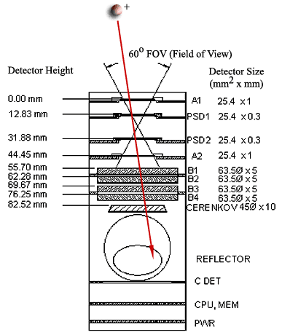
Parameters

A side view of MARIE is sketched in the adjacent figure. The detector is composed primarily of three types of silicon detectors: the A detectors, which are square in cross-section (25.4 mm on a side) and 1 mm in depth; the B detectors, circular, 63.5 mm diameter and 5 mm thick; and the PSDs, or position-sensitive detectors. The PSDs are square double-sided strip detectors with 24 1 mm strips on each side (the strips on one side are orthogonal to those on the other side), and have a thickness of 0.3 mm. There are two A detectors, A1 and A2; sandwiched in between them are PSD1 and PSD2; behind A2, there are the B detectors, B1 through B4. Downstream of B4 is a circular piece of quartz, 10 mm thick, that radiates photons (Cerenkov radiation) generated by the passage of high-velocity particles through it. The photons are reflected by a 45º mirror into a photomultiplier tube that sits out of the path of particles that hit the detectors.

The MARIE is triggered by a coincidence of hits in detectors A1 and A2. Once triggered, the data acquisition system records 12-bit digitized outputs which are proportional to the energies deposited in the A and B detectors. A two-byte data word is stored for each of these channels. The pulse height from the phototube is similarly digitized in 12 bits and stored.

Readout of the PSDs is more complex. Each PSD has two orthogonal sides, referred to as columns and rows. The following description applies to each side of each detector. Onboard hardware analyzes the signals from each of the 24 strips and finds the two largest pulse heights. For each, the pulse height is digitized in 8 bits (256 channels) and stored, along with the strip number. The largest pulse height and position are referred to as “event1”, the second-largest as “event2.” The event2 data are usually noise. Four quantities are stored for each side of each detector, so that a total of sixteen words (thirty-two bytes) of PSD data are stored on each event. The eight-bit pulse heights are referred to as “magnitudes” (abbreviated to “_Mag” in the list below). The positions (listed as “_Pos below) are valid only when in the range 1 to 24.

The full 72-byte data structure for each event is listed below. The first nine bytes are instrument and record identifiers, checksums, etc. Bytes 10-15 are the timestamp. Detector data begin at byte 16 and consist of 23 2-byte words. Bytes 62-72 are flags, the first seven of which are unused; the last four are the PSD status registers (one for each side of each PSD).

TypeId : Byte; { identifies what kind of record this is }
InstID : Byte;
RunId : Byte; { identifies the current run }
RecordId: Byte; { running count of records }
len : Word; { 2 bytes - size of actual record on flash }
CheckSum: word; { 2 bytes }
NumberEvents: byte; { 1 byte total of events per 100 ms. FF max}
Time : real; { 6 bytes}
Events : EventsArray; { 46 bytes }
Flags : FlagsArray; { 11 bytes }

The 23 2-byte words of detector data are ordered as follows:

A1, A2, B1, B2, B3, B4, C1; { for all, valid data in the lowest 12 bits }
PSD1_Row_Event1_Mag; { valid data in the lowest 8 bits }
PSD1_Row_Event1_Pos; { valid data in the range 1 to 24 }
PSD1_Row_Event2_Mag; { valid data in the lowest 8 bits }
PSD1_Row_Event2_Pos; { valid data in the range 1 to 24 }
PSD1_Col_Event1_Mag; { valid data in the lowest 8 bits }
PSD1_Col_Event1_Pos; { valid data in the range 1 to 24 }
PSD1_Col_Event2_Mag; { valid data in the lowest 8 bits }
PSD1_Col_Event2_Pos; { valid data in the range 1 to 24 }

PSD2_Row_Event1_Mag; { valid data in the lowest 8 bits }

PSD2_Row_Event1_Pos; { valid data in the range 1 to 24 }
PSD2_Row_Event2_Mag; { valid data in the lowest 8 bits }
PSD2_Row_Event2_Pos; { valid data in the range 1 to 24 }
PSD2_Col_Event1_Mag; { valid data in the lowest 8 bits }
PSD2_Col_Event1_Pos; { valid data in the range 1 to 24 }
PSD2_Col_Event2_Mag; { valid data in the lowest 8 bits }
PSD2_Col_Event2_Pos; { valid data in the range 1 to 24 }

The 11 bytes of the flag array are, in order:

FlagA1, FlagA2, FlagA3,
FlagB1, FlagB2, FlagB3, FlagC1,
FlagPSD1_Row, FlagPSD2_Row, FlagPSD1_Col, FlagPSD2_Col

Only the last four contain valid data.

Processing
These are unprocessed raw data.

Ancillary Data
No ancillary data are being provided.

Coordinate System
MARIE’s internal coordinate system is as per the detector diagram above. The PSDs have their own coordinate system in the sense that each strip (corresponding to a row or a column) is assigned a sequential number from 1 to 24. These values are not referenced to any other coordinate system, as the primary purpose of the PSDs is to calculate the angle at which incident particles traverse the silicon detectors. With valid hits in all rows and columns, the angle θ with respect to the vertical (normal incidence) can be calculated as follows. We define Δr = PSD1_Row_Pos – PSD2_Row_Pos, Δc = PSD1_Col_Pos – PSD2_Col_Pos, and d is the distance between PSD1 and PSD2. Then

$$\text{tan}\left(θ\right)=\sqrt{\frac{{Δr}^{2}+{Δc}^{2}}{d}}$$

Software

Software to convert the raw data to text is provided. Only the detector data and time (Julian day) are written to the output file.

Media/Format

MARIE Raw Data Confidence Level Note

Review

These data have been reviewed by the instrument team and are of the highest quality that can be generated at this time. After submission to the PDS, these data will undergo PDS peer review.

Data Coverage/Quality

MARIE was on for parts of the 2001 Mars Odyssey cruise phase, starting in late April 2001 and ending in late July 2001. A problem with the onboard computer occurred in early August, and the instrument was turned off until mid-March, 2002, after Odyssey’s mapping orbit had been established. Data have been collected from that time to the present without major interruption. Routine minor interruptions of up to 36 hours have been encountered during the orbital phase; the outages occur when the instrument’s data is erased (after having been downloaded). Additional shorter outages of approximately 2 hours duration occur on a daily basis while data are downloaded.

Limitations

Geometric Acceptance

MARIE’s geometry is optimized for detecting particles coming into the detector (hitting A1 first) in a forward cone of half-angle approximately 30º. The angle is defined with respect to the centerline of the silicon detectors. Particles incident at larger angles may hit one or more detectors, but will not satisfy the requirement of coincident hits in A1 and A2. Forward-going particles encounter minimal (but finite) mass before entering MARIE, and must have residual range sufficient to penetrate as far as A2. As of this writing (May 2002), best estimates of the material in front of MARIE lead to the prediction that the minimum free-space (i.e., before encountering any material) kinetic energy required for a proton to reach A2 is about 30 MeV. MARIE can also be triggered by particles entering from the rear, provided they are sufficiently energetic to hit both A2 and A1. For a proton, this corresponds to a minimum energy of 72 MeV incident on B4. However, any such particle must pass through a considerable (currently unknown) mass in order to reach B4. (The mass in question is Odyssey’s oxidizer tank.) Backward-going particles must therefore be far more energetic than their forward-going counterparts in order to trigger.

In the data, backward-going particles can, in some cases, be distinguished by the patterns of energy deposition they leave in the silicon detectors; for particular particle/energy combinations, these patterns may be quite distinct from those of forward-going particles of the same type and energy. In addition, the Cerenkov detector is directional, and no Cerenkov photons will be recorded for backwards-going particles.

Saturation of Electronics

As of May 2002, all MARIE data have been taken with all silicon detectors operating at full depletion. The gains of the electronics – combined with the limitations on input voltage into the analog-to-digital converters (ADCs) – are such that the A channels saturate at approximately 70 MeV energy deposited, while the B channels saturate at about 350 MeV energy deposited. Because deposited energy is a function of the charge (Z) squared of an incident heavy ion, this limits the detectable range of particle charges. In the present configuration, the largest usable signal corresponds to highly-energetic ions of charge 11. The Galactic Cosmic Radiation contains all elements up to uranium, though ions heavier than iron (charge 26) are rare. Because iron ions contribute substantially to the dose equivalent astronauts will receive once outside the geomagnetosphere, it is important to detect them. In order to do so, the only modification to MARIE that can be made from the ground is to reduce the bias voltage on two (or possibly all four) of the B detectors. Current plans are to reduce the voltage on B3 and B4 only. Laboratory tests with similar detectors indicate that this is a feasible approach, albeit with considerable loss of resolution. The degradation in data quality will likely render B3 and B4 unusable for detailed analysis of protons and other light ions. The voltage change will likely be implemented in June 2002.

PSD Performance

The PSD performance for sparsely-ionizing particles such as protons is known to be marginal. The detectors are thin (300 μm), so that signals are small and noise (which falls with increasing detector depth) is relatively large. The onboard algorithm for finding hits returns many 0 values (no hit found), many more values of 1 than is physically reasonable, and in the case of PSD1 columns, many more values of 24 than is physically reasonable. It is likely the case that the edge channels of the PSDs are nosier than those in the middle, and hence are often mistakenly identified as having been hit. The figure below shows representative position distributions for all four detector sides. An event sample consisting of relatively highly-ionizing events has been chosen. If the detectors were working as expected, all histograms would show broad distributions peaked in the middle. Only the distribution of hits in the PSD1 rows approximates the expected shape. One possible improvement would be to raise the thresholds the hit-finding algorithm uses. This would result in more “0” values (no hit found) but would reduce or eliminate erroneous positions from noise hits.

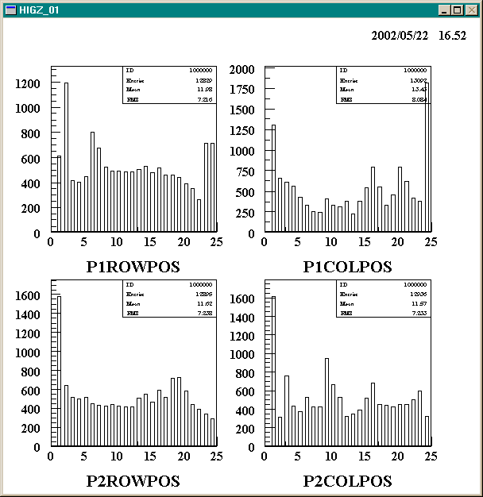

Cerenkov Detector Performance

The Cerenkov detector performance is currently marginal. Signals are smaller than expected, which suggests that the voltage on the photomultiplier tube is too low. Investigations are underway to determine how much the voltage can be increased.

References

A manuscript containing a detailed description of MARIE is in preparation at the time of this writing (May 2002). For the moment, the best source of additional information about MARIE is on the web at http://marie.jsc.nasa.gov.

